**Engr228 Lab #2 Spring, 2020**

**Voltage Dividers, Nodal and Mesh Analysis**

**Name _____________________________**

**Note: This lab is a combination of a normal prelab (calculations, plotting, etc.) and a normal lab exercise (making and recording actual measurements). It is long, but no more work than if the class was being conducted on campus.**

**Introduction**

This lab exercise is designed to further your understanding of the use of the lab equipment and to verify Kirchhoff’s theorems through nodal and mesh analysis. You will construct and analyze a circuit to verify Kirchhoff’s laws and make power calculations to verify the conservation of power.

**Objectives**

* Gain more experience in making DC voltage and current measurements;
* Gain more experience in making resistance measurements;
* Gain more experience in the construction of circuits using your solderless breadboard;
* Verify Kirchhoff’s laws through node and mesh analysis;
* Verify conservation of power.

**Equipment**

* Digilent Analog Discovery 2 Module;
* Handheld DMM;
* Breadboard;
* Assorted resistors;
* Assorted wires.

**References**

* Zybooks text book;
* Course web site;
* Resistor color-code chart.

**Background**

All DC circuit analysis (the determining of currents, voltages, and resistances throughout a circuit) can be done with the use of three rules:

1. **Ohm's law**

This law states that the potential difference across a circuit element is equal to the product of the current through and the resistance of the circuit element. Mathematically, this can be expressed as:

$V= IR$

Ohm's law can be applied to an entire circuit or to individual parts of the circuit.

1. **Kirchhoff’s Current Law (KCL)**

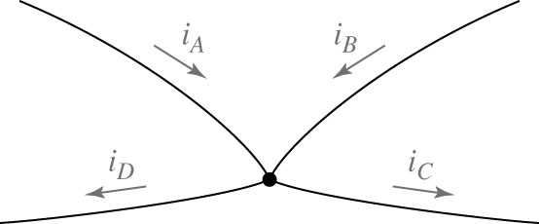This rule states that the algebraic sum of all currents at a node (junction point) is zero. Often, currents coming into a node are considered negative and currents leaving a node are considered positive. For the figure at the right,

*iA + iB = iC + iD*

KCL is also a statement of the law of conservation of charge. Since no charge may be stored at a node and since charge cannot be created or destroyed at the node, the total current entering a node must equal the total current leaving a node.

1. 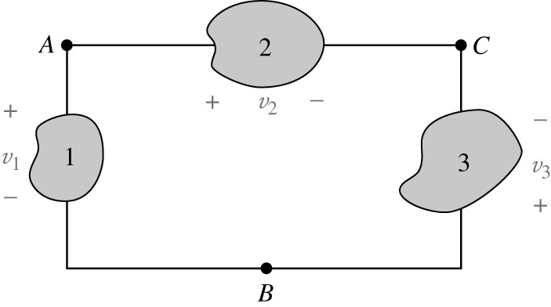**Kirchhoff’s Voltage Law (KVL)**

This rule states that the algebraic sum of all the changes in potential (voltages) around a loop must equal zero. Often, a potential difference is considered positive if the potential is getting smaller in the direction of the current flow. For the circuit at the right,

*-v1 + v2 - v3 = 0 or v2 = v1 + v3*

This is a statement of the law of conservation of energy. Since potential differences correspond to energy changes and since energy cannot be created or destroyed in ordinary electrical interactions, the energy dissipated by the current as it passes through the circuit must equal the energy provided by the power sources.

**Procedure**

**Throughout this lab, round all predicted values, measured values, and percentage errors to four significant digits, but carry more digits through intermediate calculations.**

1. From your resistor selection, select the resistors shown in the table below. Measure and record the value of each resistor.
2. Using the following formula, calculate and record the percentage error. Note that your percentage errors should all be less than 5%.

$$Percentage Error= |(Calculated value-Measured value)|/(Calculated value)*100\%$$

|  |  |  |  |
| --- | --- | --- | --- |
| Resistor ID | Nominal Value (Ω) | Measured Value (Ω) | Percentage Error (%) |
| R1 | 10KΩ |  |  |
| R2 | 20KΩ |  |  |
| R3 | 30KΩ |  |  |
| R4 | 20KΩ |  |  |
| R5 | 10KΩ |  |  |

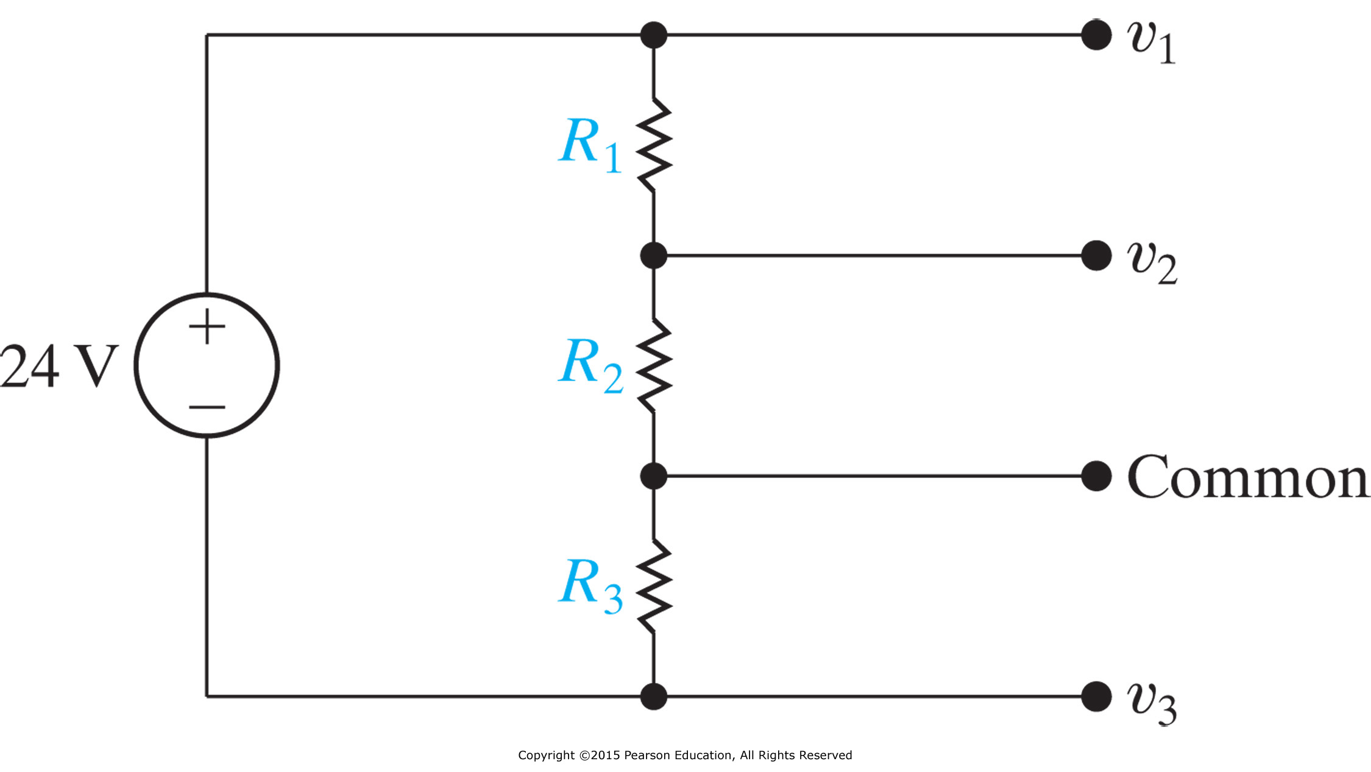

A

B

1. Use the voltage divider law to calculate the voltages at nodes A and B in the circuit at the right. Use your measured resistor values from step 2. Record your answers in the table below. Set V = 5.00 volts.
2. Wire up the circuit and verify the voltages at nodes A and B. Record your answers below.

|  |  |  |  |
| --- | --- | --- | --- |
| Node | Calculated Value (V) | Measured Value (V) | Percentage Error (%) |
| A |  |  |  |
| B |  |  |  |

1. Calculate the current flowing through R3 in the circuit in step 3. Record your answer in the table below.
2. Measure the current flowing through R3 and record your answer in the table below.

|  |  |  |  |
| --- | --- | --- | --- |
| Current | Calculated Value (A) | Measured Value (A) | Percentage Error (%) |
| R3 |  |  |  |



1. Using your breadboard, construct the circuit shown at the right. It’s helpful if the orientation of parts on the breadboard correspond physically to the orientation of the schematic.
2. Fill in the table on the next page. The first column should be calculated using your measured resistor values from step 2 of this lab. The second column should be measured values. Note – you need to measure the mesh currents by determining where to put the ammeter in your circuit so you measure one, and only one, mesh current at a time.

|  |  |  |  |
| --- | --- | --- | --- |
| **Circuit**  **Parameter** | **Calculated** | **Measured** | **% Error** |
| V2 (V) |  |  |  |
| V3 (V) |  |  |  |
| I1 (mA) |  |  |  |
| I2 (mA) |  |  |  |
| I3 (mA) |  |  |  |
| P5V (mW) |  |  |  |
| PR1 (mW) |  |  |  |
| PR2 (mW) |  |  |  |
| PR3 (mW) |  |  |  |
| PR4 (mW) |  |  |  |
| PR5 (mW) |  |  |  |

1. Calculate Vx in the circuit of step 7:

Vx using mesh currents: ____________ V

Vx using node voltages: ____________ V

1. Using your measured values from the table above, verify that power is conserved in your circuit. Show your calculations below.
2. Using your measured voltage values (step 8), and measured resistance values (step 2), verify Kirchhoff’s current law at nodes V2 and V3. Show your calculations below.
3. Using your measured current values (step 8), and measured resistance values (step 2), verify Kirchhoff’s voltage law for all three meshes. Show your calculations below.

**To Turn In**

Do your work on wither the .pdf or .docx version of the lab and place in the **lab2** drop box by 2pm on Friday, April 17.