Engr228 Lab #5 Spring, 2020

Natural and Forced Response of First-Order Circuits

Name _____________________________

Introduction
This experiment investigates the natural and forced responses of first-order circuits. Using four different circuit set-ups, you will do calculations and verify your numbers with a lab setup. You will construct and analyze both RC and RL circuits.

Lab Objectives
- Understand voltage and current relationships in a capacitor;
- Understand voltage and current relationships in an inductor;
- Understand the natural and forced responses of first-order RC circuits.

Equipment
- Waveforms software;
- Digilent Analog Discovery 2 Module;
- Breadboard;
- Assorted components and wires.

References
- Zybooks text book;
- Course web site;
- Resistor color-code chart.

Preamble
I have found four YouTube videos that demonstrate the principles I wish for you to learn. I will have you watch these four videos, and work with circuits similar to what are being demonstrated. These videos are part of a series entitled “Real Analog – Circuits 1 labs” found on YouTube.

Procedure

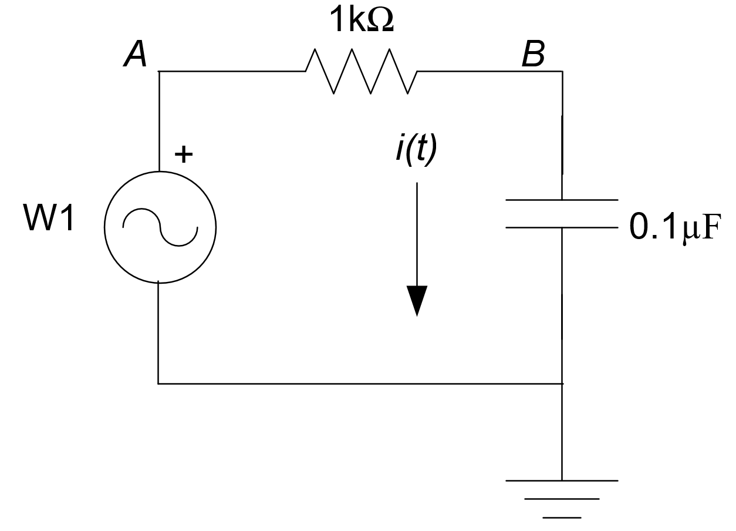
Part I
The first circuit you will be working with is shown on the right. I have changed values of the resistor and capacitor from those used in the video to match values you have in your parts kit, while maintaining the same time constant of the demo circuit.

- Watch the following video on capacitor voltage-current relationships. As you do so, make notes of how you are going to wire this circuit up on your bread board. You only need to watch the first six minutes. Ignore the part on measuring the leakage current as you don’t have an electrolytic capacitor in your stash. Note – you can still do the leakage test using the capacitor you have if you wish.

Capacitor V-C Relations

- Use your handheld meter to measure and record the values of your resistor and capacitor in the circuit above. Note these values are different than those in the video.

Capacitor = ___________ μF

Resistor = ____________ Ω

- Wire up your circuit and run through the experiment as done in the video. Report how your lab experiment worked. Were you able to get results similar to the demo results? Please elaborate.

- What new features did you learn about your Waveforms software?

Part II
- Watch the following video on inductor voltage-current relations. Note that you cannot measure your inductor value with your meter. We can do that in the lab on campus with an instrument called an LRC meter.

Inductor V-C Relations
- Construct the circuit seen in the video. You will have to substitute your 22μH inductor for the 1mH specified in the video. You will also have to settle for a different time constant. To keep the same time constant as the video, you would need a 2.2Ω resistor. Also, use a 100 Ω series resistor and set your Wavegen frequency to 100kHz.
Note that you won’t (or shouldn’t) see much of an effect from the internal inductor series resistor demonstrated in the last part of the video. This is because the series resistor of your inductor is quite low – I measured mine at 0.1Ω.

- Report how your lab experiment worked. Were you able to get results similar to the demo results?

Part III
- Next, watch the following video on the natural circuit response of an RC circuit.

RC Natural Circuit Response

- Wire up the circuit in the video. Note that you will be using your 0.1μF capacitor instead of the 47μF used in the video. Use 10kΩ resistors in place of the 2.2kΩ resistors. This will make the time constant in your circuit approximately 100 times faster than in the video. Please make the necessary changes in your virtual instruments.

- Report how your lab experiment worked. Were you able to get results similar to the demo results? Especially report on how your measured time constant compares with your calculated value.

Part IV
- Finally, watch the last video on the forced response of an RC circuit. Note that for this part, you only need to watch and complete the first 3:20 of the video.

RC Circuit Forced Response

- Using the same circuit as in Part III, follow the same process as in the video. Report how your lab experiment worked. Were you able to get results similar to the demo results? Especially report on how your measured time constant compares with your calculated value.

Conclusions
- Report on your overall understanding of the principles outlined in this lab. Specifically comment on:
  - Usage of the Waveforms software and the lab instruments.

  - Measurement of the natural response of RC circuits.

  - Measurement of the forced response of RC circuits.

  - Time constants.

To Turn In
Do your work on either the .pdf or .docx version of the lab and place in the lab5 drop box by 11:30pm on Sunday, May 10. May the force be with you.

