Engr228 Lab #6 Spring, 2020

Forced Response of a Series RLC Circuit

Name _____________________________

Introduction
This experiment investigates a series RLC circuit driven by an AC Voltage. The relationship of the output voltage (V_{O}) with the input voltage (V_{I}) exhibits the characteristics of a band-pass filter which means that it passes a selective band of frequencies and blocks frequencies outside of this band. To learn how this works, you will explore the frequency response, both magnitude and phase, of a series RLC circuit.

Lab Objectives
- Continue developing proficiency with the function generator and oscilloscope;
- Understand magnitude and phase relationships in series RLC circuits;
- Understand the VI characteristics of capacitors, inductors, and resistors;
- Witness some limitations of lab instruments.

Equipment
- Waveforms software;
- Digilent Analog Discovery 2 Module;
- Breadboard;
- Assorted components and wires.

References
- Zybooks text book;
- Course web site;
- Resistor color-code chart.

Procedure
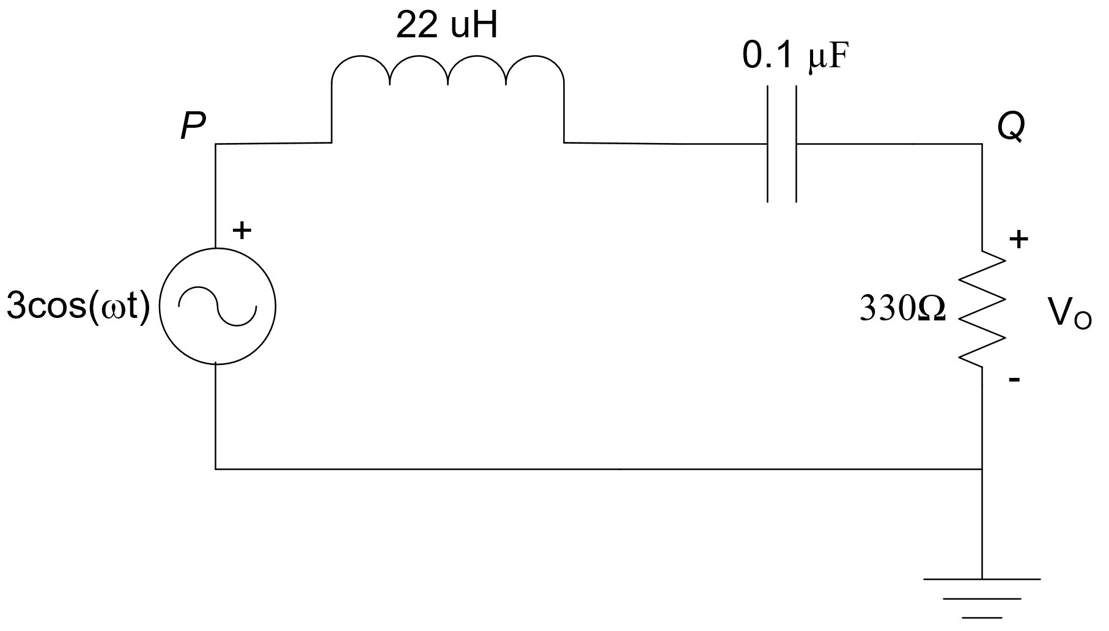
- Measure and record the values of the components shown in the circuit at the right. Note you can’t measure the inductor.

C = __________ nF

R = __________ Ω

- Using your breadboard, construct the circuit shown above. Connect the channel 1 oscilloscope probe between points P and ground and the channel 2 oscilloscope probe between points Q and ground.

- Set the waveform generator to output a sine wave with initial frequency of 100 Hz and 3V_{peak}

- Measure the voltages at points P and Q for the frequencies shown in the table below:

  - Use the Measurement function so you can directly read the P and Q peak-to-peak voltages, frequency, and period;
  - You will likely have to adjust the sensitivity of channel 2 as the frequency changes (necessary if measurements appear in red).
  - For each frequency setting, you must also take a measurement of the phase difference by using the method demonstrated in the laboratory lecture. Note that θ is positive for frequencies that occur before the theoretical peak voltage (around 107,000Hz) and negative for frequencies that occur after the peak voltage.

F (Hz) | P (v_{pp}) | Q (v_{pp}) | Q/P | θ (degrees)
100
500
1k
2k
5k
10k
20k
50k
100k
200k
500k
1M
2M
3M
4M
5M
6M
7M
8M
9M
10M

The equations below are the theoretical derivations for the magnitude and phase responses of the circuit on page 1. I have derived these for you. These equations are general in terms of R, L, and C. Fill out the equations below using your actual values for R and C that you measured in step 1. Use the nominal value for the inductor. Your results for magnitude and phase will be functions of ω.

$$\left|\frac{V_{Q}}{V_{P}}\right|=\sqrt{\frac{C^{2}R^{2}ω^{2}}{C^{2}L^{2}ω^{4}+C^{2}R^{2}ω^{2}-2CLω^{2}+1}}$$

$$θ=-\tan^{-1}\left(\frac{CLω^{2}-1}{CRω}\right)$$

- From the theoretical magnitude equation above, calculate the center frequency f₀, which is the frequency where the response is maximum. To find this number, differentiate the magnitude equation with respect to ω, set the resulting equation equal to zero, and solve for ω. (Use any tool you wish).

- Using Excel, plot magnitude vs. frequency (Hz) from your Q/P column in the table above. On the same graph, plot theoretical magnitude (V_{Q}/V_{P}) vs. frequency (Hz). Note that the theoretical formula is using ω so you need to replace each ω with 2πf.

- Also in Excel, plot phase vs. frequency (Hz) from your table above. On the same graph, plot theoretical phase vs. frequency (Hz).

- Compare your result in step 5 with that of a series RLC circuit:

$$f_{0}=\frac{ω_{0}}{2π}=\frac{1}{2π}\frac{1}{\sqrt{LC}}$$

- From the graph in step 6, eyeball the center frequency (f_{O}) and compare to the calculated value from step 5.

 | Experimental | Theoretical
f_{O} (Hz)

- Turn in this report and your plots from steps 6 and 7.

