Engr228 Lab #7 Spring, 2020

Forced Response of a Series RLC Circuit – Part II

Name _____________________________

Introduction
Last week you investigated a series RLC circuit driven by an AC Voltage. You compiled magnitude and phase data for frequencies ranging from 100Hz to 10Mhz. In this lab, you will utilize phasors to analyze the same series RLC circuit, and compare theoretical calculations to observed data.

Objectives
- Understand phasor analysis of a series RLC circuit;
- Understand the VI characteristics of capacitors, inductors, and resistors;
- Continue developing proficiency with the function generator and oscilloscope.

Equipment
- Waveforms software;
- Digilent Analog Discovery 2 Module;
- Breadboard;
- Assorted components and wires.

References
- Zybooks text book;
- Course web site;
- Resistor color-code chart.

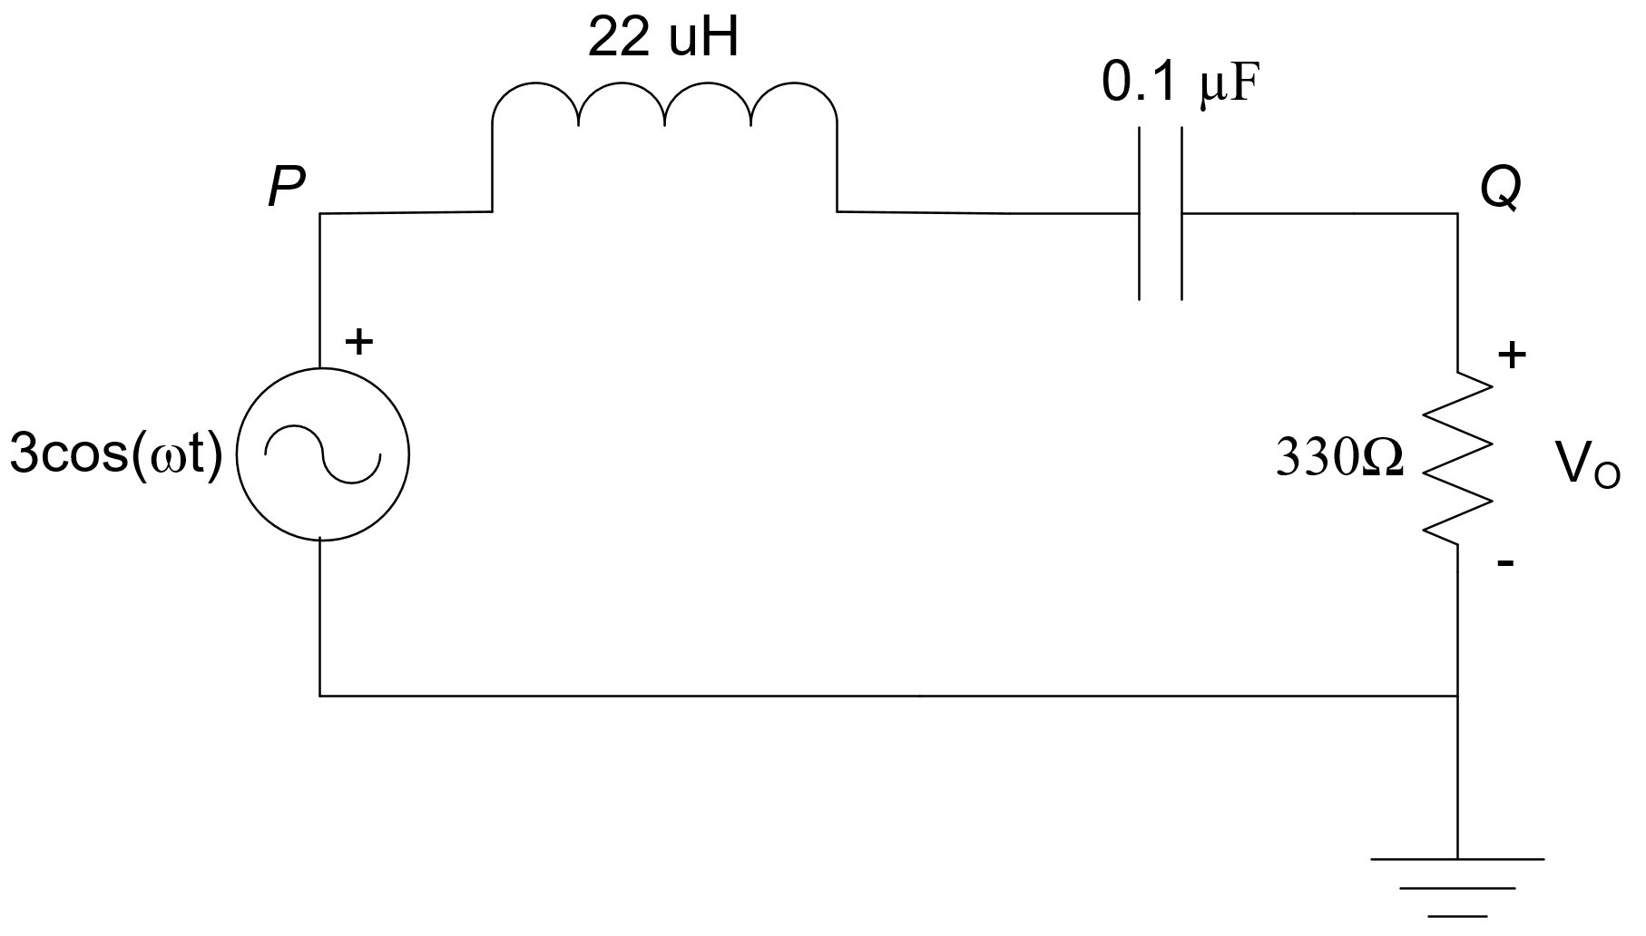
Procedure

This lab will be using the same circuit and components as lab #6 from last week.

- For reference, measure or copy the values from last week for your resistor and capacitor. Assume the nominal value for inductance.

C = __________ nF

R = __________ Ω

- Use phasors to derive an expression for the voltage ratio (V_{Q}/V_{P}) as a function of frequency, where V_{P} is the sinusoidal voltage source and V_{Q} is the voltage across the resistor.

- Using your expression from part 2, divide it into two parts, magnitude and phase. Both of these expressions will be functions of ω.

- Using your breadboard, construct the circuit shown above. Connect the channel 1 oscilloscope probe between points P and ground and the channel 2 oscilloscope probe between points Q and ground.

- Set the waveform generator to output a sine wave with initial frequency of 10kHz and 3V_{peak}

- Last week you measured the magnitude and phase at point Q and compare it to your calculated values. Do so again below, but use the equations you developed in step 3 instead of the ones I gave you for comparison. It’s up to you to determine what values to record below. That’s why I have left the columns unlabeled. Note that θ is positive for frequencies that occur before the theoretical peak voltage (around 107,000Hz) and negative for frequencies that occur after the peak voltage.

F (Hz)
10khz
25khz
50khz
75khz

100khz
125khz
150khz
200khz
300khz
500khz

- Use phasors to calculate the current, I, in your circuit for f = 100khz. Express it as both a magnitude and a phase.

- You know that voltage and current are always in phase across a resistor. Calculate what the voltage across the resistor should be for f = 100khz and use your oscilloscope to measure and display the voltage and current (add a math channel). Report on your results. Feel free to draw waveforms if it is helpful.

- You know that voltage and current are always 90° out of phase for an inductor. Calculate what the voltage across the inductor should be for f = 100khz and use your oscilloscope to measure and display the voltage and current. Measure the phase difference between them and report on your results. Feel free to draw waveforms if it is helpful.

- You know that voltage and current are always 90° out of phase for a capacitor. Calculate what the voltage across the capacitor should be for f = 100khz and use your oscilloscope to measure and display the voltage and current. Measure the phase difference between them and report on your results. Feel free to draw waveforms if it is helpful.

