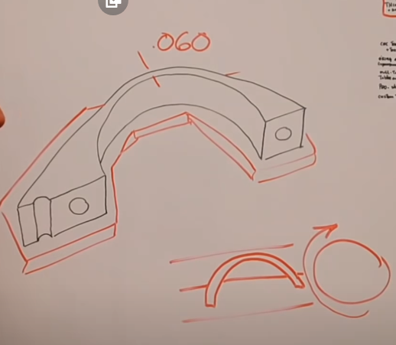

* For this wall thickness parts, make sure that the cutter pushes the part into the vice. Benefits include:
  + Better surface finish
  + Less noise/chatter
  + Tighter tolerance