Mori Seiki NVX 5080 (1st Generation)
Correct operation order/workflow:
Turn on machine -> touch off all tools -> enter WCS for G54 -> upload program (*.nc) -> dry run (run program w/ offsets) -> run program

Machine Startup

1 | Turn switch on back of machine to ‘on’ position | 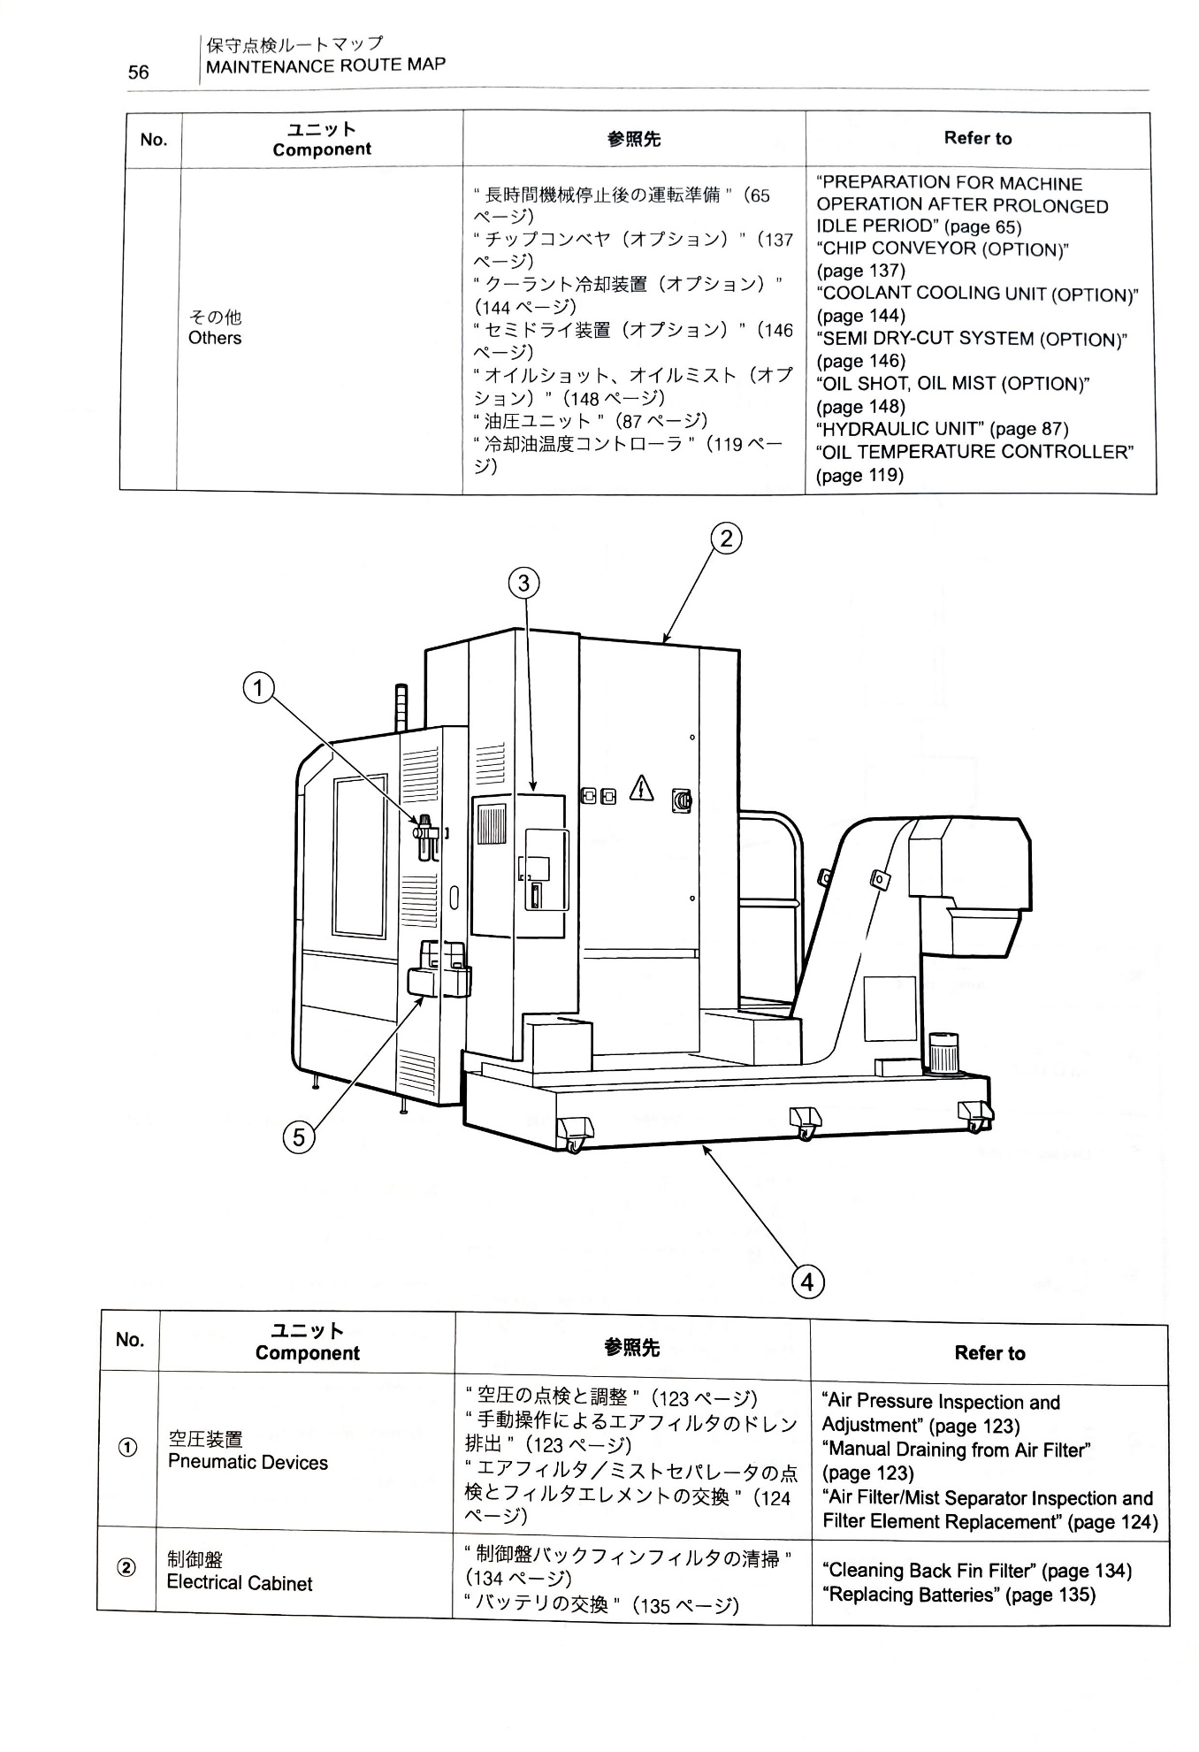
2 | Press ‘on’ button at front panel of machine | 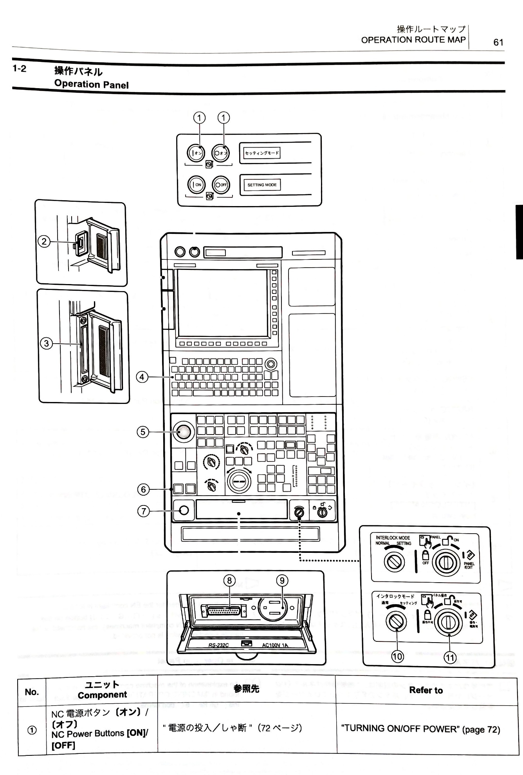
3 | Wait about 75 seconds for the safety warning message to come up
4 | Press “ok” | 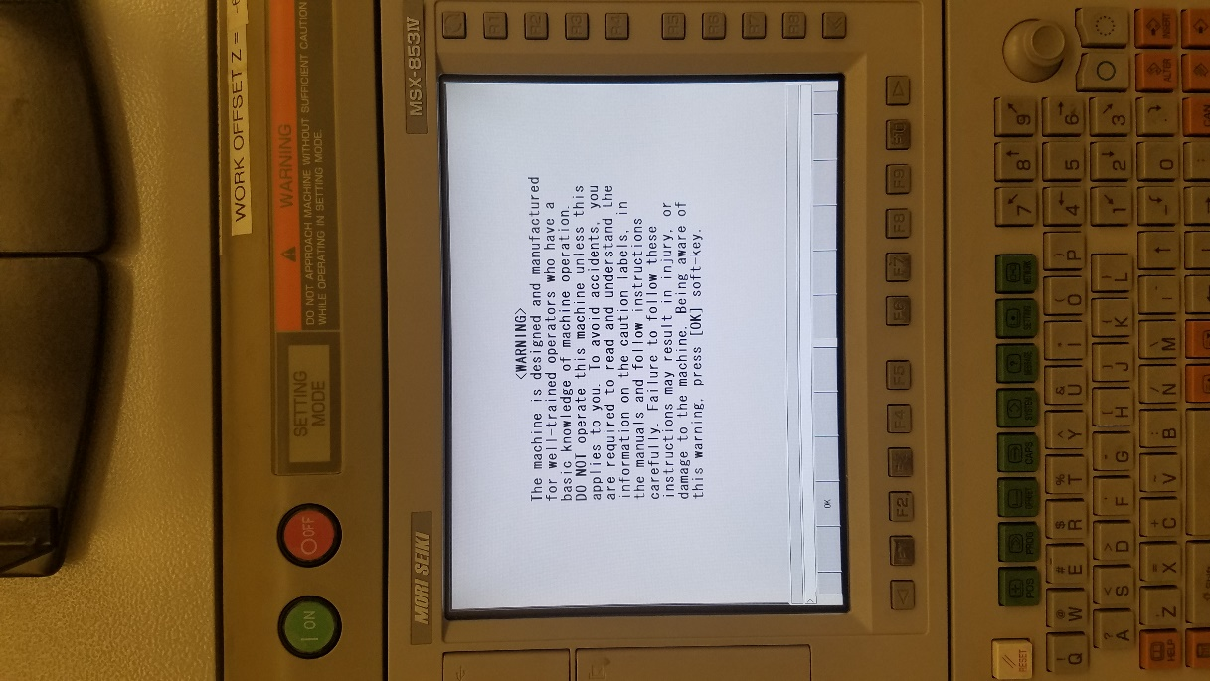  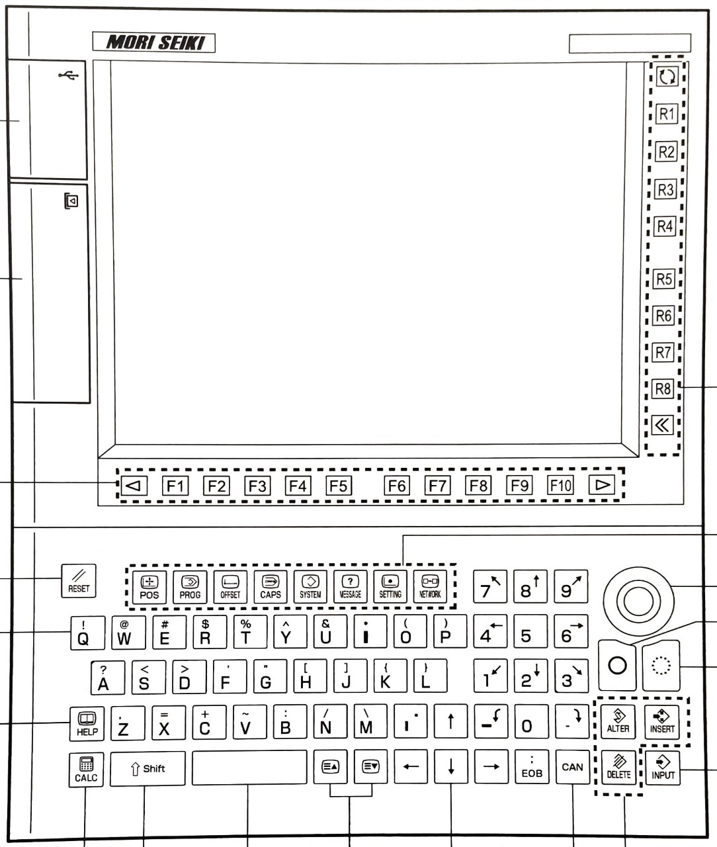
5 | Open and close doors | } beginning to follow on-screen instructions

Machine Shutdown
- Verify no operations are in progress, e.g. nothing is moving inside the machine
- Turn switch on back of machine to ‘off’ position

Basic Commands & Functions
Home: G91 G30 X0Y0Z0
Tool Change: Tx; M6; -> input (or insert?)
1 | To enter commands, switch to MDI mode (MDI stands for Manual Data Input) | 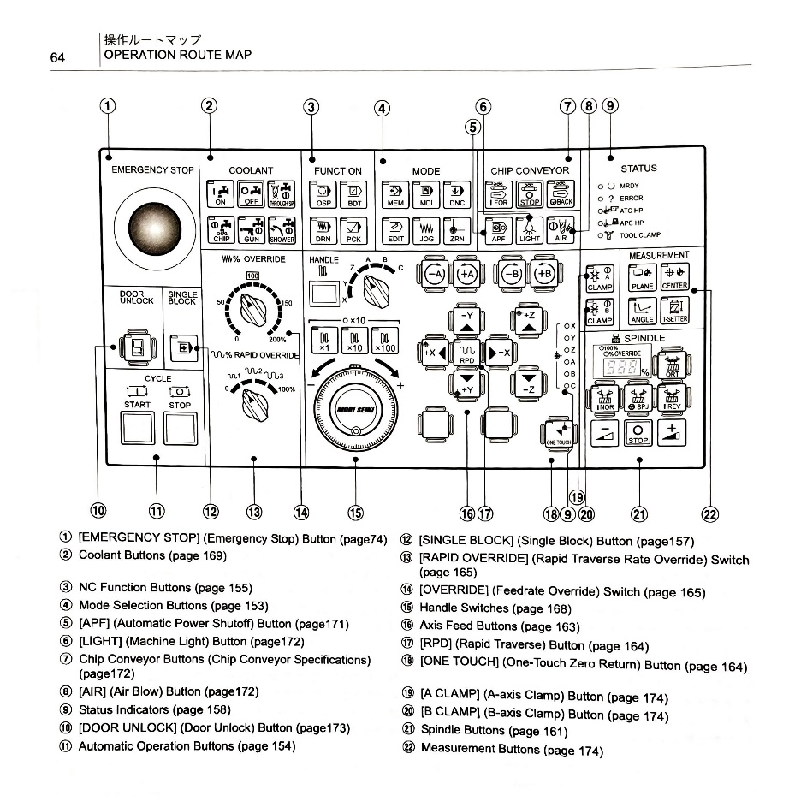
2 | You may need to press ‘PROG’ (program) button to display the correct screen | 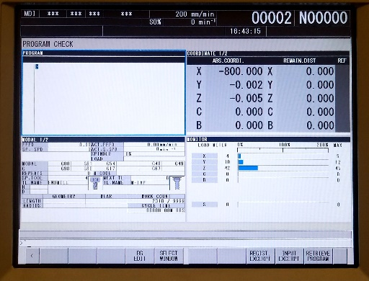
3 | Type out various commands with the keyboard, then press ‘insert’ to add the code
4 | then press ‘start’ to execute the commands you just entered

Adding a Program
 | Plug in USB with correctly formatted g-code on the USB
1 | Switch to ‘MEM’ mode
2 | You should see a screen like this: | 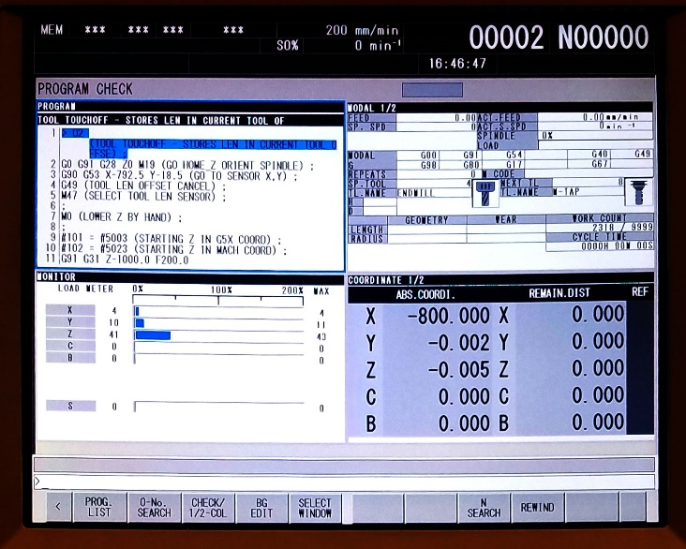
3 | Select “PROG LIST”, which will be assigned to “F1” | 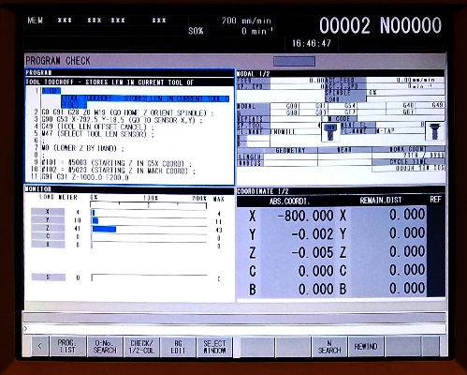
4 | Select “PUNCH/READ”, which will be assigned to “F3” | 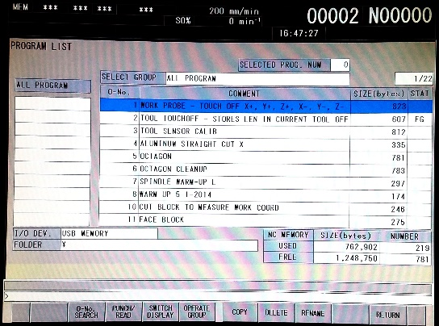
 | Select “READ”, which will be assigned to “F2”  This will allow you to read the files on the USB drive | 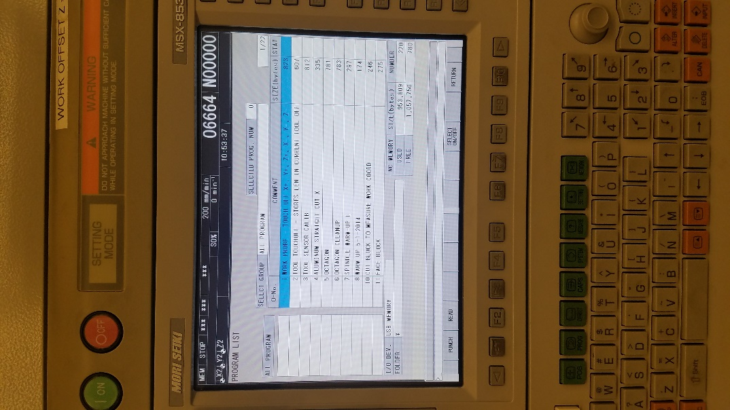
 | You will see a selection of *.nc files, (hypothetically ones you have put there). Navigate to your desired file with the arrow keys  Hit “execute” which is assigned to “F6” key  Sidenote - If your GCODE files are in a folder on your drive, you can enter the folder by pressing “INPUT” with the desired folder selected | 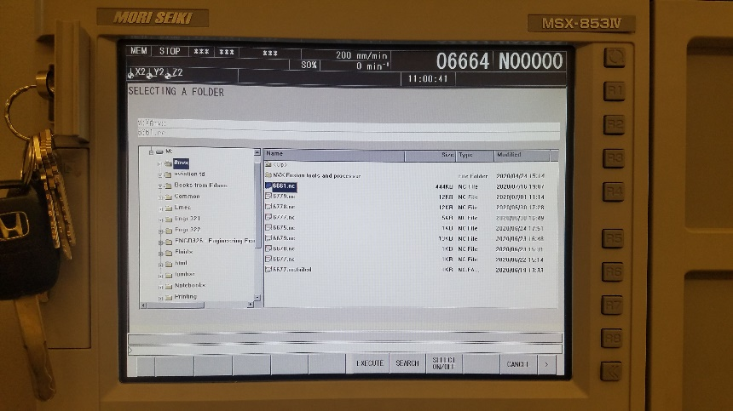
5 | Use the “page up/page down” and the “up/down arrows” to navigate to your program. Verify it has been imported, then hit “RETURN”, which is assigned to “F10” | 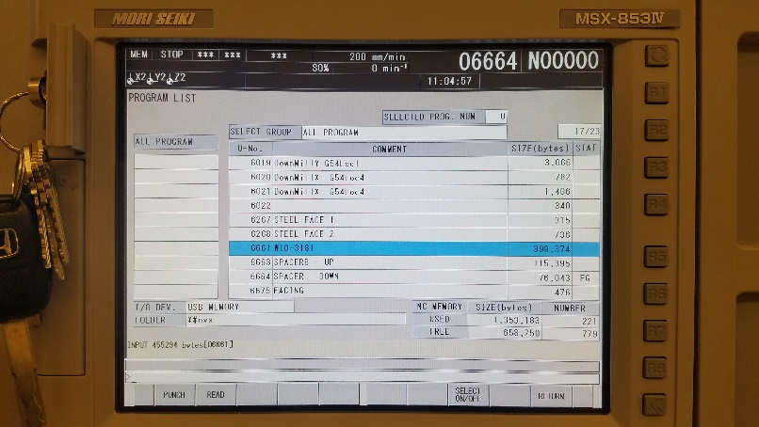
6 | Hit “RETURN” again. You will see a screen like this now  (you’ll have to hit “RETURN” a total of twice to leave this part of the program | 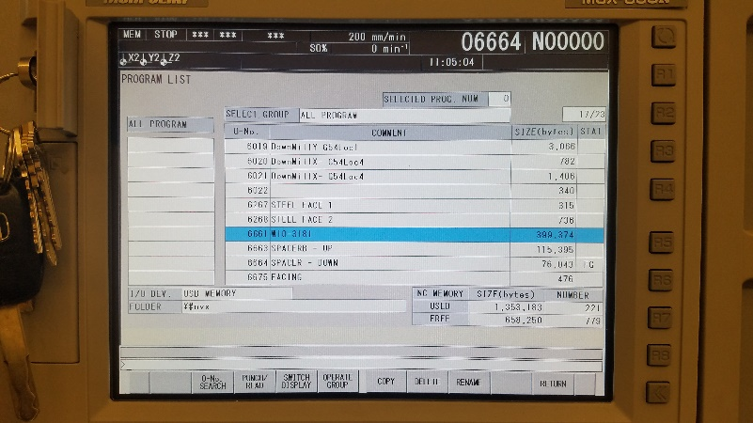
7 | From this screen, type in the 4-digit number assigned to your program. In this example, I type “6661”, then press “O-No. SEARCH”, which is assigned to “F2” | 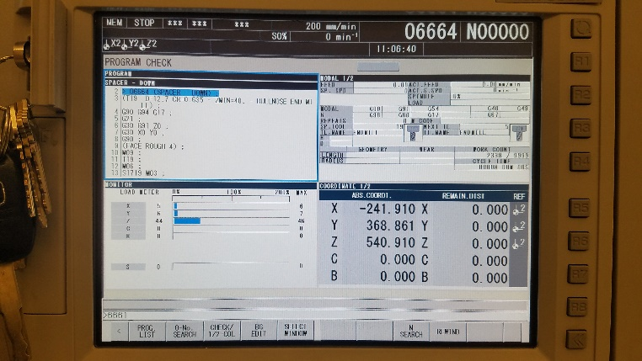
8 | As you can see, the program in the upper left window changes from the previous program to our selected program.  Provided you have performed all the necessary preparations (see the list on pg ____), you may press start to begin your operation (although a dry-run is highly encouraged) | 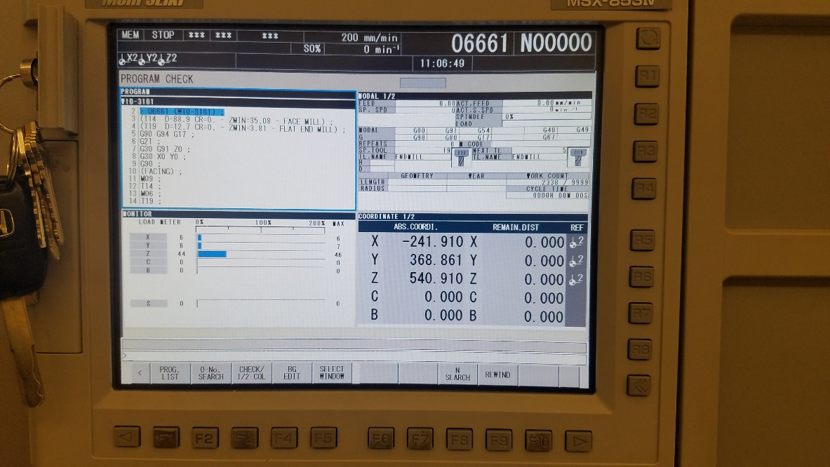
 | NOTE: Once you are finished with your program, delete it. The NVX5080 only has 2,000,000 bytes of storage capacity, which equates to 2 MB of storage. It’s not much, so do future users a favor and delete your programs once you’re done with them.

Deleting a Program
 | Switch to ‘MEM’ mode
 | You may need to press ‘PROG’ (program) button to display the correct screen | 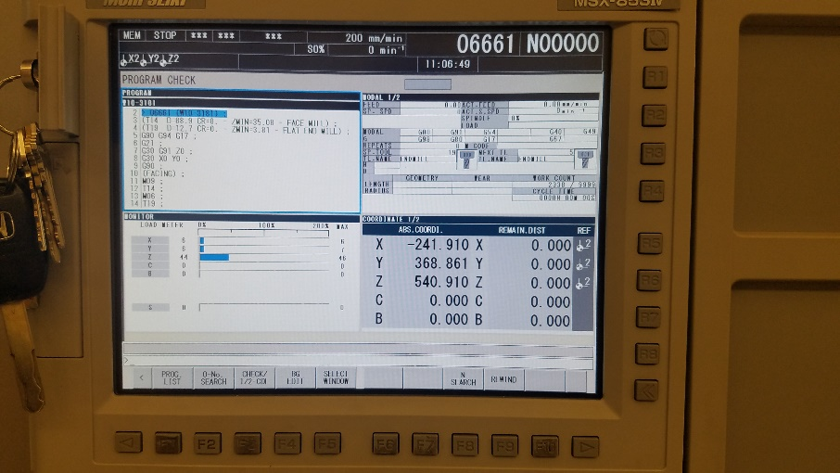
 | Switch to a different program like “02” using “O-no. SEARCH”  This moves the program you will delete out of the active memory so you can delete it | 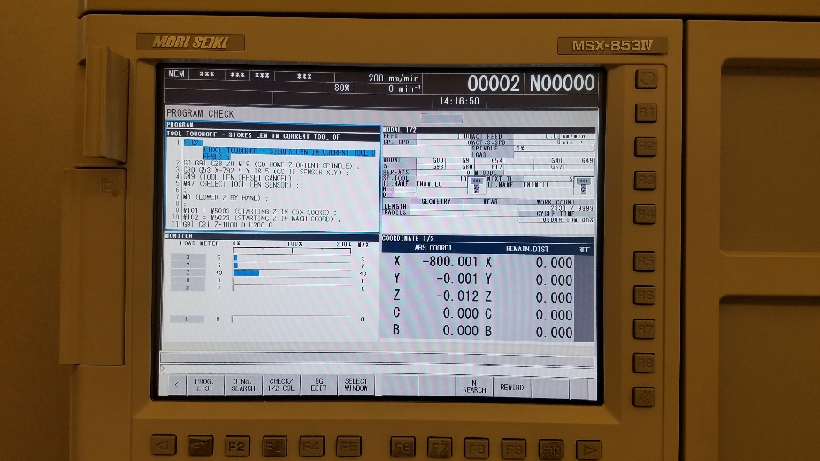
 | Press “PROG. LIST” which is assigned to “F1”
 | Scroll down using “Page down” and “arrow keys” to select the desired program | 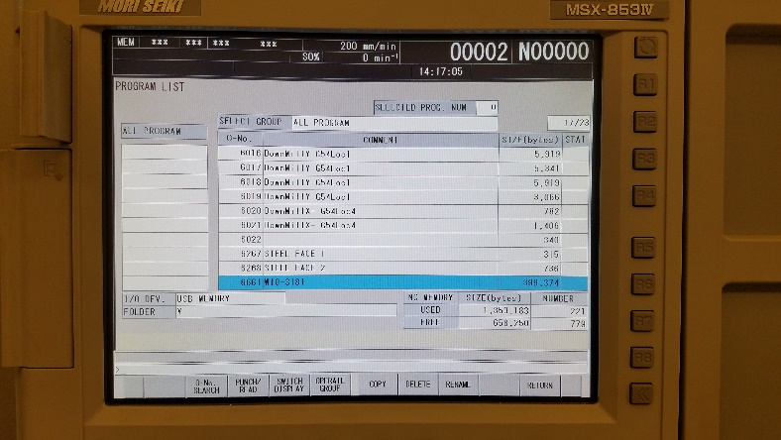
 | Select “DELETE”, which is assigned to “F7”
 | Select “DELETE” again, which has been reassigned to “F6” | 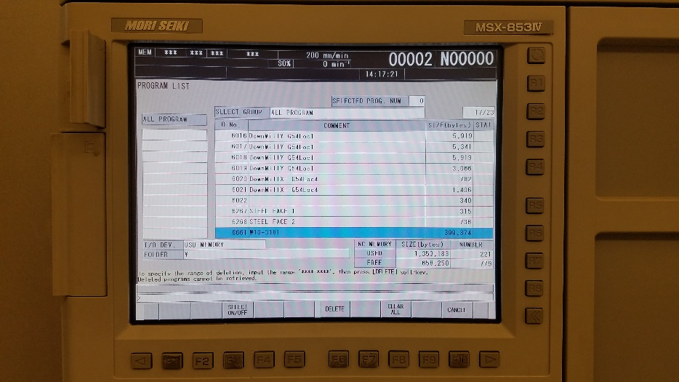
 | Select “EXECUTE”, which is assigned to “F7”  Congratulations! Your program is now deleted. | 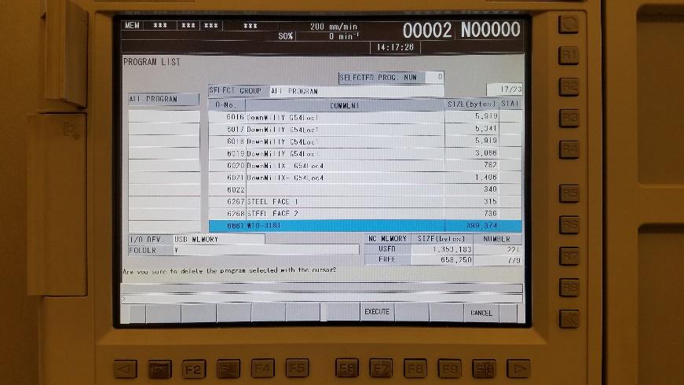
 | Congratulations! Your program is now deleted. | 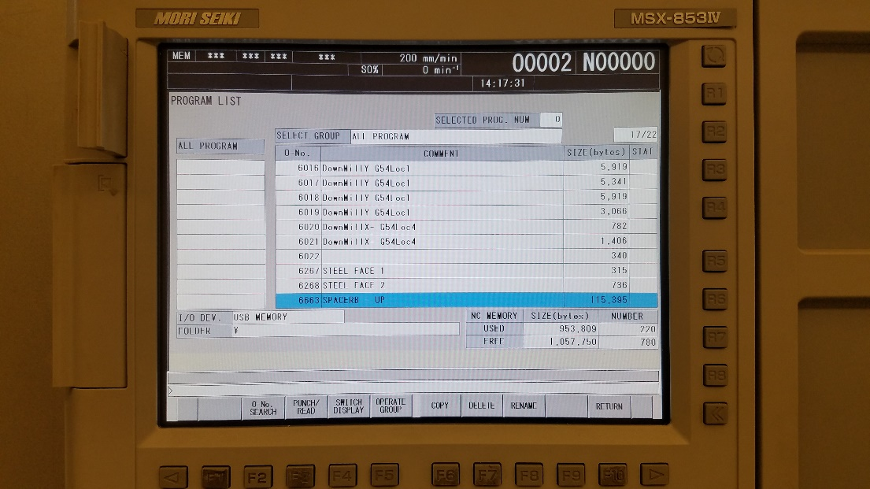
 | Press “RETURN”, which is assigned to “F10” to go to the ‘main’ screen.

Offsets

Adding/Removing tools

Calibrating tool length (0002) (aka tool touch-off)
1 | Switch to ‘MEM’ mode
2 | Type “02”, then press “O-num search”, which will be assigned to “F2”  This will bring program 2 into the active memory. | 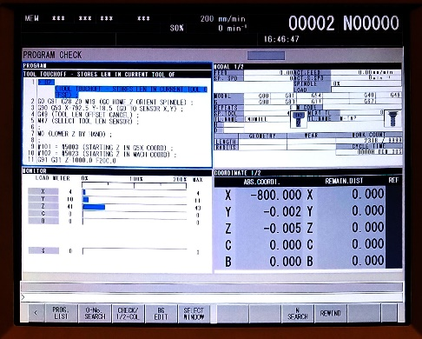
3 | Press “start” to begin the tool touch-off program
4 | Select the “Z” axis using the dial indicator
5 | Press the “x100” button to activate the manual control over the axis you have selected
6 | Turn the _______ CCW (counterclockwise) to bring the tool down close to the touch-off probe
7 | Once the tip of the tool is approximately 20mm from the touch-off probe, press “MEM” to move back to memory mode
8 | Press “start” to finish the touching off.  The tool will slowly move down, touch the probe, then move up to z-max
 | Repeat this process for as many tools as you are using in your program. It is good practice to perform this touch-off probe every time in case someone has used the machine before you without your knowledge.
 | Press “RESET” to stop the beeping

Finding Work Coordinate System (WCS) coordinates
 | Here’s where the process of machining becomes less straightforward.
 | Clamp your workpiece in the vise however you see fit. Use your engineering judgement.
 | You want to find the point that corresponds with the origin you select in Fusion360 (or whatever CAM software you are using)
 | From any screen, switch to “JOG” mode
 | With one hand on the collet, push up on it and use the other hand to press the button  (lower the Z axis if you’re having to strain too much to push up on the collet)  My advice conflicts with the official manual, so feel free to use whichever method you’d like, I’m not your mother.  The official manual also warns against improper procedure for fear “injury/lower back pain” | 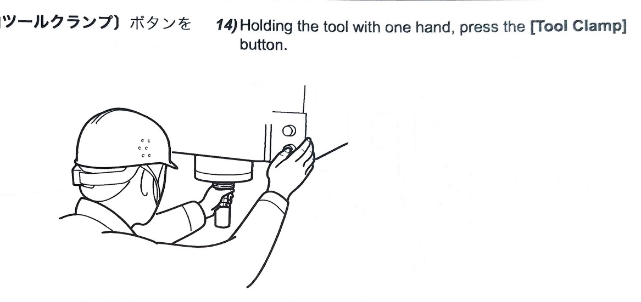  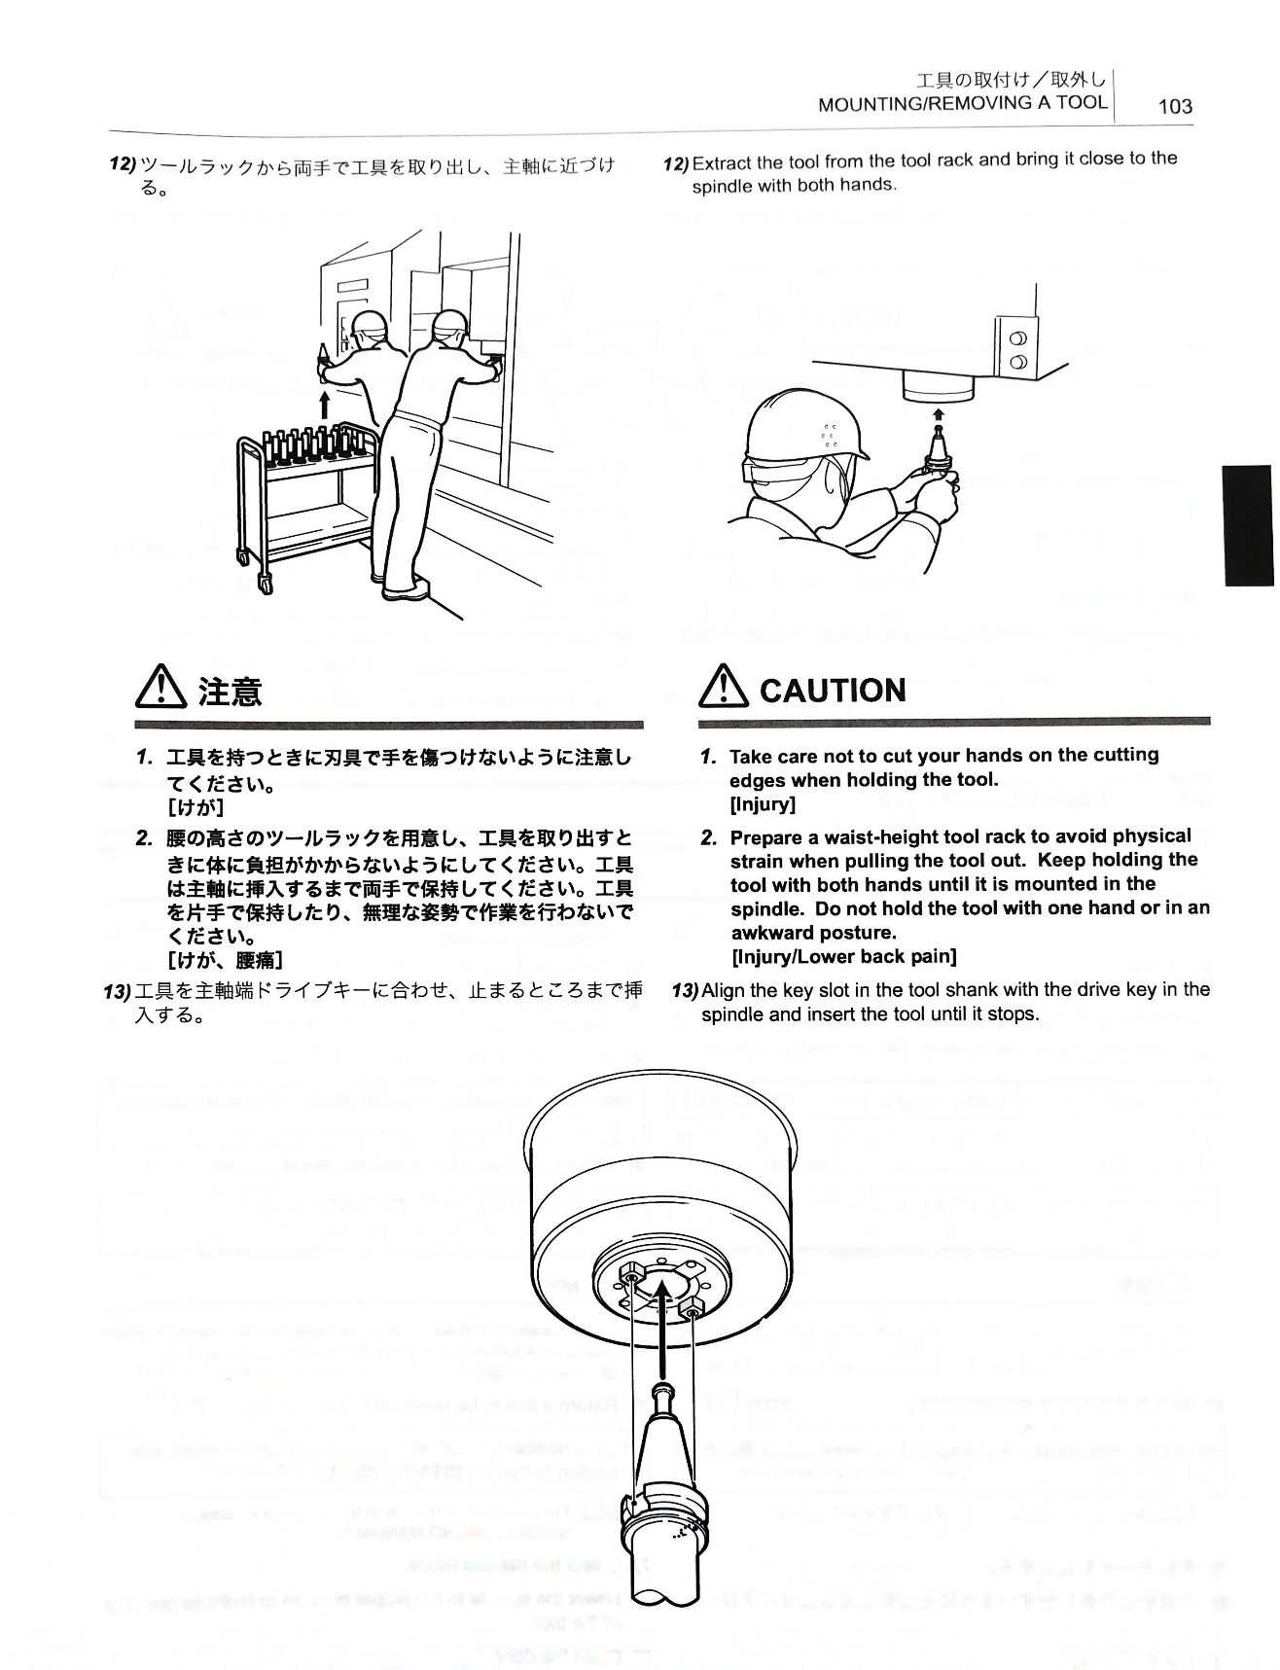
 | Place the tool in the collet holder. Dropped tools = bad
 | Move the touch-off probe into the ______. With the other hand, press the “Grab” button
 | Spin the probe around so you can see the dial. Then close the doors.
 | Press the “x100” button and spin the dial to navigate the tip of the probe to the

Dry run
(see ‘offsets’)
 | Once you have your WCS and stock set up, you are ready for a dry run. To perform a dry run, the only offset necessary is a positive Z+ offset. 20.0 mm is standard, but it can vary depending on the operations you are testing.
Select “OFFSET”.
(It doesn’t matter which mode you are in.)
 | Use arrowkeys to navigate to “Z” under “G54” (unless you are using a different WCS than G54) | 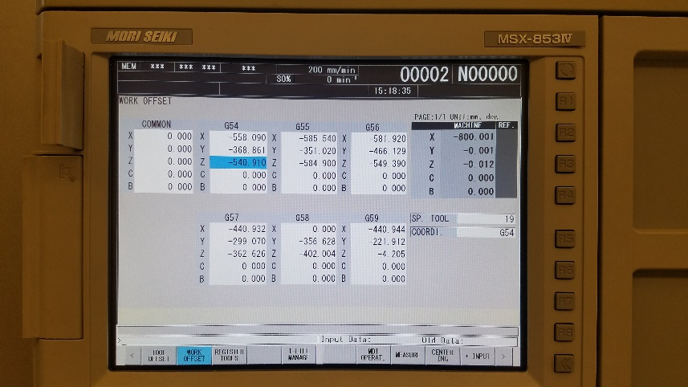
 | Use the keyboard to enter “+20.0” (or whatever offset you have deemed appropriate), then press “+input”, which will be assigned to “F10”  Note: “+” can be accessed by pressing “shift + c”  Two points here:  The units are in mm  If you don’t include the decimal point and the 0, the computer is likely to misinterpret your input. | 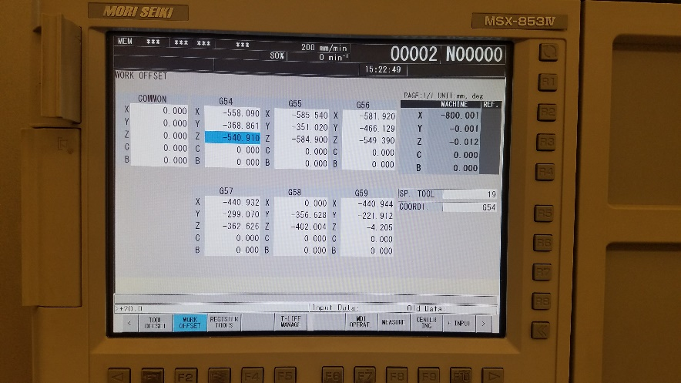
 | Verify that your input was accepted by looking at “input data” vs “old data”. If you don’t’ see that, something went wrong | 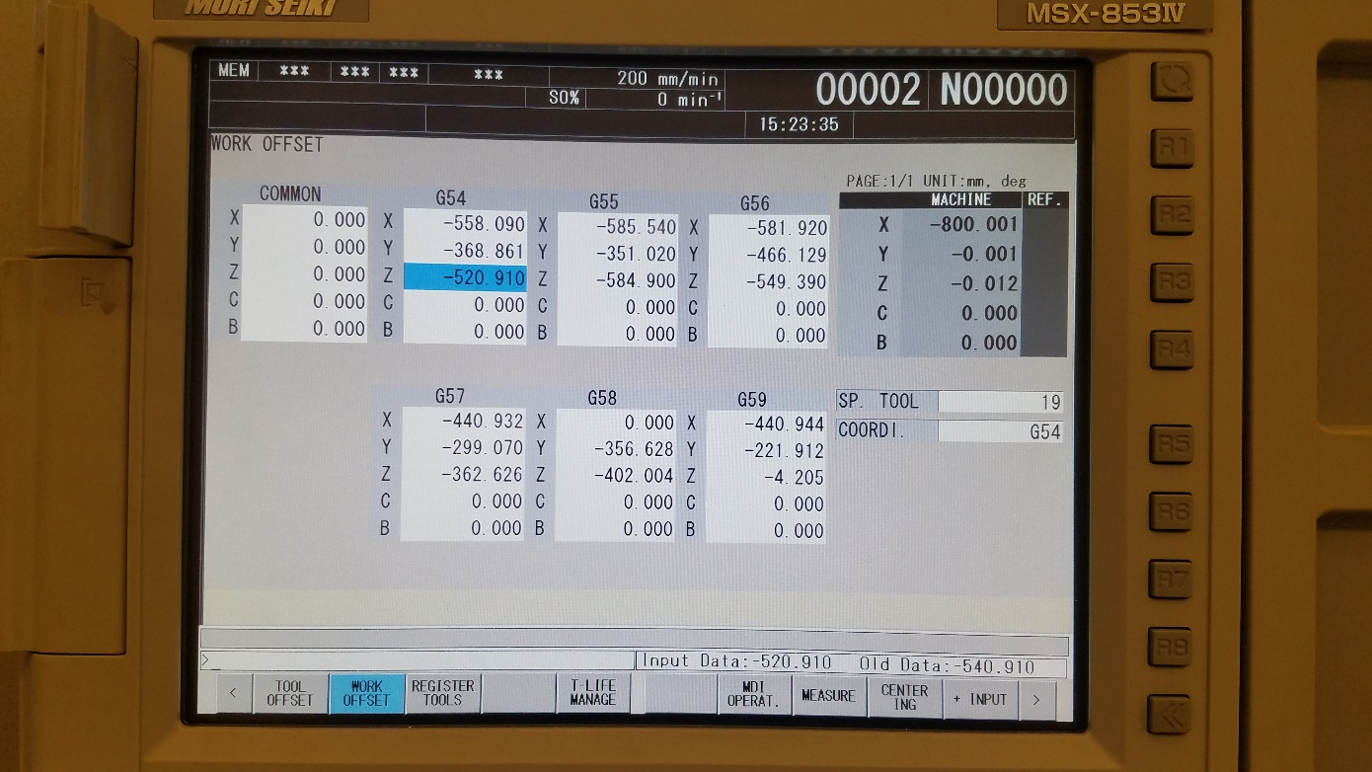
 | From here, you can select “PROG” and run your program.
 | Press “coolant off” for a better view of what’s going on
 | Once you’ve verified your toolpaths look good, you can remove the 20.0 mm offset.
 | Select “OFFSET”
 | Verify you have the “Z” axis selected
 | Using the keyboard, enter “-20.0”, then press “+input”, which is assigned to “F10” | 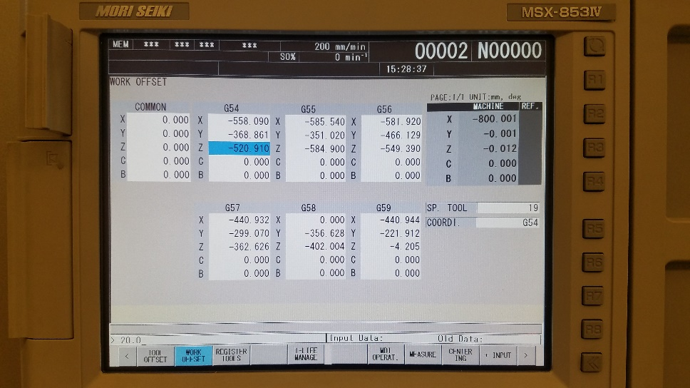
 | Now you’re ready to run your program for real!

Maintenance
Coolant refilling
Oil Refilling

Tips and Tricks (and warnings)
Switch to another program (like 0002) before deleting a program for re-upload to avoid the waring that comes from trying to delete a program currently in memory
Do not press the ‘reset’ button while an automatic tool change (ATC) is in progress. The NVX will throw an error saying the ATC is not aligned, and the machine will have to be fixed. See ‘troubleshooting’ for how to fix this error

Troubleshooting

