Before a measurement or communication can be corrupted by noise, there must be a noise source, a coupling channel, and a noise receiver.

Noise sources are everywhere. Examples include: flourescent lights, motor brush noise, high level signals near sensitive low level inputs, computers, etc.
Noise source
Coupling
Channel
Receiver

Methods of Noise Coupling

Coupling through common impedance

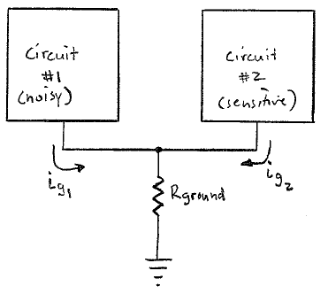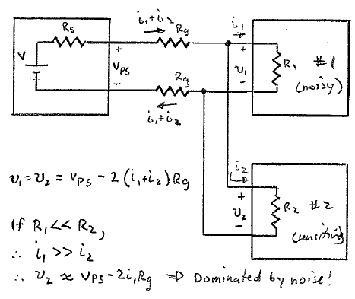

If Circuit #1 has a large dynamic ground current, circuit #2 will see a large dynamic change in the voltage at its “ground” terminal. The solution is to provide separate ground conductors for each circuit all the way back to the common ground point (typically at a power supply), and to reduce R_{ground} as much as possible (heavier conductor, better connections).

Electric field coupling

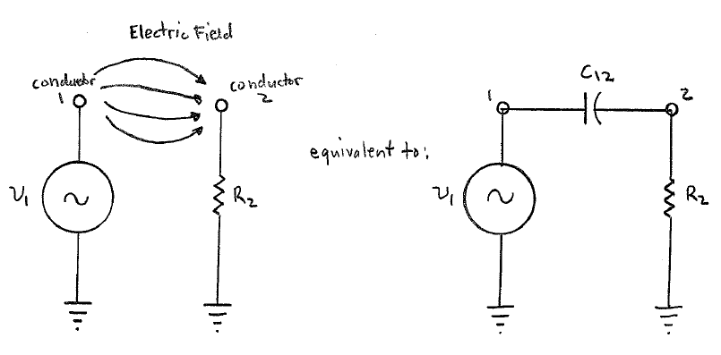

A time-varying voltage on a conductor will create a time-varying electric field. Another nearby conductor intercepting this field will have a corresponding voltage induced on it. This electric field coupling can be modelled as a capacitance between the two conductors. There is also capacitance between each conductor and ground.

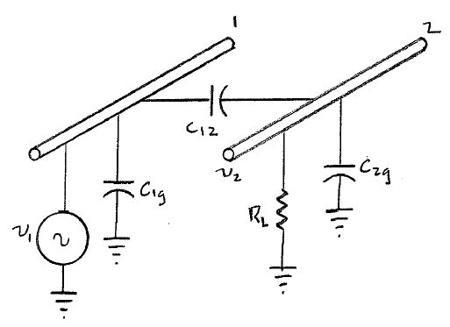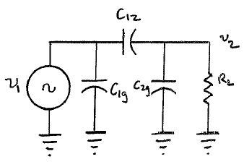

$v_{2}=\frac{jω\left[\frac{C_{\text{12}}}{C_{\text{12}}+C_{2g}}\right]}{jω+\frac{1}{R(C_{\text{12}}+C_{2g})}}v_{1}$
If noise receiver is low impedance, $R_{L}\text{<<}\frac{1}{jω(C_{\text{12}}+C_{2g})}$
$$⇒v_{2}≈{jωR}_{L}C_{\text{12}}v_{1}$$

so noise pickup is proportional to frequency, load resistance, coupling capacitance, and noise voltage level.
If noise receiver is high impedance, $R_{L}\text{>>}\frac{1}{jω(C_{\text{12}}+C_{2g})}$
$$v_{2}≈\frac{C_{\text{12}}}{C_{\text{12}}+C_{2g}}v_{1}$$

so noise pickup is independent of frequency and load resistance.

The solution to electric field or capacitive coupling is to shield the sensitive conductor.
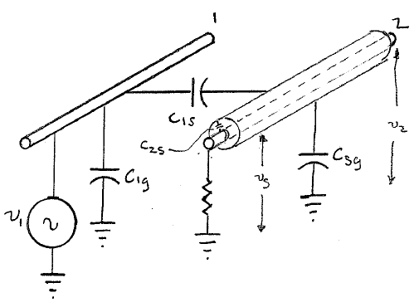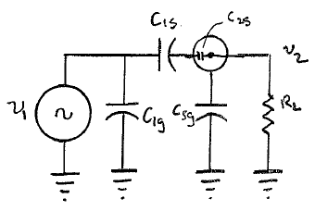

If we ground the shield, v_{s} = 0, so v₂ = 0 also! Any portion of the inner conductor that sticks out of the shield will have a small C₁₂ and so will pick up a small noise voltage, but the shield will stop most of the electric field coupling.

Now, where should the shield be grounded? If you have a sensor at one end of the cable and an instrument at the other end, should you ground it at the sensor end, the instrument end, both, or at additional points in between?

Since C_{1s} is not 0, and since there will be a non-zero resistance between each end of the shield, you will get some noise voltage induced on the shield itself. If you ground the shield at both ends, there will be common impedance coupling of noise into your sensor/instrument circuit. Ground the shield at one end only, whichever end is convenient to a good ground. The C_{2s} capacitance between the shield and the inner conductor can also allow a small amount of noise coupling if their are varying voltages on the shield.

Magnetic field coupling

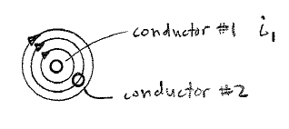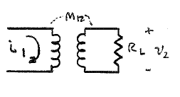

A time varying magnetic field caused by current flowing in conductor #1 will couple to parallel conductor #2 because of mutual inductance, M₁₂.

$v_{2}={jωΘ}_{\text{12}}={jωM}_{\text{12}}i_{1}$

Reducing mutual inductance may involve greater separation of parallel conductors, magnetic shielding, or a different geometry (don’t run the conductors in parallel).

The magnetic flux in circuit 2 due to current in circuit 1 is $Θ_{\text{12}}$, which is the product of the B field and the area of circuit 2.

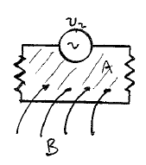$v2=−\frac{d}{\text{dt}}\int_{A}{\vec{B}}⋅\vec{A}$

If the closed loop is stationary (not a motor...), and the flux is sinusoidal in time but constant over the area of the loop, then

$v_{2}=jω\text{BA}\text{cos}θ$

where $θ$ is the angle between the loop and the magnetic flux vector.

To reduce v₂, reduce B (greater spacing), A (twisted pair cable), or cos$θ$ (get loop ⊥ to flux).

