Programming the Cut Paths
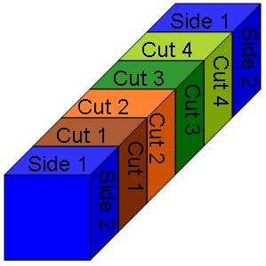
Figure 1

The puzzle piece cutter has the capability of cutting any combination of slots from either side 1 or side2. To ensure the machine is properly programmed for a particular bur puzzle it is essential to understand how to enter the cut paths into the DirectSOFT32 software.
- Ensure the PLC is turned on, the programming cable is properly connected, and the PLC is in Terminal mode.
- Open the DirectSOFT32 software application.
- Open the memory editor by either accessing it from the menu or pressing CTRL-Y.
- Find memory location v1200. This should be labeled B1S1 representing Block 1, Side 1. The memory locations for the second side start a v1210 but should be visible when v1200 is searched for.
- The memory location is in 16 bit binary. A 1 represents a cut and a 0 represents no cut. Figure 1 shows the layout of the block. The last bit in the series of binary digits corresponds to CUT 1, the second to last CUT 2, and so on. If, for example, the machine should cut CUT 1 and CUT 3, the binary patter would look like 0000000000000101.
- Once all the side 1 and side2 memory locations are properly set exit the memory editor.
Two Burr Puzzle Programs

The burr puzzle cutting machine comes with two distinct programs for the convenience of the customer. The first 1 side program is faster and cuts the blocks from a single side. However, if the customer is experiencing excessive blowout of the block resulting in miscalibration of the cut, it is recommended to load the 2 side program. It will cut into the block from both sides at the most critical areas to minimalize the effects of blowout.

