Glass/Metal Nozzle Assembly Process

ENGR 480

December 15, 2017

Team Chebeleu:

Nicholas Chebeleu, Caleb Tessema, Farai Kusina

[**Introduction**](#_p98lsrf8alok) **2**

[**Instructions**](#_gz4juzgvrfil) **2**

[Loading the Machine](#_p1o8ww4ve56w) 2

[Starting the Machine](#_359xbgqwoata) 2

[Clearing Jams](#_44cz44wpflsg) 3

[**Diagrams**](#_uwtb8zrnl497) **3**

[Annotated Photos](#_i0j0garj67yp) 3

[Figure 1: System](#_lu2bbvs6f156) 3

[Figure 2: Heating Assembly 4](#_ur9v6sq19v4t)

Figure 3: Robot Head 4

[Motoman Job programs](#_wutbvb6xy80o) 5

[Wiring Diagrams](#_ozh61wyrqmzh) 6

[**Description of Machine Operation**](#_9hvwwy8uzqlt)6

[Part-Feeder](#_exycfurug851) 6

[Robot](#_af0wp6l9jbbb) 7

[Heating Assembly](#_5uj8mesyfi2w) 7

[Slide](#_smxv7ain0fg5) 7

[**Maintenance**](#_efpx2y9rwaes)7

[**Future Improvements**](#_77uunl5bl4r1)7

[**Performance Data**](#_w9bgq3xiiby7)8

# 

# 

# Introduction

This User-manual contains series of instructional guidelines, annotated photos, and wiring diagrams, which are all essential informational pieces to help the user utilize this machine. This guide includes a description of the machines operational systems functions, capabilities and sequential procedures for the use, access, and maintenance of the assembly system. Future improvements considerations are also defined within this document, which could bolster the accuracy and efficiency of the system.

# Instructions

## **Loading the Machine**

1. Wash the glass tubes and nozzle tips in an ultrasonic acetone and isopropyl alcohol bath.
2. Fit two smooth-edged 10mm glass tubes onto the two stakes near the center of the loading plate and two nozzles, tip first, in the smaller holes in front of them on the loading plate both oriented towards the Motoman.
3. Make sure the vacuum tubes on the Motoman Arm are securely fit and clear of potential tangling.
4. Ensure that the air compressor nozzle is attached to the induction heater via the copper tube.
5. Make sure that everything is properly plugged in.

## **Starting the Machine**

A visual inspection should be performed before powering the system. Ensure the components are free of debris and unobstructed. Conduct an inspection on the nozzles and glass tubes parts to ensure there are no deformities. Inspect the wiring and other electrical components to ensure they are connected and in good condition. Once the inspection is complete, follow the procedure below to start the machine

1. Ensure the controller door is fully closed and secure. Once secured, turn the Main Power Switch to the ON position.
2. On the Motoman controller, set the key on the “Mode” switch to the “Play” position.
3. Select the “Jobs” button from the on-screen menu
4. Navigate to the assembly program (Niaroops) and select it.
5. Press the “Servo On/Ready” button from the on-screen menu on unlock servos
6. Press the “Start” button.

The “Start” button will initiate the manufacturing process and it will not stop until the process is complete unless it is manually interrupted. Once the robot has completed the robot has completed the manufacturing cycle for all the loaded parts a shutdown procedure may be initiated.

1. Ensure all servo motors are shut down via E-stop if the system will remain in Play mode. Alternatively, placing the system in teach mode will also remove servo power. After servo motors are shut down, turn the Main Power Switch to the Off position

## **Clearing Jams**

In the occurrence of a parts jam, or any other parts malfunction that causes a breakdown in the manufacturing process follow the procedure below

1. Press the “Emergency Stop” button
2. Issue the home command
3. Disable any functions such as the vacuum, cooling system, heater etc.
4. Manually remove the jammed or misaligned parts when it is safe to do so
5. Restart the assembly process.

# Diagrams

## Annotated Photos

## ../Desktop/IMG_0004.jpgFigure 1: System

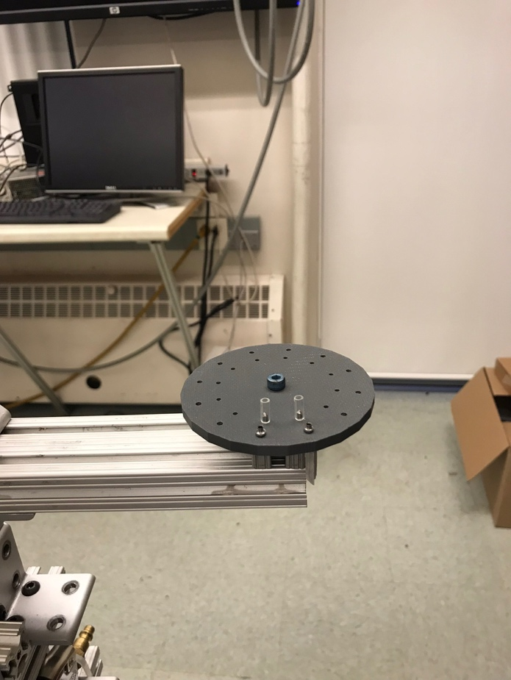

## **Part Feeder (Turret)**

## **Part Stopper**

Part 2: Heating System

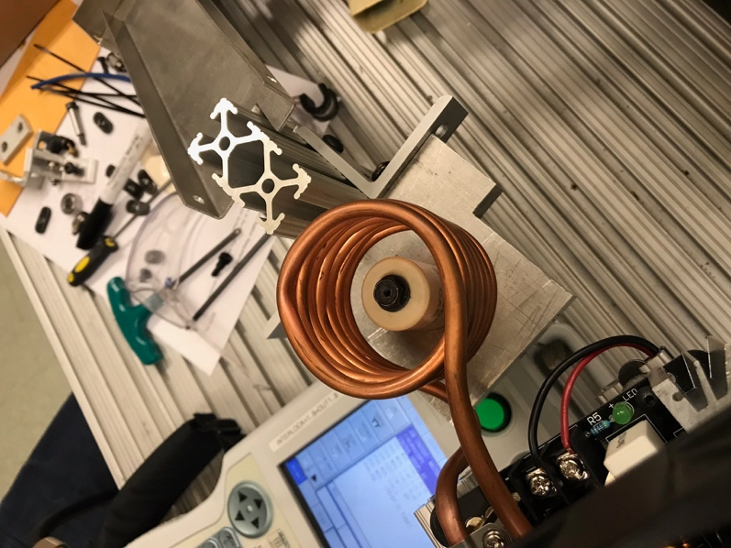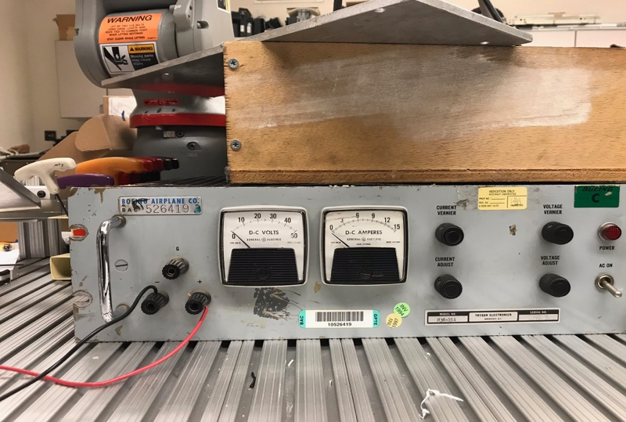

## Part 3: Robot Head

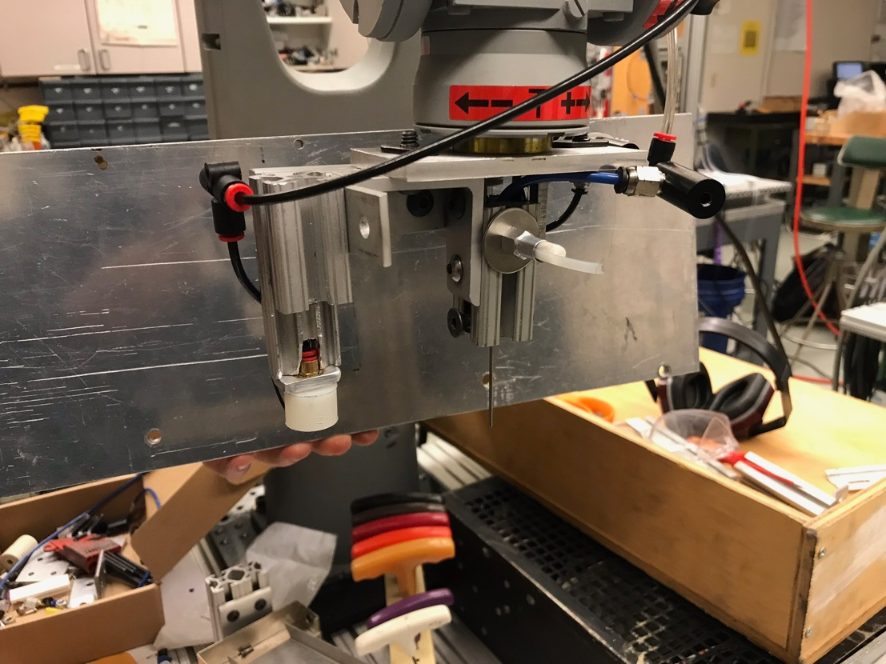

## **Glass Tube Vac/Blow**

## **Nozzle Vac**

## **Turret Indexer**

## Motoman Program

## //INST

## ///DATE 2017/12/12 16:12

## ///COMM USE WISELY

## ///ATTR SC,RW

## ///GROUP1 RB1

## NOP

## MOVL C00000 //READY AT TURRET

## MOVL C00001 V=15.0 PL=0 //INDEX TURRET

## MOVL C00002 V=5.0 //BACK OFF NOZ

## MOVL C00003 PL=0 //ABOVE TURRET - READY

## MOVL C00004 V=50.0 PL=0 //ACCURATE POS ABOVE GLASS

## MOVL C00005 V=2.0 PL=0 //IN GLASS

## DOUT OT#(1) ON //GLASS VAC

## TIMER T=1.00

## MOVL C00006 V=20.0 PL=0 //BACK OFF GLASS

## DOUT OT#(2) ON //NOZZLE VAC

## MOVL C00007 V=50.0 PL=0 //ACCURATE POS ABOVE NOZ

## MOVL C00008 V=5.0 PL=0 //DEEPER IN NOZ - TURRET

## MOVL C00009 V=3.0 PL=0 //ABOVE NOZ - TURRET

## MOVL C00010 //TO THE COILS

## MOVL C00011 //TO THE COILS

## MOVL C00012 //IN THE COILS

## MOVL C00013 V=20.0 PL=0 //NOZZLE IN COIL

## MOVL C00014 V=2.0 PL=0 //NOZZLE IN NUT

## DOUT OT#(2) OFF //NOZZLE VAC

## MOVL C00015 //ABOVE NUT

## MOVL C00016 //IN THE COILS

## MOVL C00017 V=40.0

## MOVL C00018 V=40.0 PL=0 //ABOVE COIL

## MOVL C00019 V=20.0 PL=0 //ABOVE NOZ W/ GLASS

## DOUT OT#(1) OFF //GLASS VAC

## DOUT OT#(6) ON //GLASS BLOW

## MOVL C00020 V=5.0 PL=0 //BACK OFF GLASS

## DOUT OT#(6) OFF //GLASS BLOW

## DOUT OT#(8) ON //COIL POWER

## MOVL C00021 V=40.0 //WAIT FOR HEATER

## TIMER T=300.00

## DOUT OT#(8) OFF //COIL POWER

## TIMER T=90.00

## MOVL C00022 V=30.0 PL=0 //READY TO EXTRACT

## TIMER T=5.00

## DOUT OT#(2) ON //NOZZLE VAC

## MOVL C00023 V=10.0 PL=0 //IN ASM

## MOVL C00024 V=10.0 PL=0 //ASM OUT OF NUT

## MOVL C00025 V=50.0 PL=0

## MOVL C00026 V=50.0 PL=0

## MOVL C00027

## MOVL C00028 V=50.0 PL=0 //EJECT ON SLIDE

## DOUT OT#(2) OFF //NOZZLE VAC

## TIMER T=0.25

## MOVL C00029 V=100.0

## MOVL C00030 V=100.0 //READY AT TURRET

## END

## ../Desktop/Screen%20Shot%202017-12-10%20at%204.13.56%20PM.pngWiring Diagrams

# 

# Description of Machine Operation

The design of the assembly system and its specific components were constructed in such a manner to achieve the goal of fusing glass tubes and metal nozzles together. It is for that purpose the assembly system and its subsequent process were designed. The general outline of the procedure is defined by three process, which are accomplished through the implementation of the sub-assemblies found below. The first process is characterized by manually loading the part feeder with nozzles and glass tubes and utilizing the robot for a pick and place process. Once parts are placed correctly in the heating assembly, the part heating occurs. Lastly, through another pick and place operation, the fused parts are released onto the slide, which carries them to the designated collection area.

## **Part-Feeder**

The part feeder is a disc with precisely spaced holes drilled to hold the nozzle and the glass tubes. Currently we only have two nozzles and two glass tubes to begin the process. The glass tubes sit on two stakes that protrude from two chosen holes on the plate, and two nozzles sit in the two holes in front of them. Besides being the loading dock for the parts, the feeder rotates and is stopped by part stopper protruding from the underside of the part feeder disk which allows the robot arm to pick up parts consistently from the same spot.

## **Robot**

The Motoman robot arm is very crucial to this process because it is the mechanism that moves and places the parts in this operation. The arm uses servo motors and is controllable through a screened remote that allows the creation of different paths and functions that allow the arm to move as well as control whichever distinct gripper that is decided to be used. For this operation, the gripper is a two pronged mechanism that has a vacuum tip on one end that is used to pick up the nozzles, while the other end has another vacuum backed tip to help pick up the glass tubes. In the middle of the fork there is a protruding piece of plastic that aids in rotating the part feeder to the next needed position.

## **Heating Assembly**

The heating assembly includes an induction heater with a coiled copper tube connected to it acting as the controlled outlet for the generated heat. In this process, the nozzle is dropped into a cylindrical furnace that fits inside the copper coil. The glass tube is then placed on the flange of the nozzle and is held in place by a small extension from the top of the nozzle that it is set on. The induction heater generates heat to the coil which then heats up the glass enough so that it is fused to the nozzle when it is cooled off.

## **Slide**

The slide is the final installment for this process. After the glass tubes and the nozzles are fused together, the robot arm drops them onto a slide placed near the heating assembly which is directed towards a ledge that will hold them and allow the piece to cool down. The slide is made from thin sheet metal and bent to form.

# Maintenance

Maintenance will include slight readjustments and recalibrations to the robot arm’s path if parts on the table are to be adjusted or moved. The Motoman arm, if any malfunction happens, should be dealt with by a specialist.

# Future Improvements

The one issue with this operation is that in order to flawlessly function, the robot has to be as precise as possible with no error. The biggest improvement that could be made for this process is the creation of jigs that allow for function through error. This improvement will increase the success rate of the robot arm by putting less stress on precision. Another major improvement that needs to be made is that there needs to be some sort of sensor implemented that tells us when something is not working because as of now the only way to know is through observation. Creating an aluminum part feeder would also be beneficial because the holes would be exactly where they need to be, and it would eliminate any error that would come from differences in hole size and position. Another improvement that could be made for this process is implementing an air push stage for the needle vacuum. It was observed that the needle vacuum could potentially pick up debris for the surrounding environment. Implementation of a vacuum clearance stage before parts are picked will decrease the likelihood of debris affecting vacuum efficiency in the future.

# Performance Data

*How many parts can it produce before reloading* Currently, 2. With addition of more pegs for the glass tubes, we will be able to load 12 sets at nozzles and tubes before needing to reload. Our process allows for continuous work flow however. The operator never needs to stop the manufacturing process to load more nozzles and tubes into the part feeder. Loading can be done while the robot is waiting 5 minutes for the heating element to fuse the glass to the metal nozzle.

*How fast does it go through the process* The process from start to finish takes 6 minutes. In 6 minutes, the robot will load a nozzle and glass tube into the heating element (45 sec), heat the two up to fuse the glass to the nozzle (5 min), and offload the assembly and return to the turret ready to load the next nozzle and glass tube (15 sec).

*Success Rate*

Loading the induction heater with nozzles and glass tubes is so far at 100% success rate. Extracting the assembly out of the induction heater after the heating process is at 50% success rate because we have attempted to do this twice with the final manufacturing system and it worked once, and failed the next time we tried it.

***Reportable Health and Safety Incidents*** *– A measure of the number of* [*health and safety*](http://blog.lnsresearch.com/blog/bid/129841/Getting-the-most-out-of-Environment-Health-and-Safety-Software) *incidents that were either actual incidents or near misses that were recorded as occurring over a period of time.*

During the construction of this project, one incident occurred where the robot broke a glass tube, and a glass fragment found its way into the operator’s finger.