Team No-Bot User Manual

ENGR 480

12/14/22

Team Members

Alex Aus

Colin Cheney

Christian Miller

Spencer Welch

Operating Instructions 5

Loading the machine 5

Starting the Machine 5

Clearing Jams 6

Description of Components 7

Homing 7

Operation 7

Maintenance Instructions 7

Suggestions for Future Improvements 7

Performance Data 7

Pen Dispenser 7

Operation 7

Maintenance Instructions 7

Suggestions for Future Improvements 8

Performance Data 8

Cap Remover/Replacer 8

Operation 8

Maintenance Instructions 8

Suggestions for Future Improvements 8

Performance Data 8

Pen Tip Remover/Replacer 8

Operation 8

Maintenance Instructions 9

Suggestions for Future Improvements 9

Performance Data 9

Internal Felt Remover 9

Operation 9

Maintenance Instructions 9

Suggestions for Future Improvements 9

Performance Data 9

Funnel Loader 10

Operation 10

Maintenance Instructions 10

Suggestions for Future Improvements 10

Performance Data 10

Funnel Tamper 10

Operation 10

Maintenance Instructions 10

Performance Data 10

Alcohol Dispenser 10

Operation 10

Maintenance Instructions 10

Suggestions for Future Improvements 10

Performance Data 10

Diagrams 12

Annotated Photos/Mechanical Drawings 12

PLC Ladder Logic 15

State Diagram 40

Stepper Motor Configuration 40

Wiring Table 40

# Operating Instructions

## Loading the machine

Before the machine is run, there are three consumables that need to be filled. The table needs to be connected to electricity and air supplies, and the table needs to be cleared of clutter. Additionally, quickly wipe all grips with alcohol to ensure they are free of dust. The steps for filling the consumables are as follows:

1. The Alcohol: The alcohol container needs to be filled well above the hose then the fill tube needs to be purged of air. To purge the hose of air, simply open the pump and squeeze the bottle. This will force air out of the tube. Do this until there are no more air bubbles in the line.
2. The Funnels: The disposable funnels need to be loaded onto the funnel singulation stage. They simply need to be slid onto the wire and placed above the holding (lower) piston. Ensure that the funnels are installed with the funnel up and the legs down.
3. The Markers: Insert markers into the loading tube with cap facing up. Please only use Quartet markers and ensure that they are indeed dry and needing refilled.

## Starting the Machine

To start the machine:

1. Ensure the air pressure is on by checking that the E-stop button is not engaged.

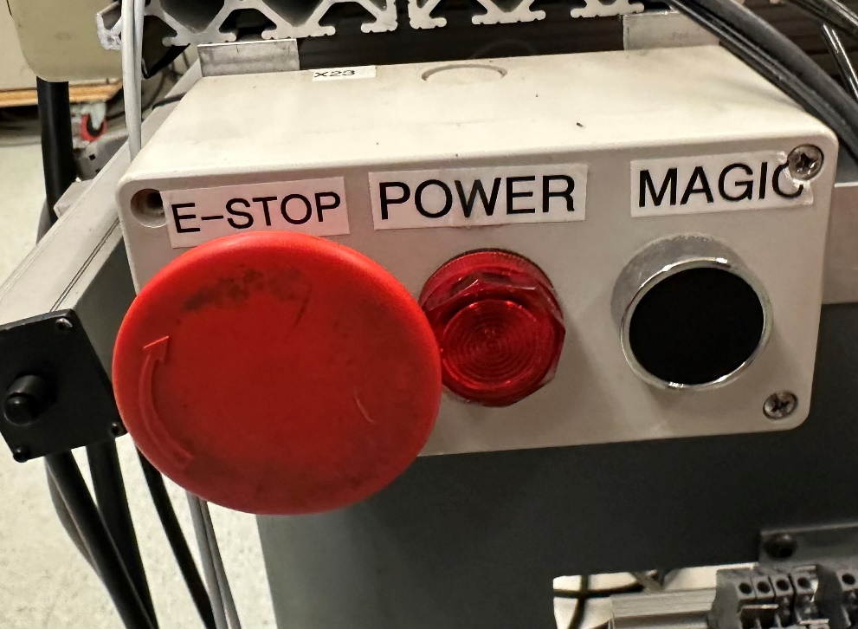

Figure 1 - E-Stop, Power light, Magic Panel

1. Check that the PLC switch is set to run. The machine will begin by homing the main boom and the horizontal gripper.

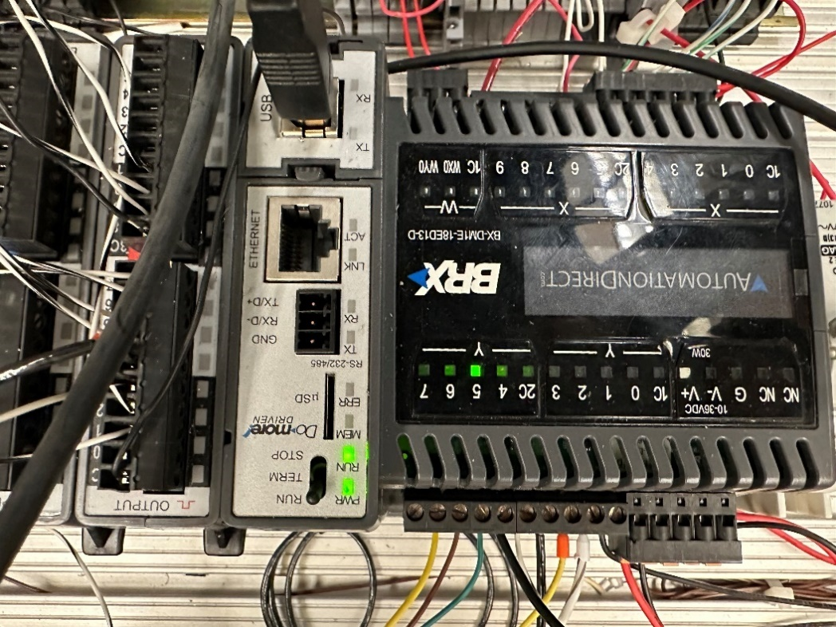

Figure 2 - PLC Top

1. The machine will wait till the button labeled “magic” is pressed. As soon as it is pressed the machine will begin to run.

## Clearing Jams

Several jam scenarios are possible:

1. The marker fails to fall into the pen gripper and is resting on its edge.
2. The cap remover fails to take the cap off the marker.
3. The machine fails to remove the head of the marker.
4. The more than one disposable funnel is dropped into the marker.
5. The marker is pushed out of the pen gripper when the marker head is reattached.

To clear each respective jam, do the following:

1. Move the marker into the gripper.
2. Quickly remove the cap and place it into the cap gripper.
3. Press the E-Stop then reattach the marker’s cap, feed it back into the feeder tube, then start the machine again.
4. Remove the extra funnel and allow the machine to continue.
5. Press the E-Stop then manually reattach the marker head and cap, then start the machine again.

# Description of Components

## Homing

### Operation

Each traveler moves to its home position. The home position for the boom is the top of its travel. At the top there is an inductive sensor that give an output when the boom reaches it. For the pen gripper the home is the pen loading position. An optical sensor gives output and stops the gripper when it is reached.

### Maintenance Instructions

1. Check that the sensors have not been moved or damaged. If they have been moved realign them. Replace them in case of damage.
2. Watch as the machine goes through the homing process. If either sensor light does not light up, press the E-Stop and realign the sensor.

### Suggestions for Future Improvements

Future improvements would include replacing the inductive homing sensor with an optical one. This change would allow for greater traverse speeds on the vertical travelers without crashing into the sensor, decreasing the overall runtime of the machine. Alternatively, to replacing the inductive sensor it could be moved so it faces the back of the boom, thus keeping the sensor out of the boom’s path of travel.

### Performance Data

Currently to avoid the vertical travelers crashing into their respective homing sensor they travel a low speed which lengthens the amount of time it takes the machine to process one marker. However, at this low speed it is easier to identify issues and stop the machine to prevent damage. This takes up most of the time and should be addressed first if performance is a concern.

## Pen Dispenser

### Operation

The loading station operates from a brass tube with two air cylinder stops, one at the bottom for the lower most pen and one 6” up to stop the second pen from falling when the first is released.

### Maintenance Instructions

1. Check that all fasteners are fully tightened, most importantly fasteners holding the t-slot on which the piece of brass tube is connected.
2. Check air connections and bottom stop orientation.
3. Make sure pen gripper is home
4. Actuate bottom stop by pressing in 2nd air solenoid on the air diaphragm, and a pen should dispense.
5. If pen does not fall into gripper repeat step 3 until pen drops in and stays in place.
6. Clean pen gripper contact surface.

### Suggestions for Future Improvements

Future improvements for this apparatus would be to place brackets between the angled and horizonal t-slot to secure it at the angle. The biggest issue with this is with any sort of vibration or slight bump the tube will slip and become misaligned with the gripper or the bottom stop.

### Performance Data

With its current state without a bracket to secure the angle the dispenser is functional but when bumped it can become misaligned. After realignment the dispenser works flawlessly.

## Cap Remover/Replacer

### Operation

This gripper is placed on the vertical traveler and is moved down to the pen from its home position. Once the gripper is at the determined position it is actuated which locks the jaws around the cap. It is then returned home pulling the cap off the pen.

To replace cap the vertical traveler and is moved down to the pen from its home position. Once the gripper is at the determined position it is actuated which unlocks the jaws from the cap. It is then returned home leaving the cap behind.

### Maintenance Instructions

1. Check Air connections and fasteners
2. Check gripper arm condition
3. Check for bent bracketry

### Suggestions for Future Improvements

A sturdier bracket for cap replacement would be helpful as this one deflects and sometimes catches on the side of the bracket as the gripper fixture is lowered over. A gripper sensor would be a good addition here too.

### Performance Data

This gripper had no significant issues on its own besides slight catches on the fixture. There were issues where the cap would not go on completely, but these issues were caused by the next station causing the pen body to move on the return pass.

## Pen Tip Remover/Replacer

### Operation

This gripper is placed on the vertical traveler and is moved down to the pen from its home position. Once the gripper is at the determined position it is actuated which locks the jaws on the tip. It is then returned home pulling the tip off the pen.

To replace tip the vertical traveler and is moved down to the pen from its home position. Once the gripper is at the determined position it is actuated which unlocks the jaws from the tip. It is then returned home leaving the tip behind.

### Maintenance Instructions

1. Check Air connections and fasteners
2. Check gripper arm condition
3. Check for bent bracketry
4. Check sensor operation
5. Clean contact surface

### Suggestions for Future Improvements

A more rigid fixture is needed for this gripper to replace the tip correctly. Often the tip would slightly kick out and catch the edge of the pen base pushing it down.

### Performance Data

When this gripper failed to insert the tip back into the pen because of alignment issues. This issue is most likely from the deflection of the fixture holding the gripper when pulling the tip from the pen.

## Internal Felt Remover

### Operation

This gripper is placed on the vertical traveler and is moved down to the pen from its home position. Once the gripper is at the determined position it is actuated which locks the jaws on the felt. It is then returned home pulling the felt off the pen.

To replace felt the vertical traveler and is moved down to the pen from its home position. Once the gripper is at the determined position it is actuated which unlocks the jaws from the felt. It is then returned home leaving the felt behind.

### Maintenance Instructions

1. Check Air connections and fasteners
2. Check gripper arm condition
3. Check for bent bracketry
4. Check sensor operation

### Suggestions for Future Improvements

A stronger connection between the gripper and the fixture is needed as it occasionally bends from use.

### Performance Data

Because of the location of the gripper the bracket occasionally bends and causes issues with gripping the felt of the pen.

## Funnel Loader

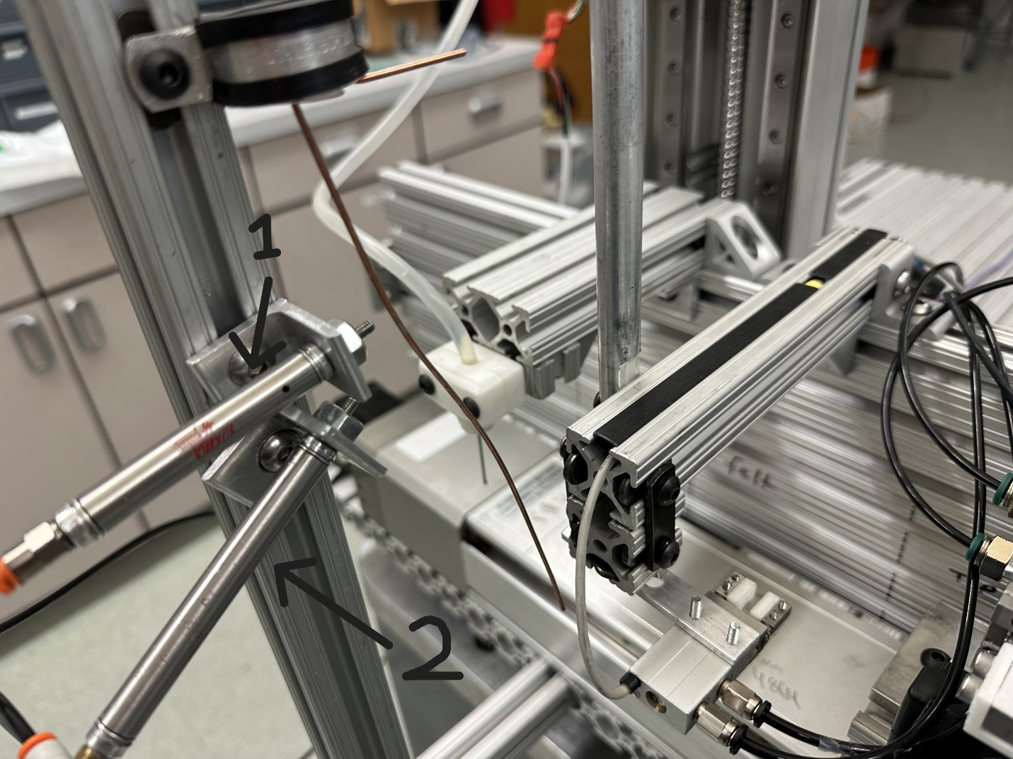

Figure 3 - Funnel Loader

### Operation

When the pen gripper reaches this station, two pneumatic pistons are activated. The piston 1 extends into the funnels lined on the wire blocking all but the lowest one from descending. Piston 2 retracts allowing the bottom funnel to slide down the wire into the marker. Once done, the piston 2 extends and piston 1 retracts.

### Maintenance Instructions

1. Check that the piston mount screws are tight.
2. Check that the wire has not been bent out of position.

### Suggestions for Future Improvements

The wire could be replaced with a steel or aluminum rod which would not bend as easily. It would need to be slightly shorter than the current wire to prevent it being in the way of the tamper. The positioning of the piston could also be adjusted to ensure consistent feeding of the funnels.

### Performance Data

Currently the wire gets out of alignment from the slightest touch. It has worked a few times, but it relies on perfect alignment and a little luck. At this time, it is good at singulation, just not delivering.

## Funnel Tamper

### Operation

This tamper is placed on the vertical traveler and is moved down to the pen from its home position. The tamper is used to press the funnel down to the base of the first compartment of the pen. Once determined position is met the vertical traveler returns home. This creates a catch free surface to guide the felt back into the pen body.

### Maintenance Instructions

1. Check fasteners
2. Check for bent bracketry

### Performance Data

This worked flawlessly and no issues were found with this.

## Alcohol Dispenser

### Operation

This dispenser is placed on the vertical traveler and is moved down to the pen from its home position. Once the dispenser is at the determined position it pumps 3 grams of fluid into the pen through the felt cavity. Once the dispensing is finished the vertical traveler returns home.

### Maintenance Instructions

1. Check electrical and tubing connections
2. Check Alcohol fluid level
3. Check gripper arm condition
4. Prime pump and remove air bubbles

### Performance Data

This system seemed to work without issues. The only potential problem is that it does not have a sensor for the PLC to know how much fluid is actually being dispensed. If primed correctly this is not an issue.

# Diagrams

## Annotated Photos/Mechanical Drawings

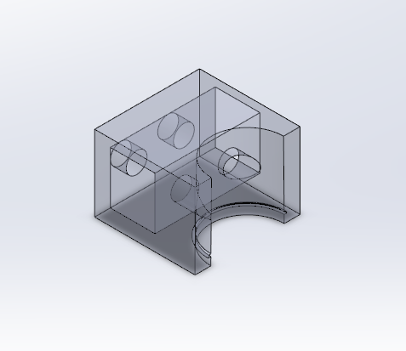

Figure - Cap Gripper (One Side)

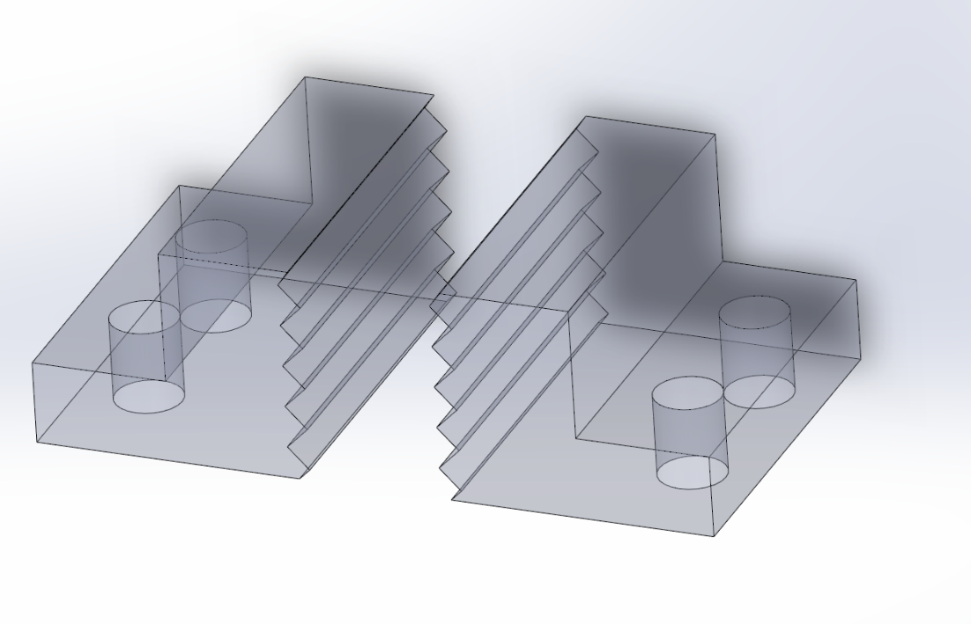

Figure 5 - Felt Gripper

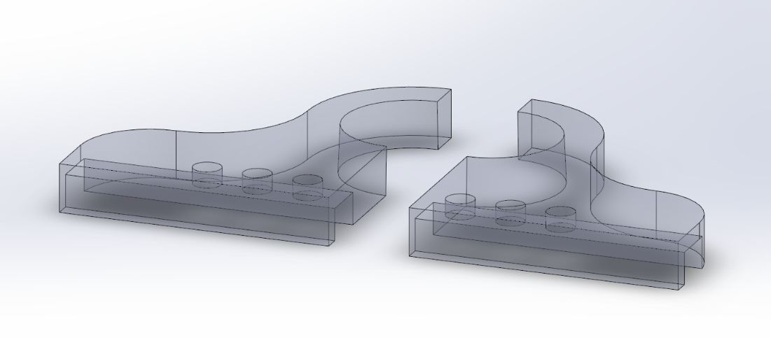

Figure 6 - Cap Gripper

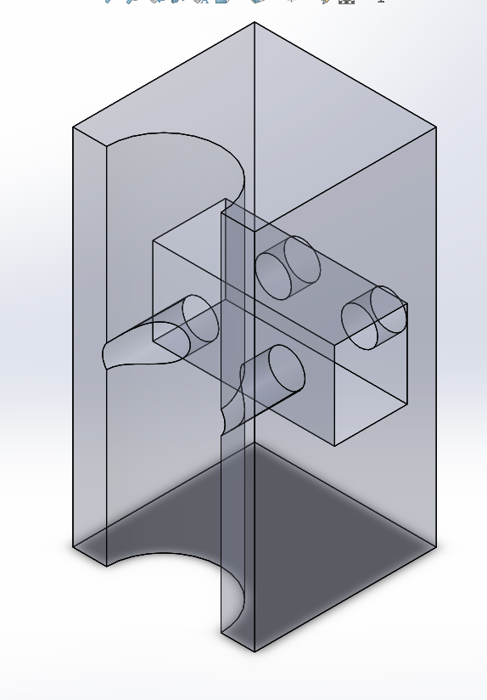

Figure 7 - Pen Gripper

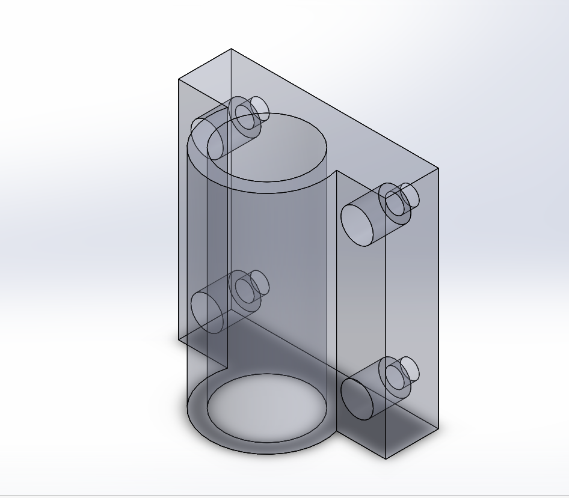

Figure 8 - Marker Feeding Tube Mount

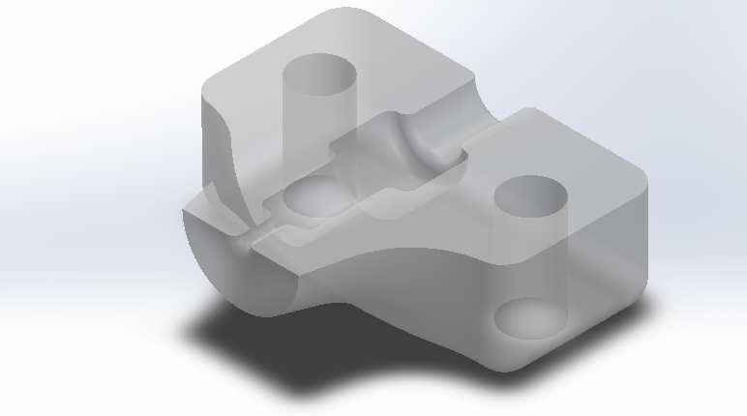

*Figure 9 – Needle Holder and Alignment Mount*

*Figure 10 – Felt Alignment Funnel*

## PLC Ladder Logic

$Main

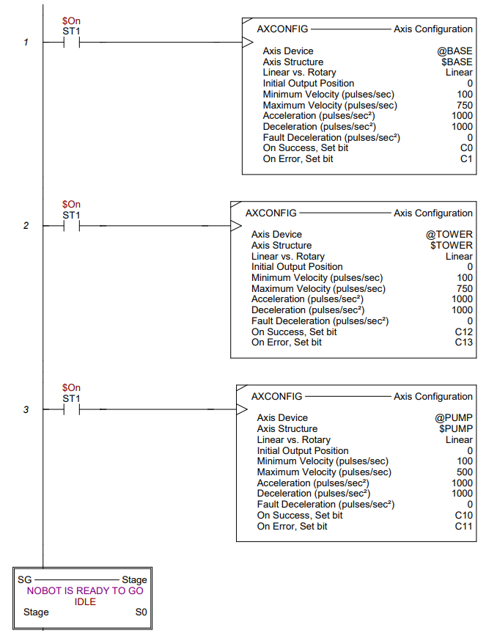

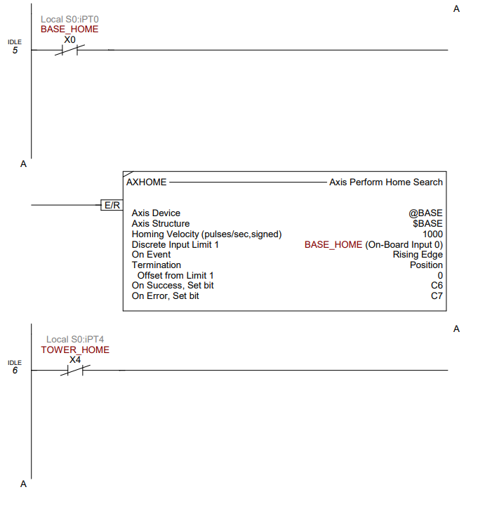

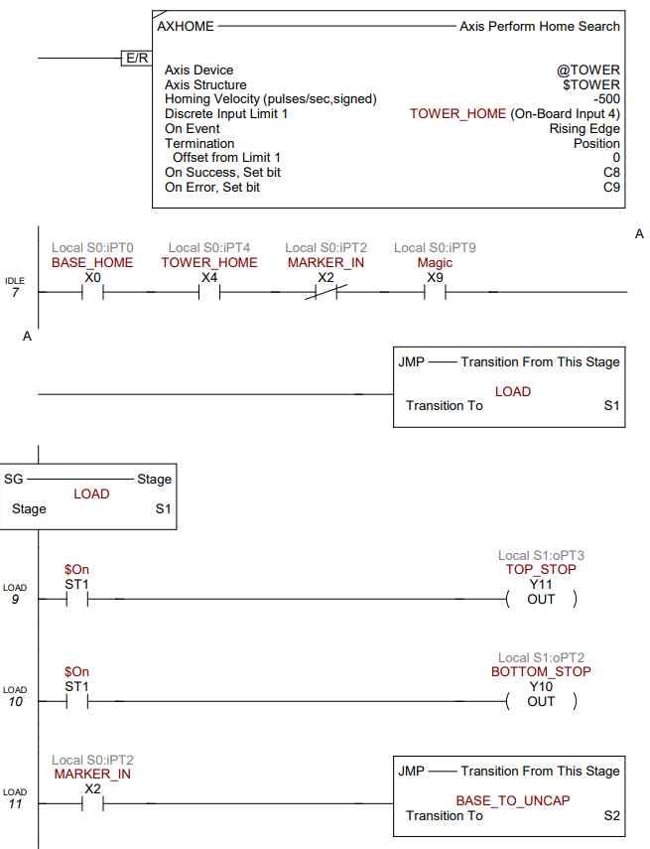

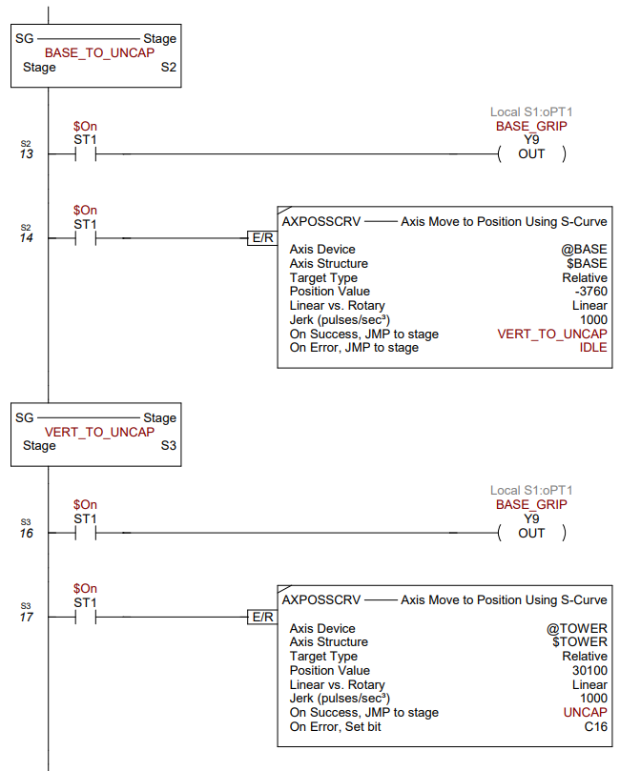

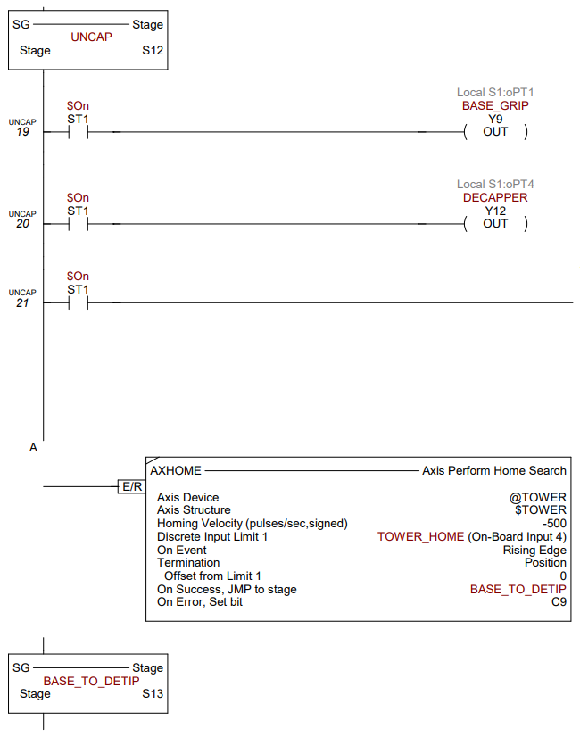

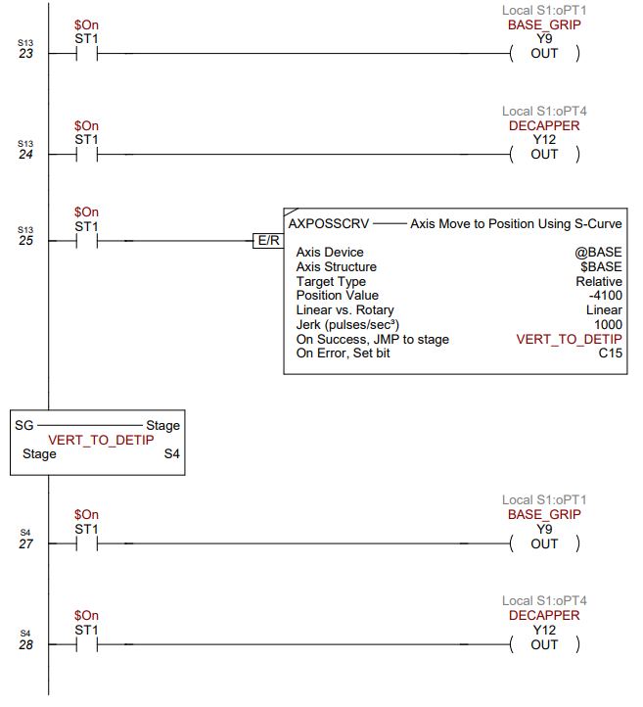

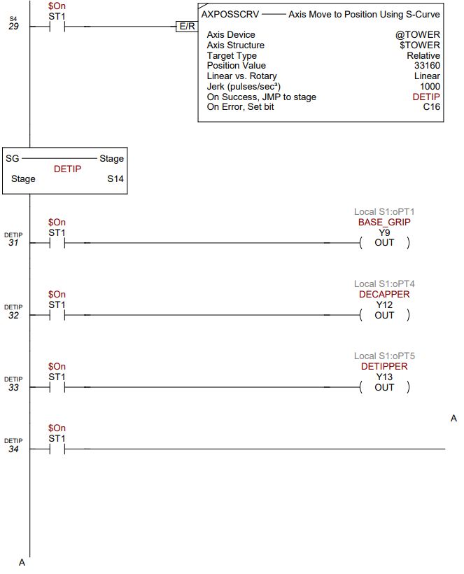

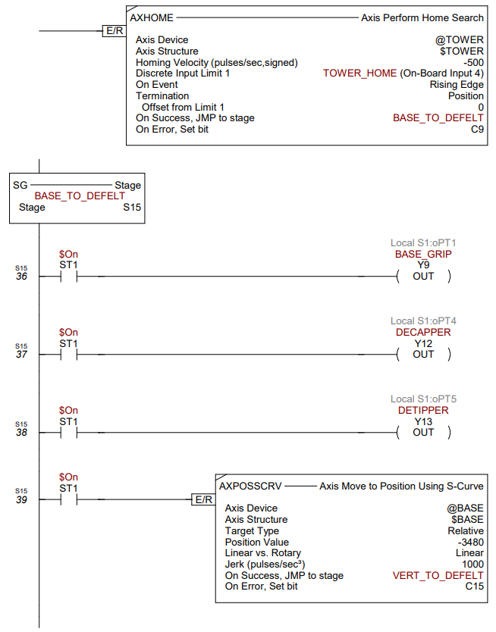

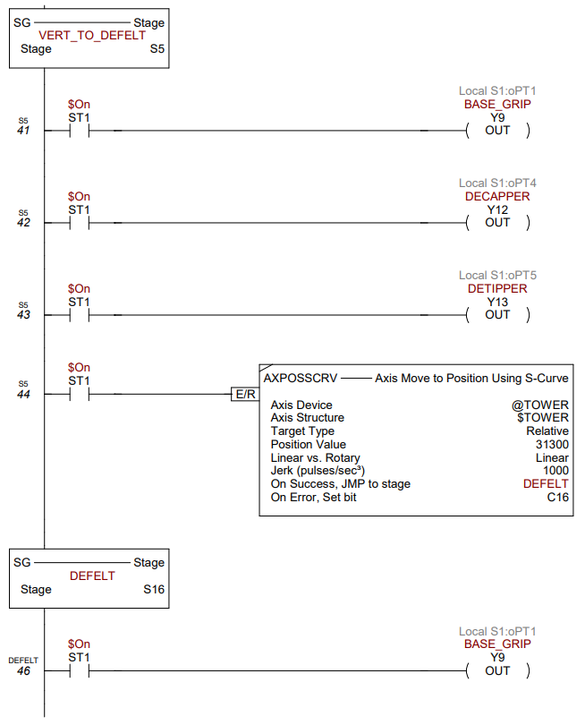

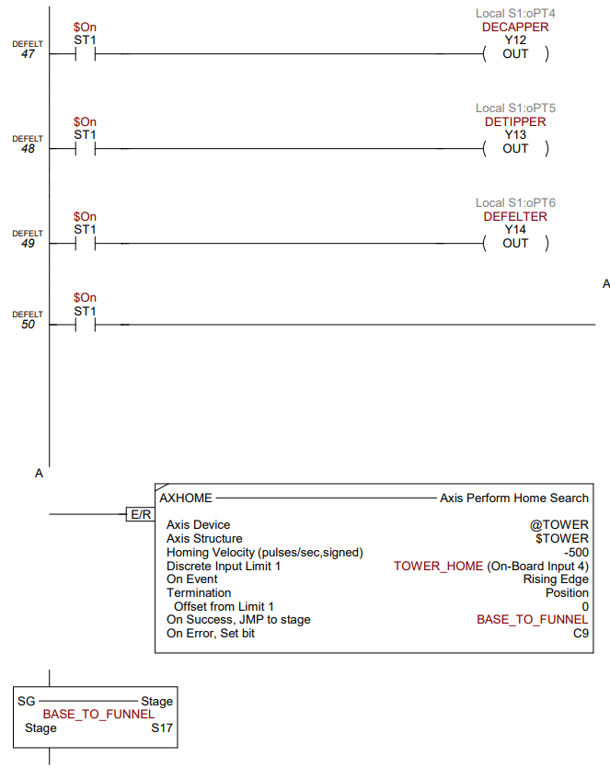

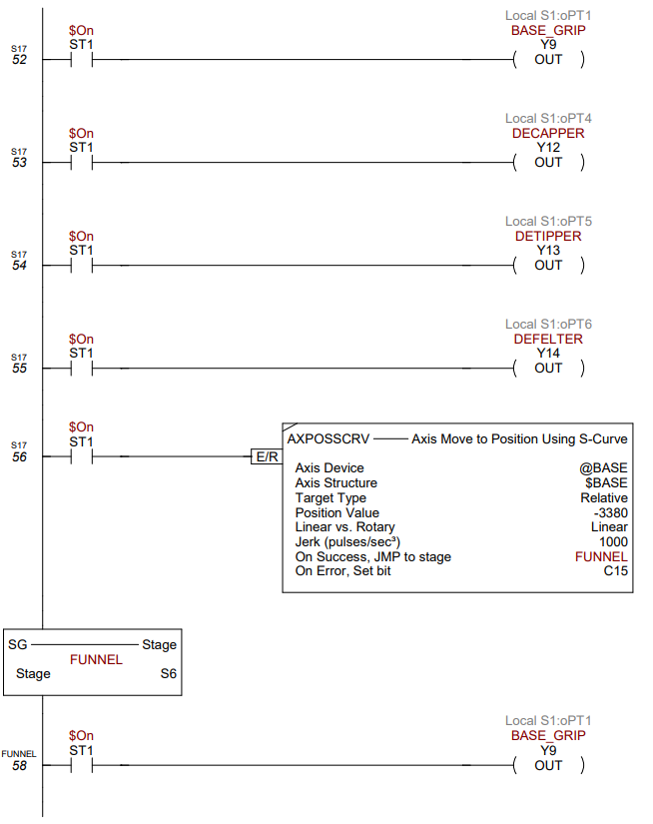

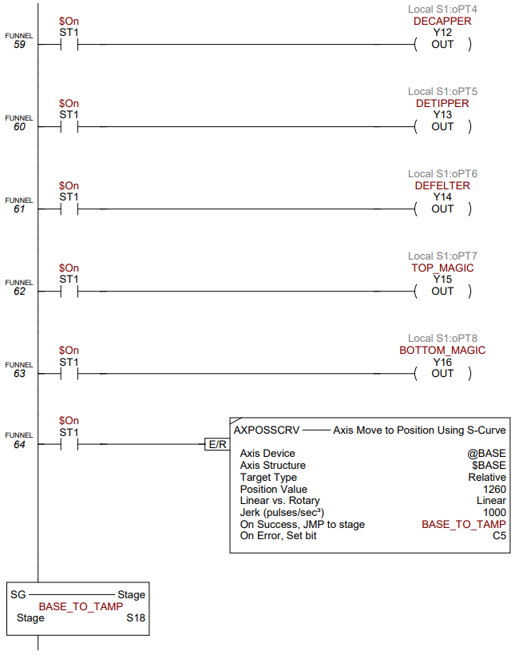

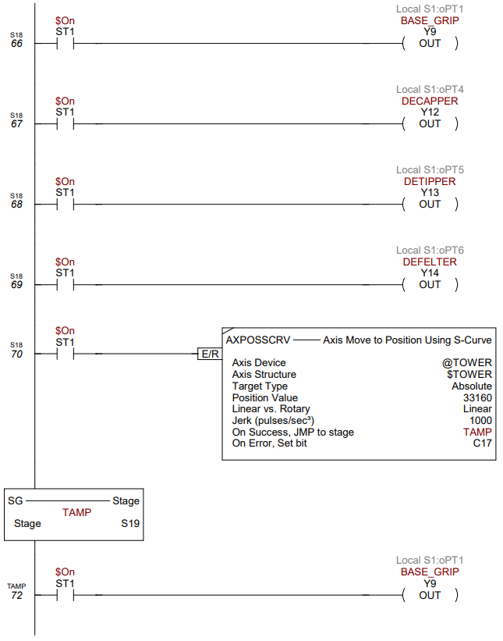

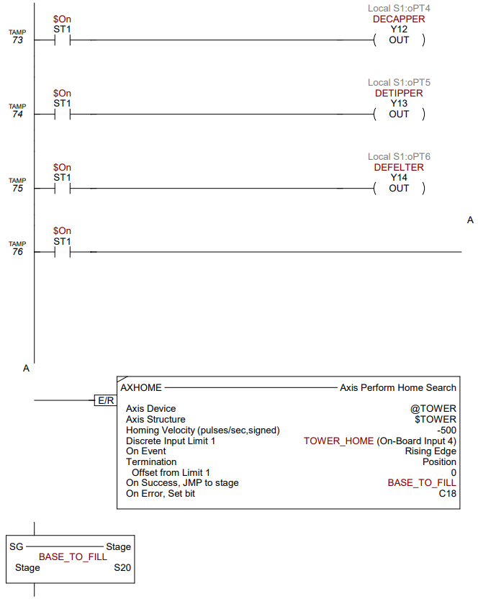

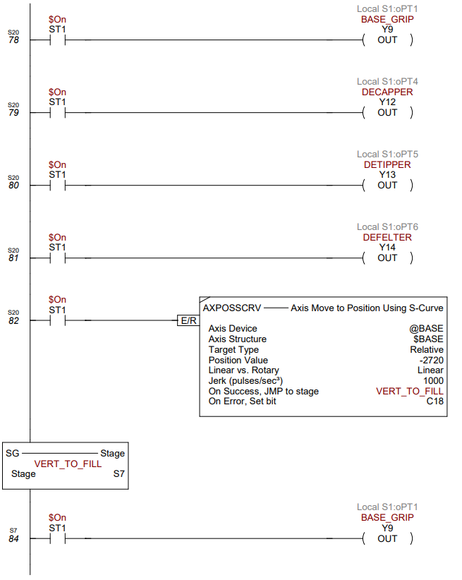

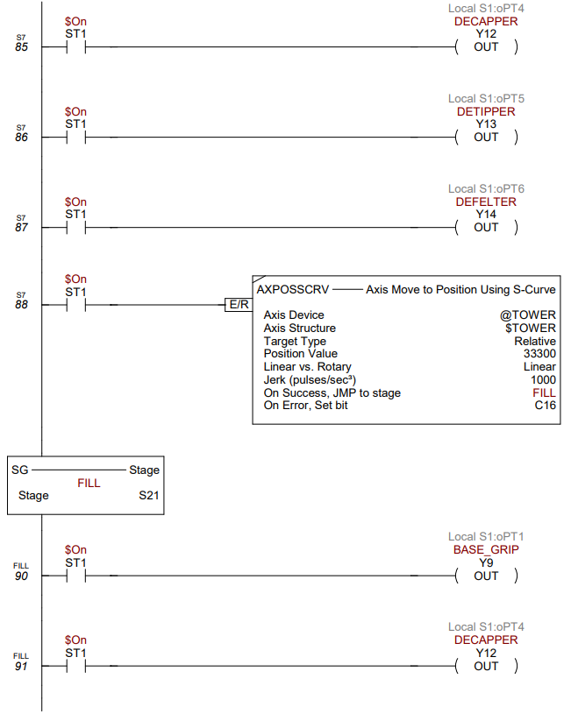

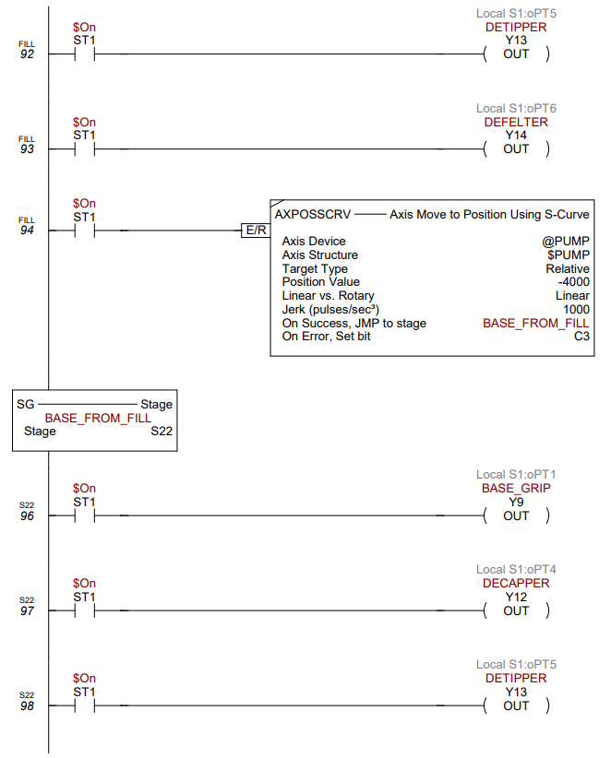

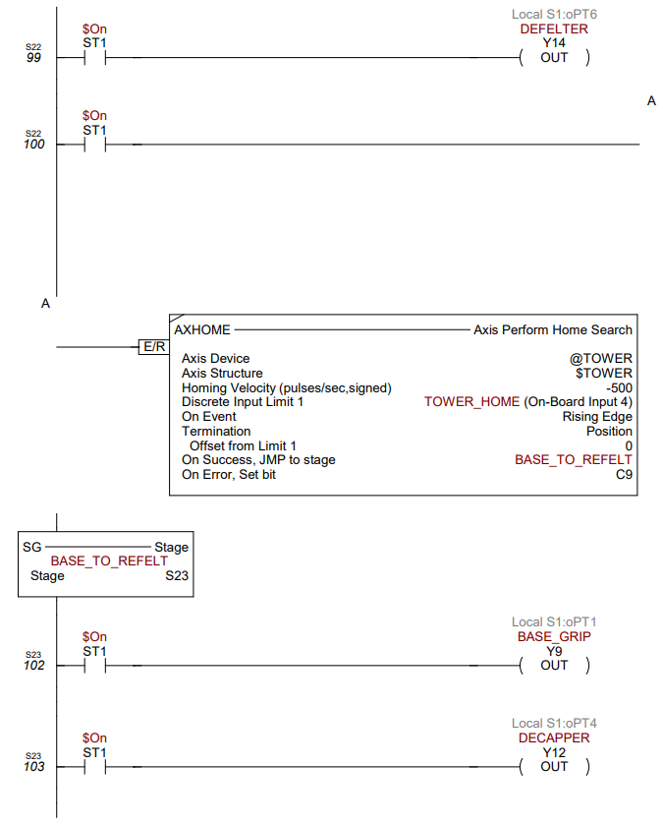

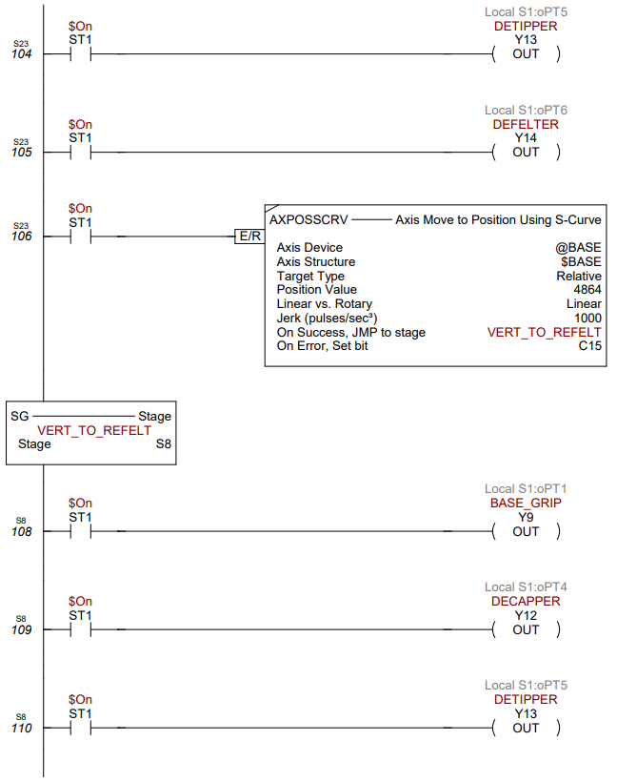

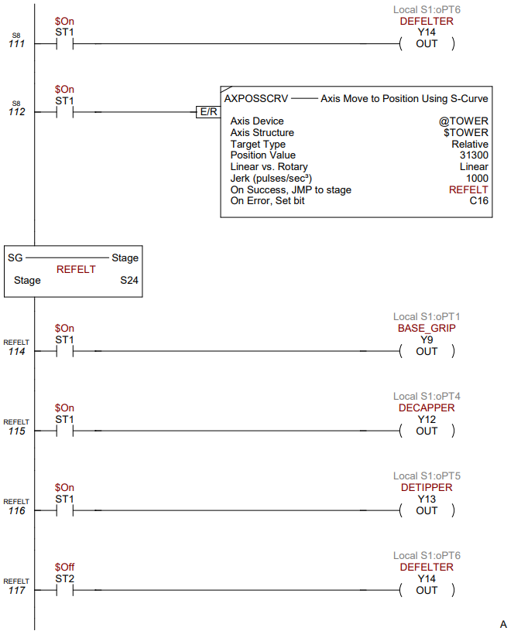

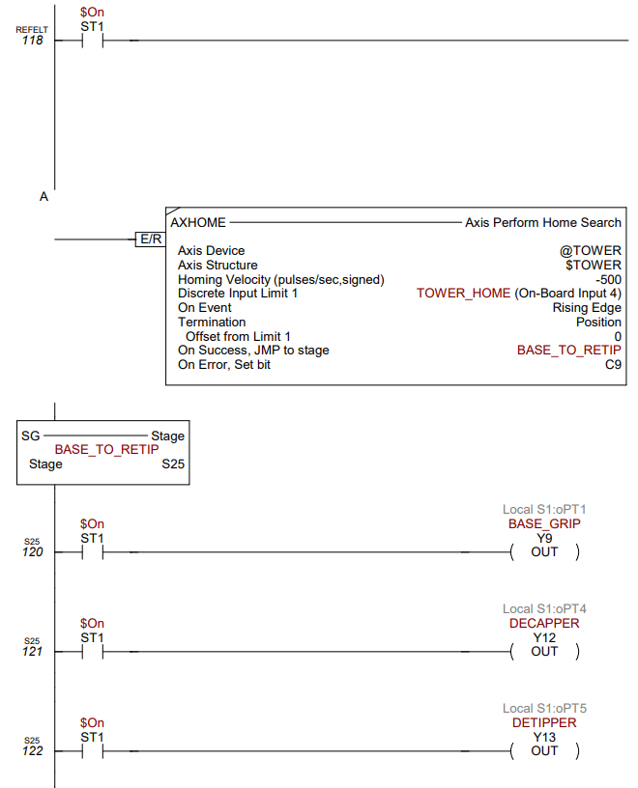

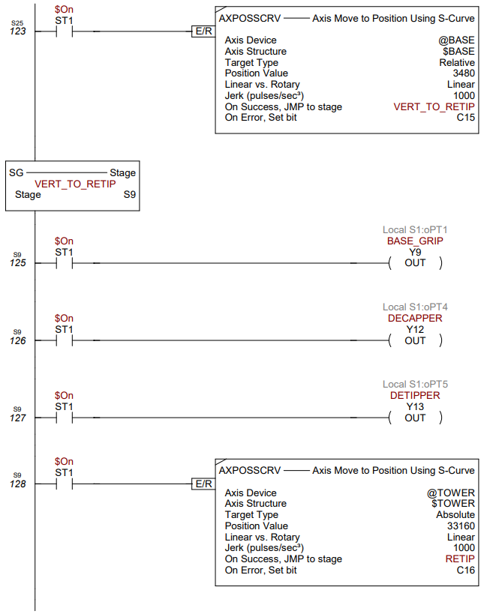

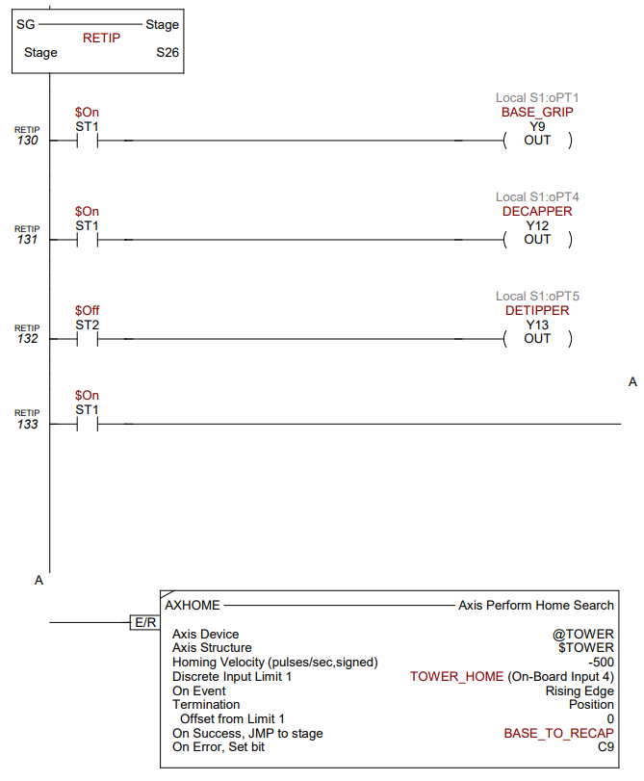

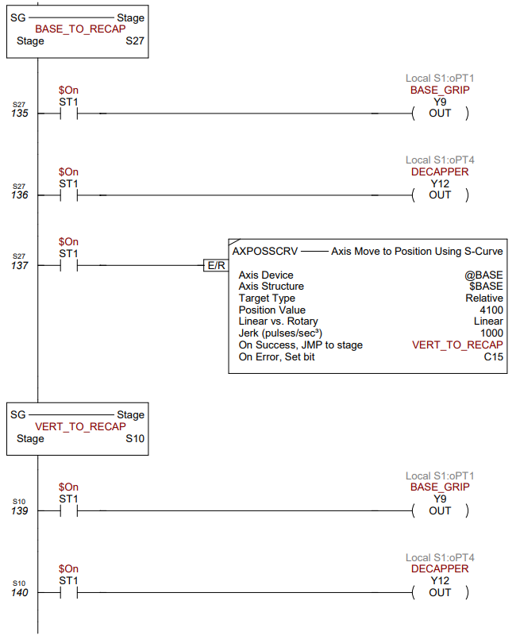

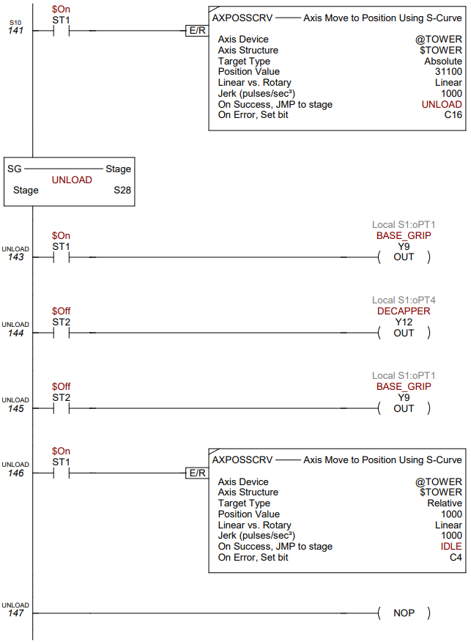

## State Diagram

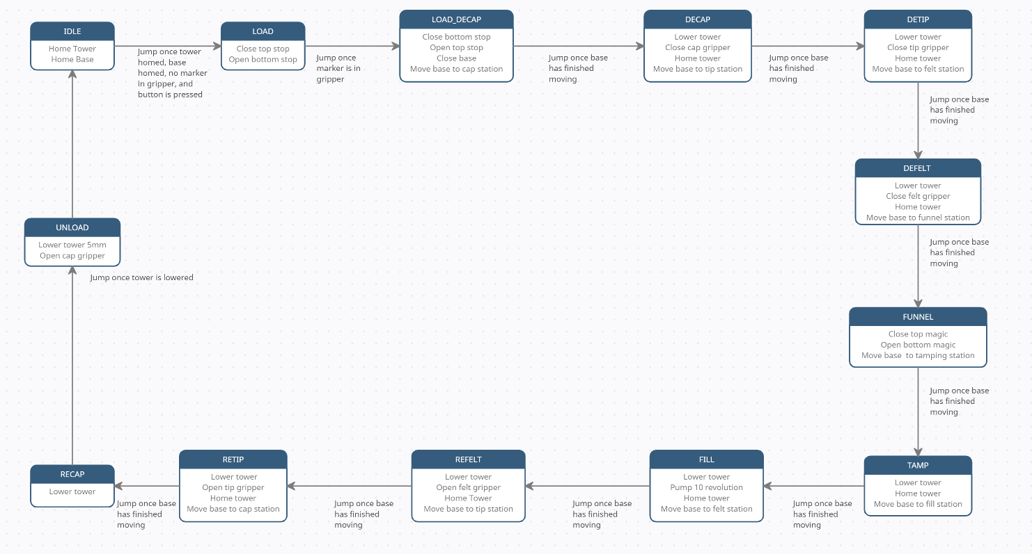

## Stepper Motor Configuration

The two tower stepper motors were wired in parallel, and the driver was set for 2000 steps/rev, the stepper motor driver for the base was set to 400steps/rev, and the pump stepper motor driver was set to 400steps/rev. In the PLC logic, the only non-standard setting in the AXCONFIG was that the maximum velocity was changed to 750 pulses per second. The AXCONFIG for the base was also set to 750 pulses per second and the pump was set to 500 pulses per second.

## Wiring Table

|  |  |  |
| --- | --- | --- |
| I/O Port | Name | Description |
| X0 | BASE_HOME | Inductive sensor for homing the base |
| X1 | TIP_GRIP_SENS | Sensor attached to the tip gripper |
| X2 | MARKER_IN | Optic sensor below marker gripper |
| X3 | FELT_GRIP_SENS | Sensor attached to the felt gripper |
| X4 | TOWER_HOME | Inductive sensor for homing the tower |
| X5 | BASE_GRIP_SENS | Sensor attached to the marker gripper |
| X9 | Magic | Green button near e-stop |
| Y0 | BASE_STEP | Steps for Base motor driver |
| Y1 | TOWER_STEP | Steps for Tower motors driver |
| Y2 | PUMP_STEP | Steps for Pump motor driver |
| Y4 | BASE_DIR | Direction for Base motor driver |
| Y5 | TOWER_DIR | Direction for Tower motor driver |
| Y6 | PUMP_DIR | Direction for Pump motor driver |
| Y9 | BASE_GRIP | Base/Marker gripper pneumatic valve |
| Y10 | BOTTOM_STOP | Pneumatic valve for bottom stopper in the marker loading mechanism |
| Y11 | TOP_STOP | Pneumatic valve for top stopper in the marker loading mechanism |
| Y12 | DECAPPER | Pneumatic valve for cap gripper |
| Y13 | DETIPPER | Pneumatic valve for tip gripper |
| Y14 | DEFELTER | Pneumatics valve for felt gripper |
| Y15 | TOP_MAGIC | Pneumatic valve for top stopper in the funnel loader |
| Y16 | BOTTOM_MAGIC | Pneumatic valve for bottom stopper in the funnel loader |
| $Main.S0 | IDLE | Stage for homing to resting position |
| $Main.S1 | LOAD | Stage for loading the marker |
| $Main.S2 | BASE_TO_UNCAP | Stage for moving the base to the cap station |
| $Main.S3 | VERT_TO_UNCAP | Stage for moving the tower down to the marker |
| $Main.S4 | VERT_TO_DETIP | Stage for moving the tower down to the marker |
| $Main.S5 | VERT_TO_DEFELT | Stage for moving the tower down to the marker |
| $Main.S6 | FUNNEL | Stage for dropping the funnel into the marker |
| $Main.S7 | VERT_TO_FILL | Stage for moving the tower down to the marker |
| $Main.S8 | VERT_TO_REFELT | Stage for moving the tower down to the marker |
| $Main.S9 | VERT_TO_RETIP | Stage for moving the tower down to the marker |
| $Main.S10 | VERT_TO_RECAP | Stage for moving the tower down to the marker |
| $Main.S12 | UNCAP | Stage for taking off the cap |
| $Main.S13 | BASE_TO_DETIP | Stage for moving the base to the tip station |
| $Main.S14 | DETIP | Stage for taking the tip off the marker |
| $Main.S15 | BASE_TO_DEFELT | Stage for moving the base to the felt station |
| $Main.S16 | DEFELT | Stage for taking the felt from the marker |
| $Main.S17 | BASE_TO_FUNNEL | Stage for moving the base to the funnel station |
| $Main.S18 | BASE_TO_TAMP | Stage for moving the base to the tamp station |
| $Main.S19 | TAMP | Stage for moving the tower down to the marker |
| $Main.S20 | BASE_TO_FILL | Stage for moving the base to the fill station |
| $Main.S21 | FILL | Stage for pumping solvent into the marker |
| $Main.S22 | BASE_FROM_FILL | Stage for homing the tower after filling |
| $Main.S23 | BASE_TO_REFELT | Stage for moving the base to the felt station |
| $Main.S24 | REFELT | Stage for putting the felt back into the marker |
| $Main.S25 | BASE_TO_RETIP | Stage for moving the base to the tip station |
| $Main.S26 | RETIP | Stage for putting the tip back into the marker |
| $Main.S27 | BASE_TO_RECAP | Stage for moving the base to the cap station |
| $Main.S28 | UNLOAD | Stage for dislodging the marker |