December 13, 2023
Evan Farley, Keaton reece, jaron schultz
walla walla university

Manufacturing system manual
engr 480
Contents
Instructions: 2
Loading the machine 2
Starting the machine 2
Clearing jams 2
Descriptions: 3
Operation of each major section 3
Pen Feed 3
Punch 3
Fill 3
Shrink Wrap Placer 3
Heat Gun 3
Pen Storage 4
Robotic Arm 4
Sensors 4
Maintenance instructions 4
Future improvements 4
Performance Data 4
Diagrams: 5
Annotated photos 5
3D Printed Parts 5
PLC ladder logic 7
State Machine Diagram 25
Motoman job program 25
Stepper motor drive configuration 32
Wiring Diagram 32

Instructions:

Loading the machine
To load the machine, insert dried out pens bottom side first into the metal cylinder next to the robotic arm. If there is no shrink wrap, push it through the slot in the side of the wrap station past the stepper motor until it just barely touches the scissors. To fill the fill station with isopropyl alcohol, fill the rubber bottle with alcohol and connect the syringe to the rubber hose that passes through the peristaltic pump. Then charge the system by opening up the pump enough that liquid flows all the way to the needle, closing the pump off when the liquid gets to the needle to prevent spillage.

Starting the machine
To start the machine, plug the PLC and the heat gun into the power strip on the side of the table. Then, turn the large switch on the side of the table to the on position to start the robot arm. Select the correct job labeled “Wrapgods” in the arm controller. After making sure that the emergency stop button is twisted up on the box next to the power strip, flipping the PLC to the run position should start up the machine.
To start the robot arm code, go into teach mode and position the robot arm in the first point listed in the motoman code. Then switch to play and press the green button while holding down the controller pressure switch. The arm will start moving towards the pen holder, pick it up and begin to move around the system.

Clearing jams
If there is an error in the machine, it should go into an error state where the arm lets go of the pen. You can then clear the jam and press the reset button. The reset button is the black button next to the emergency stop button on the table. This will reset the PLC to its initial state and will wait for the sensor on the arm to sense a pen.
If the arm makes a mistake and doesn’t go into the error state, press the emergency stop on the table or on the arm controller to completely stop the machine. You will then be able to clear the issue.
To reset the arm, use the motoman controller to move the arm back to its first point and refer to the section titled “Starting the machine” to begin operation again.

Descriptions:

Operation of each major section

Pen Feed
The pen feeder is an aluminum tube with a slot cut into it that is used to position the pens so that they can be reliably picked up by the robotic arm.

Punch
The punching system consists of a large pneumatic cylinder that pushes the tip of a nail down into a pen placed underneath it. There is also a resting place for the pen to be placed on so that the robotic arm is not trying to resist the force of the cylinder by itself.
The punch is operated by pushing the nail down through the side of the pen when the pneumatic cylinder is activated. This creates a hole in the side of the pen that can be used to refill the pen with isopropyl alcohol.

Fill
The filling station consists of a small pneumatic cylinder that pushes a needle into the hole on the side of the pen created by the punch. This needle is fed by a peristaltic pump that dispenses isopropyl alcohol from a rubber bag held next to the cylinder. There is a rest place for the pen in this stage as well.
The filling station pushes a needle into the hole created by the punch and then refills the pen with alcohol using its pump.

Shrink Wrap Placer
The shrink wrap placer is the most complicated mechanism of this project outside of the robotic arm. It consists of a stepper motor mounted on the side of a piece of extruded aluminum with a 3D printed bracket that guides the shrink wrap to its desired position. On this same piece of extruded aluminum, a pair of scissors is attached to a pneumatic arm which will close the scissors when activated. On another piece of extruded aluminum, a pneumatic arm is attached with two vacuum cups attached to it.
This section operates by advancing the shrink wrap past the scissors into the vacuum arm section. The vacuum arm will close and turn on the vacuum to hold the shrink wrap in place. The arm will then open, and the pen will be placed inside the shrink wrap. The scissors will close and cut the wrap so that the pen is now free. The robot arm can then move over to a 3D printed part that pushes on the pen to properly place the shrink wrap.

Heat Gun
The heat gun is a normal heat gun with a bracket on it that curves the heat into a circle at the end of its nozzle. This heat gun is placed on a piece of extruded aluminum high enough up that it will not heat the unused shrink wrap. The heat gun is plugged into an outlet that is run through a solid state relay, allowing the PLC to turn the heater on and off as needed.
The heat is turned on while the shrink wrap is being properly placed on the pen. Once it is hot enough, the arm will put the pen into the heat of the heat gun until the shrink wrap is properly shrunk. This process takes about 2-3 seconds.

Pen Storage
The pen storage is a cardboard box attached to the side of the table. This is where all finished pens are placed.

Robotic Arm
The robotic arm is a Motoman MH5L and is used to transfer the pen between all stations. A pneumatic arm is placed on the end with a 3D printed part which is used to hold the pen throughout the entire operation.

Sensors
There are two types of sensors used in this project. One is the infrared proximity sensor which is used extensively to detect the position of the pen in the various operations. There are IR sensors that sense the presence of the pen on the robot arm and in the punch, fill, and wrap stations as well as an IR sensor that detects the shrink wrap in the wrap station.
The other type of sensor that is used is the Hall effect sensor. This type of sensor senses the presence of magnetic fields. These sensors are used in the punch and fill stations to determine if the pneumatic cylinders are fully extended or not.

Maintenance instructions
Maintenance for this machine would involve replacing the shrink wrap when it is used up, refilling the rubber bottle with isopropyl alcohol, and refilling the pens as needed. Periodically checking the air hoses and the rubber hose for the alcohol to ensure that there are no leaks should also be done. The nail that is used to punch into the pens may bend occasionally and if it does, the nail must be bent back straight.

Future improvements
The team was unable to get the machine to be fully functional and so there are many improvements that could be made. The first improvement would be to figure out a better way to insert the needle into the pen to fill it with alcohol. The current method uses a 3D printed part that holds the needle and attaches to the pneumatic cylinder. Since the needle is offset from the cylinder, a guide had to be made to hold it in the correct orientation. This guide did not work well and there was too much play in the system. So, either making a better guide or finding a way to place the needle in line with the cylinder would be useful in improving the system.
Another place that could use improvement would be in the shrink wrap placing mechanism. The physical mechanism works well, but the PLC ladder logic was difficult to figure out and the team was unable to get it working by the time they had to present. So, further work into how the ladder logic should be set up in regards to the operations that have to be done to properly place a piece of shrink wrap on the pen would be good.
Also, the vacuum doesn’t like to hold onto the shrink wrap very strongly and so improving the design of the shrink wrap holder would be useful.

Performance Data
The manufacturing process wasn’t entirely successful in the end, but with some minor improvements it would have worked just fine. As it currently stands, the entire process takes somewhere around 2 minutes to complete, so this would be about 30 pens an hour. The main time loss is from the robot arm moving slowly, so if that was sped up the time could potentially go down to as low as a minute per pen.
The process also repeated itself very well, so as long as the pens, alcohol, and shrink wrap last, the process should be able to repeat indefinitely.

Diagrams:

Annotated photos

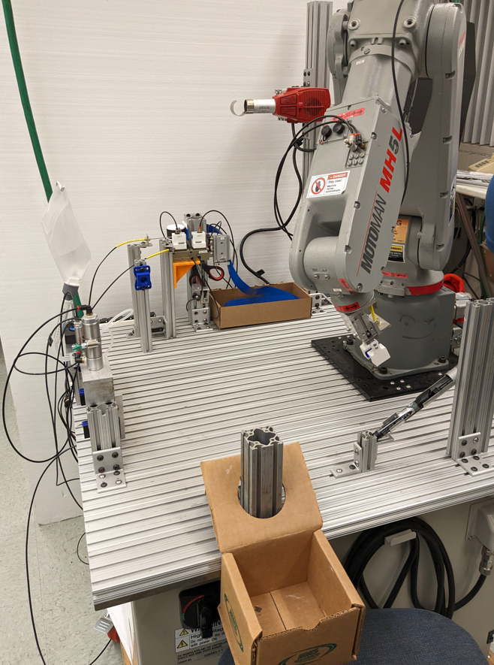
Pen feed station
Finished pen storage
Heat gun
Robot arm
Shrink wrap station
Fill station
Punch station
Full table overview
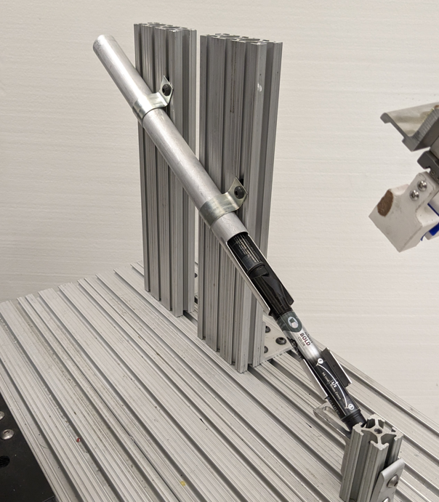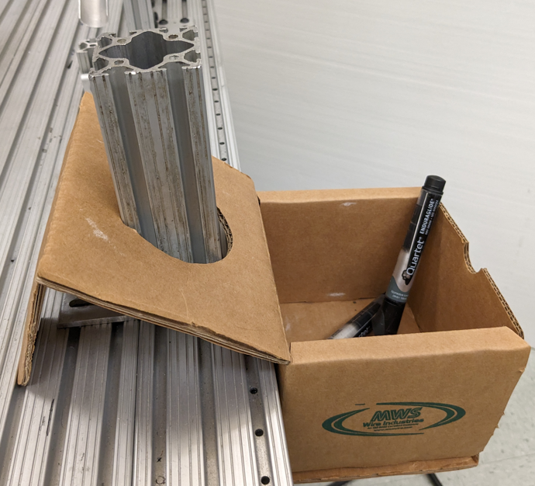
Pens inserted here
Pens ready for picking up
Finished pens
Pen feeding station (left) and finished pen drop-off and storage station (right)

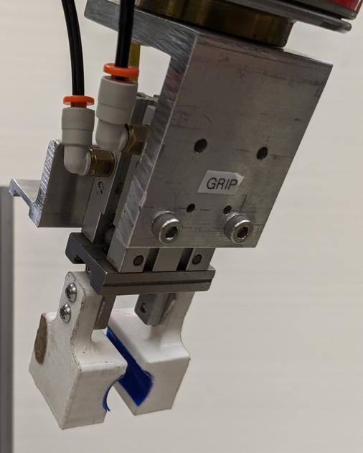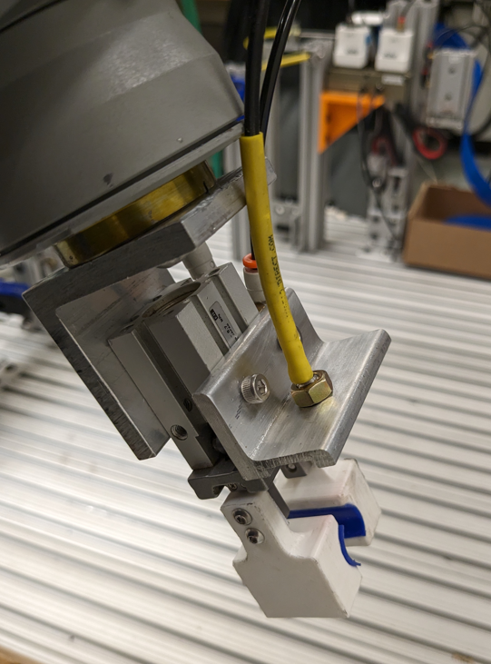
Printed grip claws
Pneumatic air ports
IR Sensor
Robotic arm gripper front (left) and back (right)
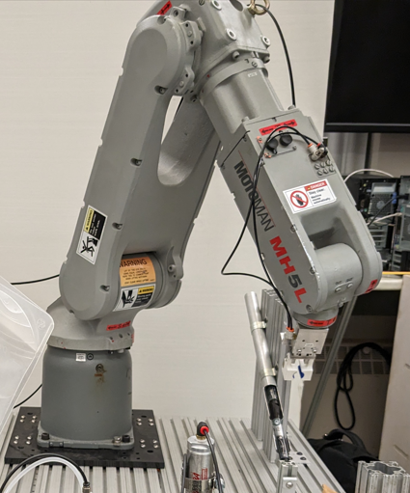
Attached gripper
Motoman MH5L robotic arm

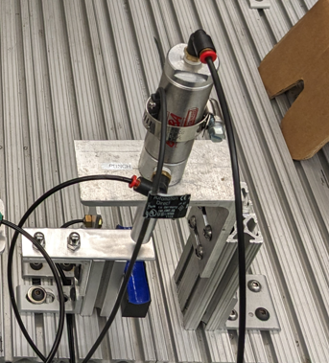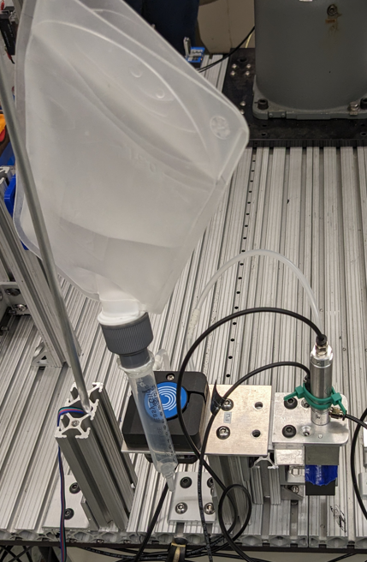
IR sensor
Hall sensor
Pneumatic cylinder
Nail (not visible)
Alcohol storage
Peristaltic pump
Dispensing alignment system
Punch station (left) and fill station (right)
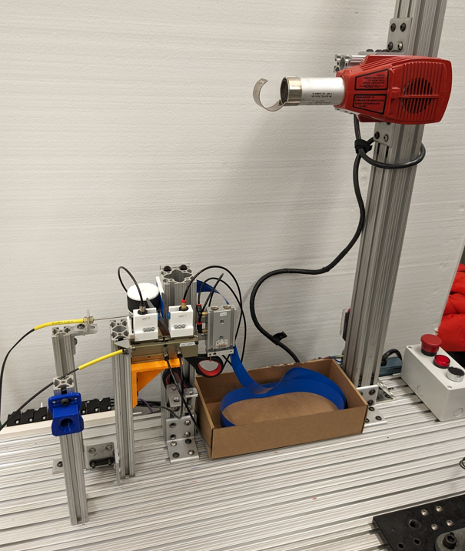
Heat gun
IR sensors
Shrink wrap storage
Shrink wrap feed mechanism
Scissor actuator
Shrink wrap alignment press
Vacuum grippers
Shrink wrap placer station and lifted heat gun station

3D Printed Parts

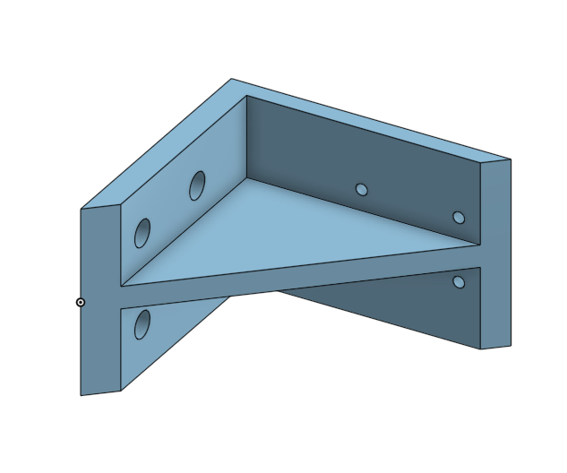
Vacuum Arm Gripper Bracket
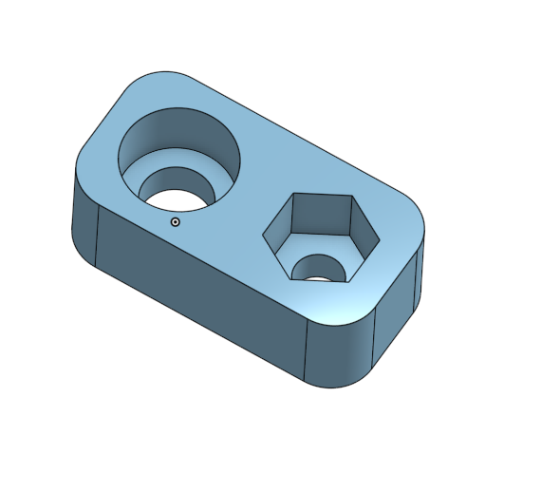
Pen Filler Needle Holder

PLC ladder logic
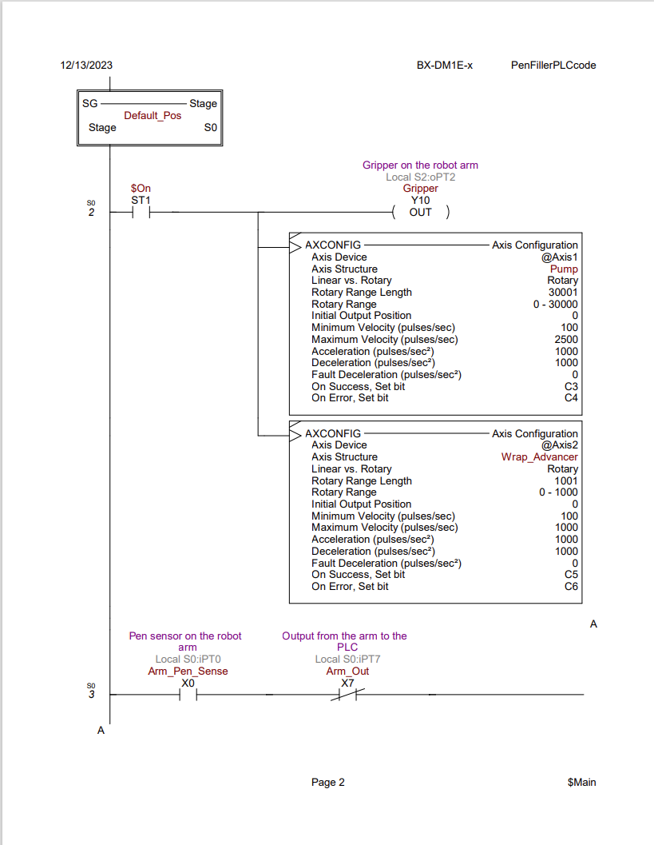
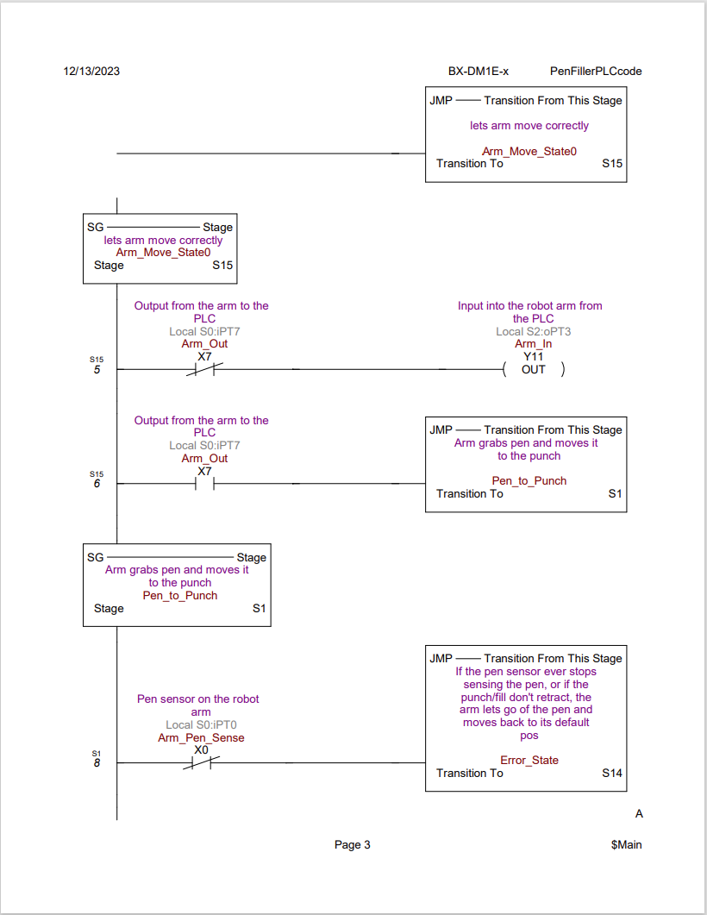
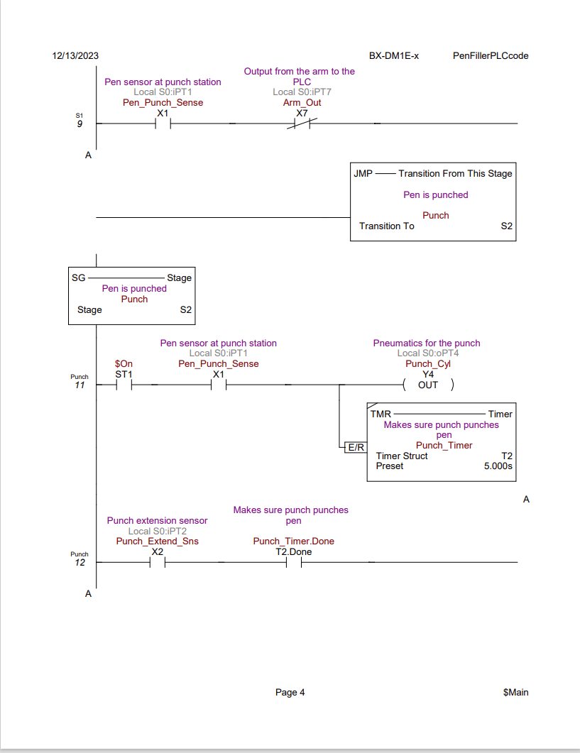
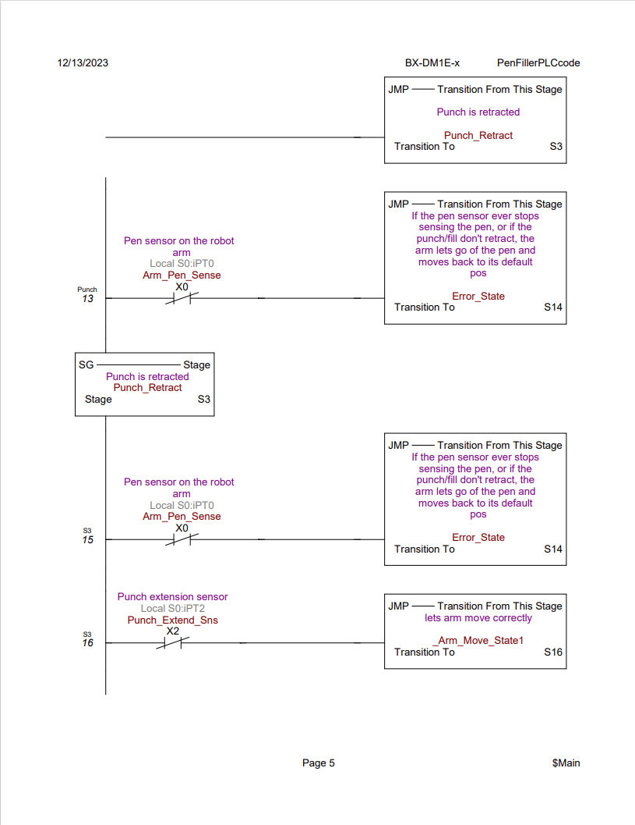
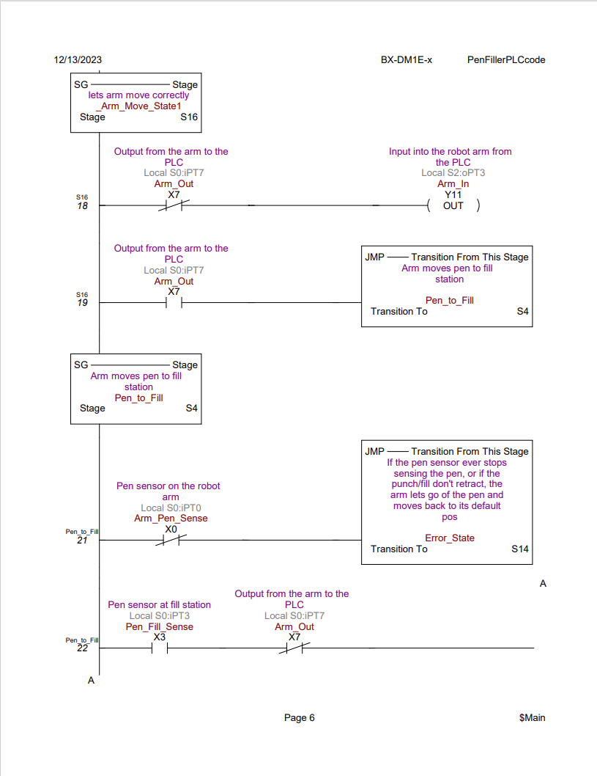
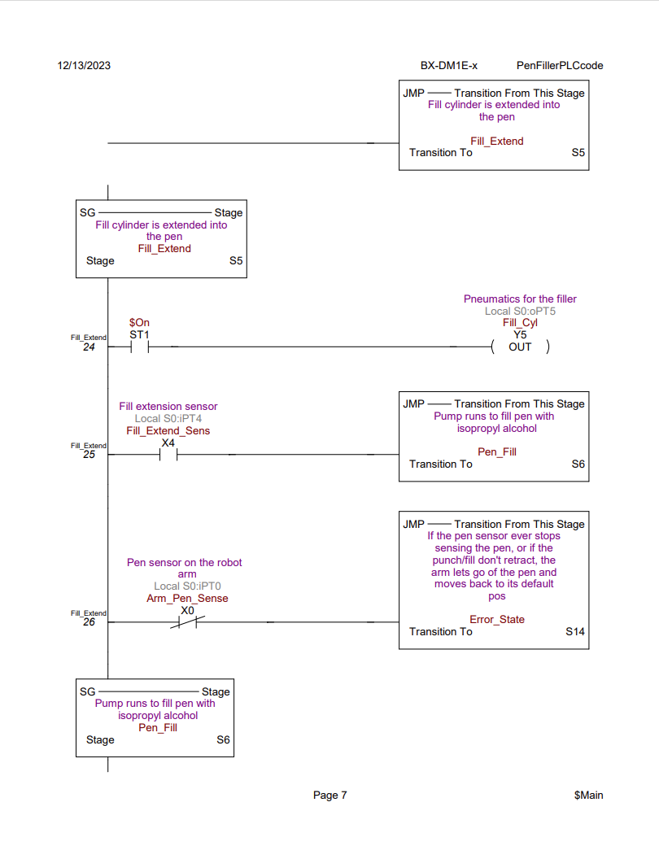
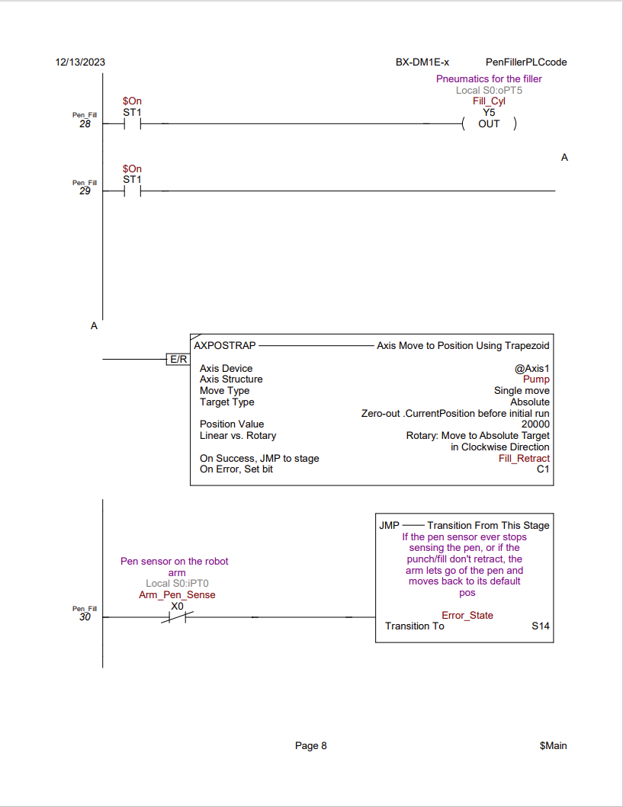
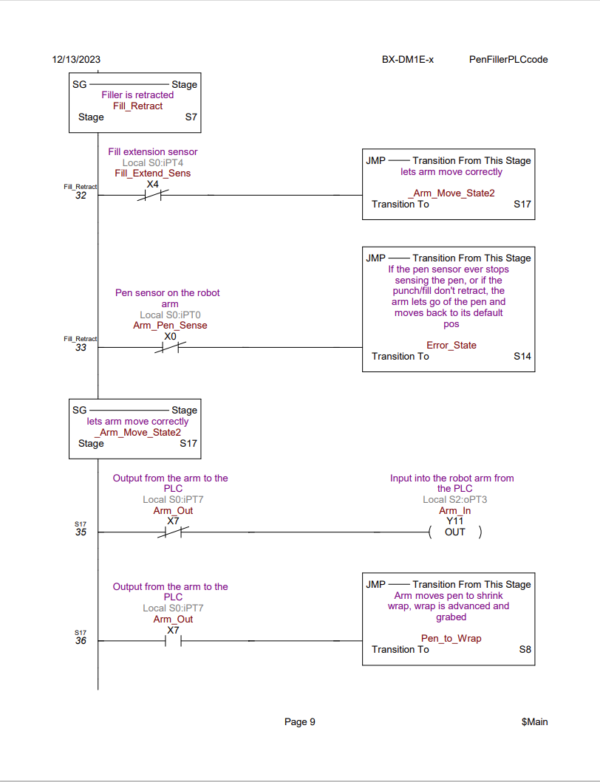
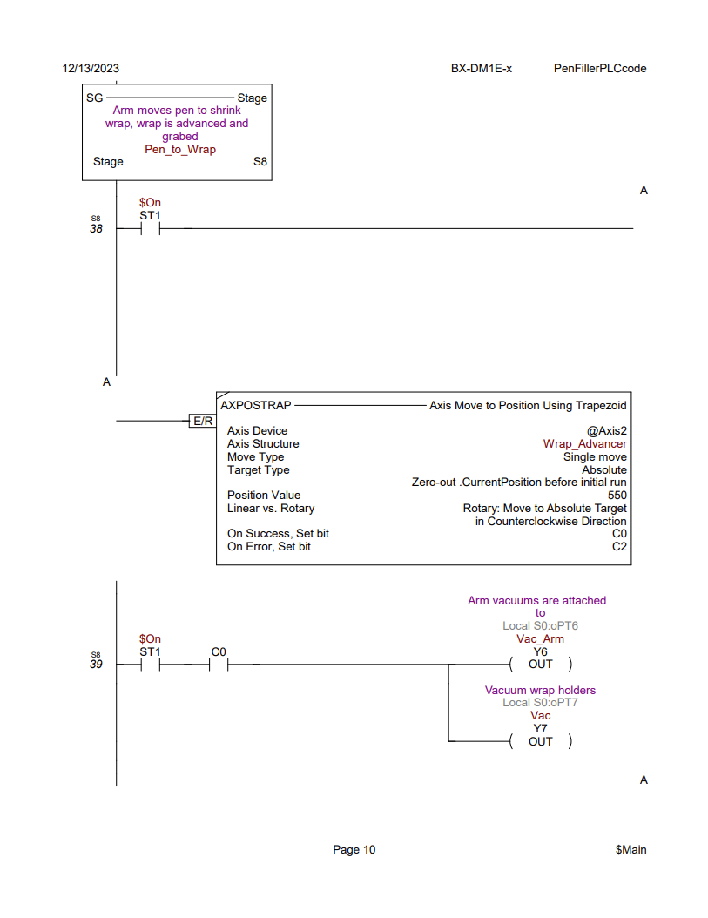
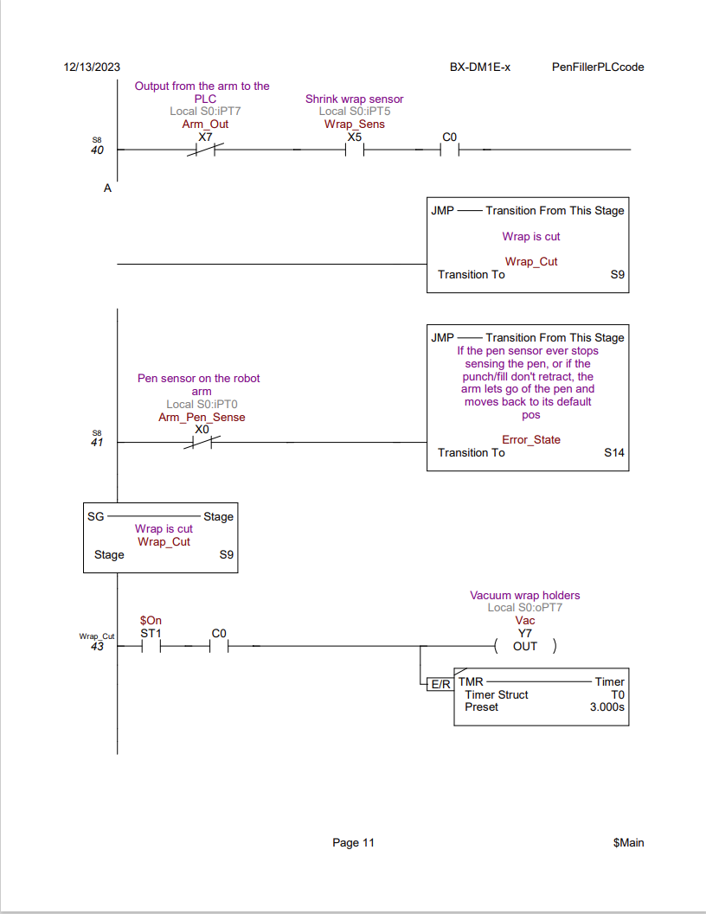
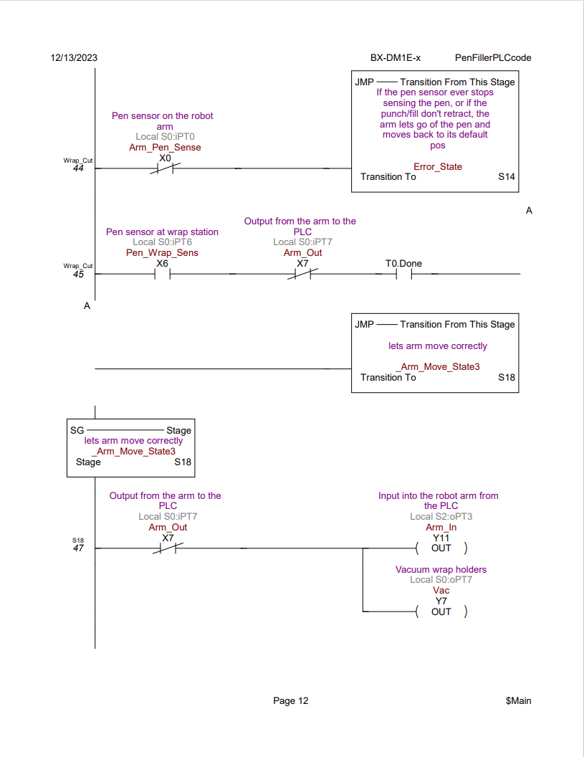
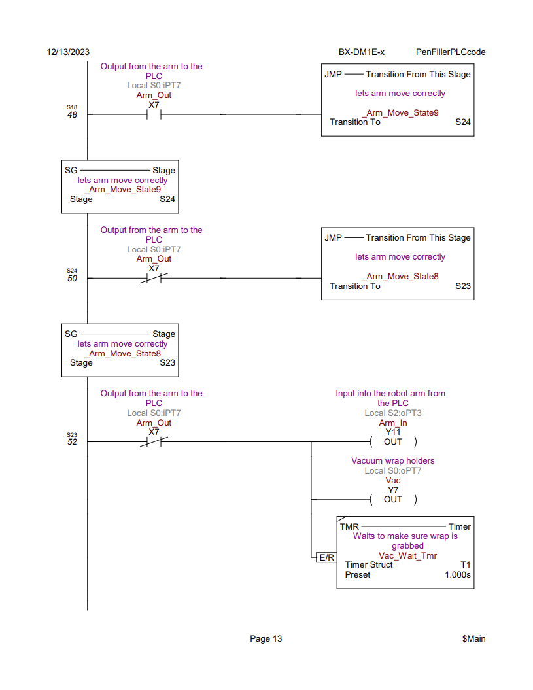
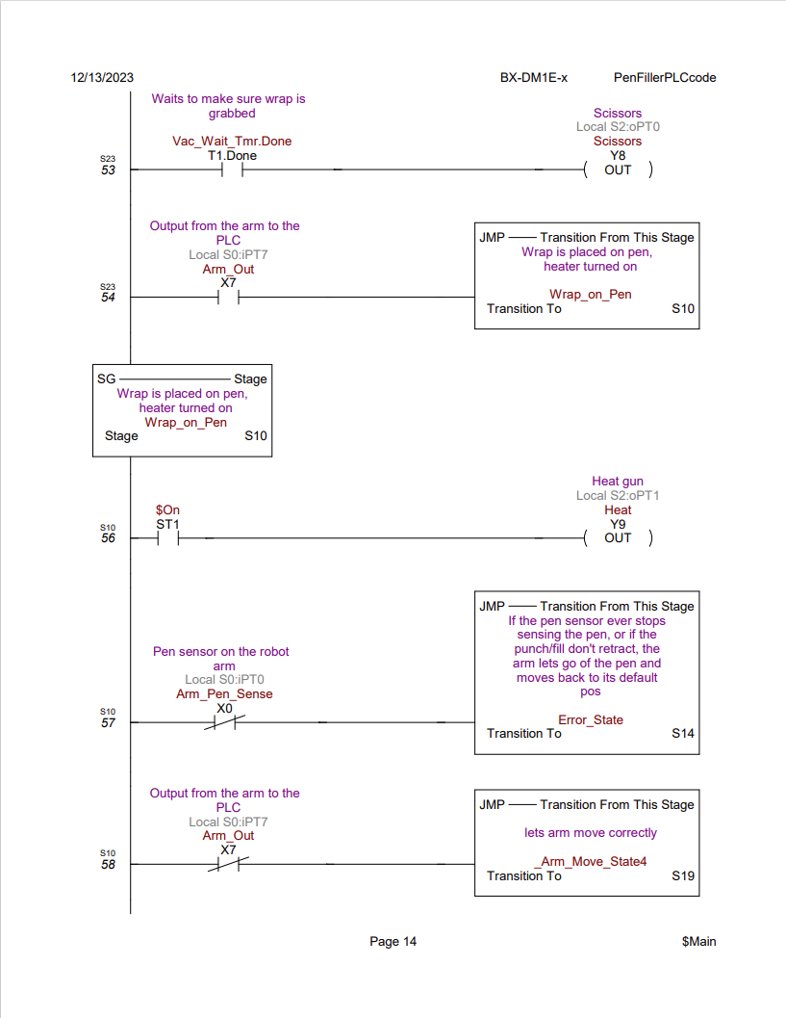
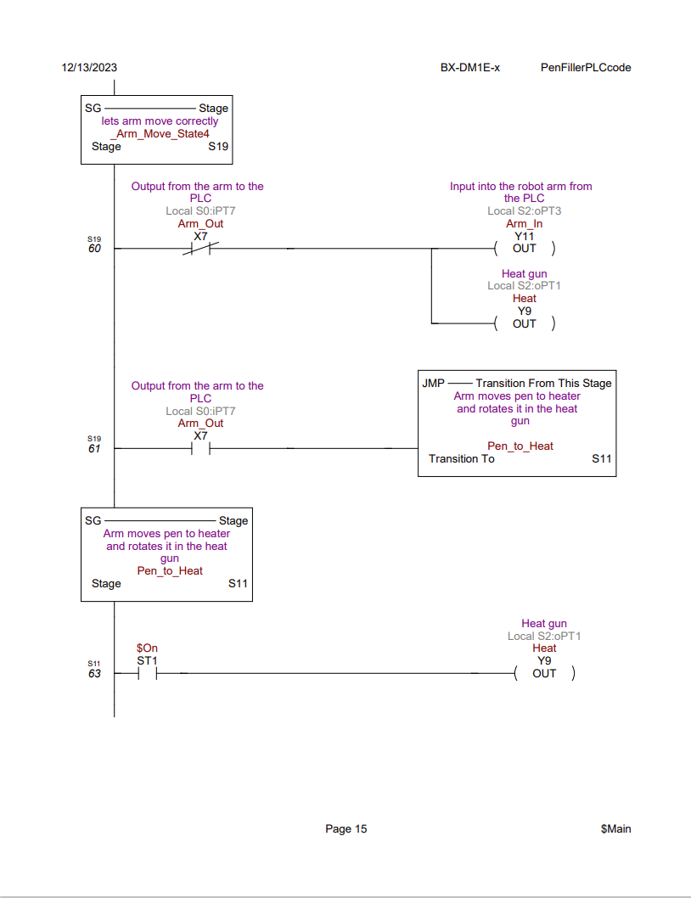
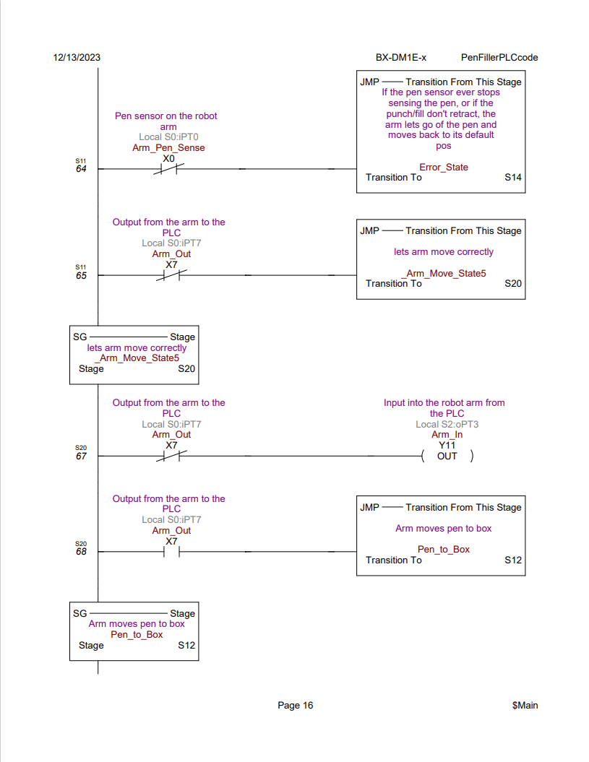
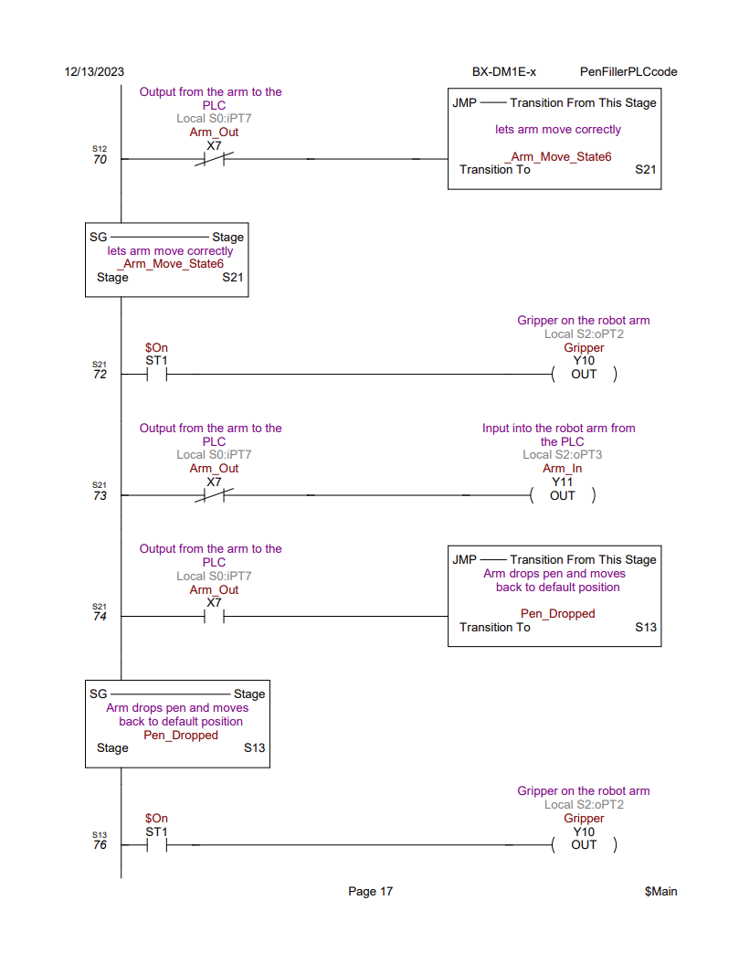
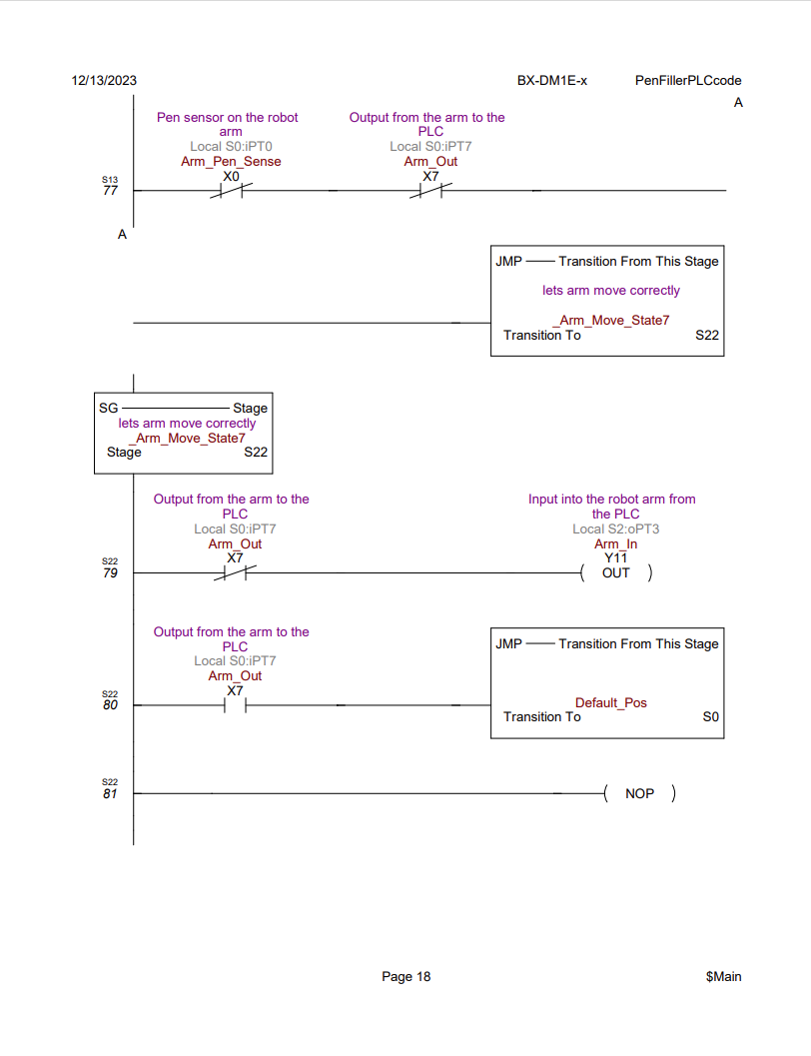
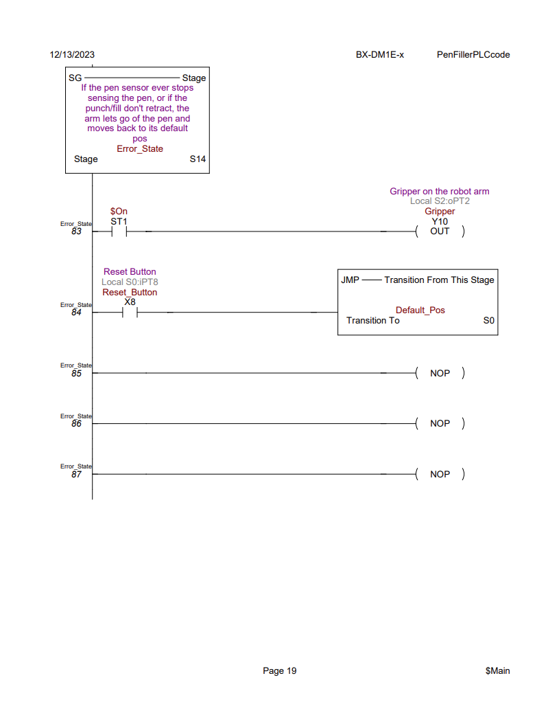

State Machine Diagram
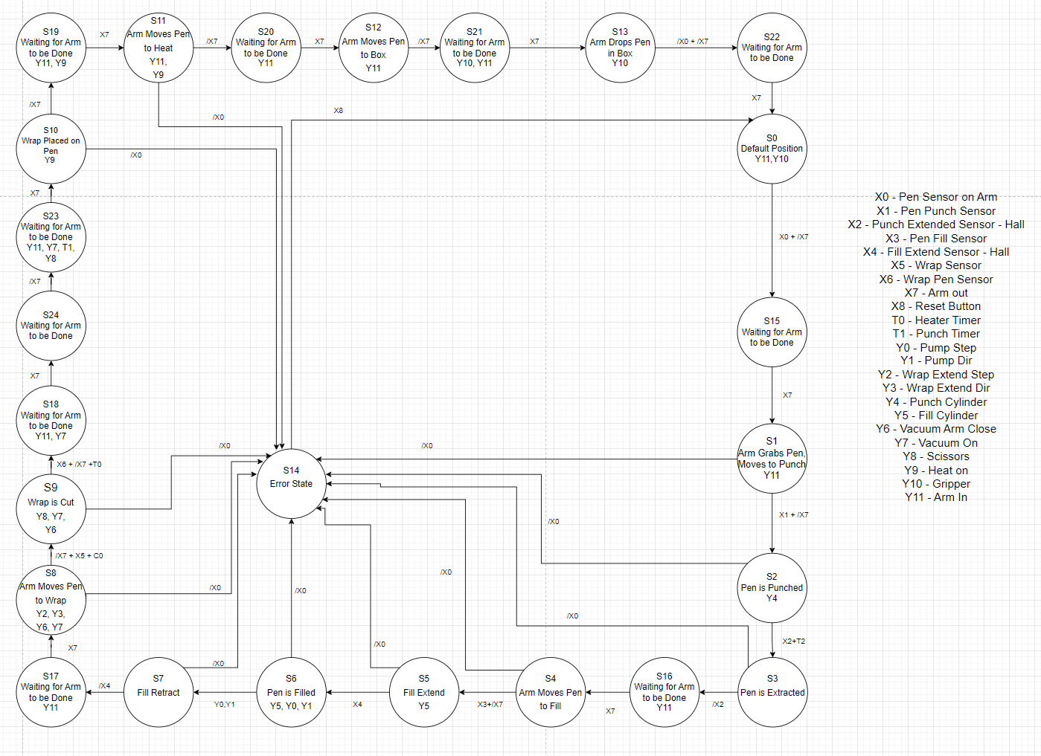

Motoman job program
/JOB
//NAME WRAPGODS
//POS
///NPOS 67,0,0,0,0,0
///TOOL 1
///POSTYPE PULSE
///PULSE
C00000=66081,33090,-43743,-21789,-54365,-170189
///TOOL 0
C00001=71059,43344,-50341,-27213,-43933,-167320
C00002=74802,52551,-53205,-33071,-37153,-164098
C00003=76436,56814,-53968,-36214,-34565,-162342
///TOOL 1
C00004=77010,56053,-54524,-36452,-34570,-162427
///TOOL 0
C00005=77216,55789,-54720,-36536,-34572,-162459
///TOOL 1
C00006=77692,55162,-55168,-36728,-34580,-162534
///TOOL 0
C00007=75101,50331,-53683,-32538,-37935,-164692
C00008=71648,41975,-50945,-27270,-44207,-167582
C00009=68188,34653,-46725,-23310,-51265,-169689
C00010=65140,29397,-41604,-20677,-57978,-171043
C00011=21601,69490,-28550,1238,-21245,-163658
C00012=20398,73234,-21093,1133,-24382,-163117
C00013=18791,79592,-8907,1006,-29365,-162399
C00014=18312,81883,-4625,970,-31083,-162186
C00015=18222,82339,-3777,963,-31422,-162146
C00016=19252,77620,-12647,1039,-27849,-162605
C00017=22223,67815,-31980,1294,-19775,-163939
C00018=3185,65728,-35743,2279,-18260,-157224
C00019=2493,80996,-7017,1273,-30691,-155729
///TOOL 1
C00020=2831,81313,-6443,1249,-30917,-155845
C00021=2855,81235,-6587,1251,-30861,-155851
///TOOL 0
C00022=2433,70501,-27632,1765,-21625,-155900
///TOOL 1
C00023=3106,62486,-61371,-85836,-2177,-151237
C00024=-39249,3974,-67724,-63741,-15078,-153344
C00025=-53732,11431,-59844,-58817,-20182,-152414
C00026=-55477,12599,-58669,-58276,-20803,-152191
C00027=-57132,13758,-57485,-57729,-21401,-152002
C00028=-58738,14933,-56265,-57167,-21991,-151840
C00029=-59135,15231,-55952,-57023,-22139,-151803
C00030=-59135,8948,-54048,-47968,-24919,-158125
C00031=-59135,6351,-53014,-44606,-26384,-160522
C00032=-59135,674,-50061,-38022,-30306,-165351
C00033=-17246,-20912,-65588,-19743,-20720,-189643
C00034=-14320,38241,-48940,-128887,-6113,-118202
C00035=-16417,38528,-48510,-123440,-6385,-120929
C00036=-18257,38814,-48080,-118906,-6656,-123169
C00037=-20155,39144,-47584,-114466,-6965,-125331
C00038=-22140,39528,-47007,-110070,-7319,-127438
C00039=-24526,40043,-46233,-105105,-7786,-129776
C00040=-26098,40414,-45670,-102009,-8115,-131205
C00041=-19754,39069,-47696,-115387,-6898,-124889
C00042=-9920,37770,-49646,-141220,-5684,-111920
C00043=-23806,-34022,-22320,-1832,-91531,-198524
C00044=-47038,-28473,-20192,-1940,-87492,-189591
C00045=-60442,-19904,-16355,-1138,-85138,-184371
C00046=-56761,-14934,-13563,3594,-90740,-185485
C00047=-53912,-10667,-11643,7419,-95546,-186137
C00048=-51370,-6473,-10217,11100,-100276,-186530
C00049=-49603,-3291,-9474,13916,-103879,-186668
C00050=-48081,-334,-9078,16609,-107252,-186668
C00051=-46538,2923,-9020,19729,-111010,-186515
C00052=-45235,5947,-9382,22851,-114563,-186208
C00053=-46134,3830,-9083,20639,-112062,-186443
C00054=-47442,978,-9004,17843,-108753,-186629
C00055=-49161,-2457,-9333,14667,-104821,-186683
C00056=-51246,-6259,-10159,11290,-100511,-186546
C00057=-53636,-10233,-11475,7805,-96029,-186191
C00058=-56450,-14491,-13345,4003,-91234,-185567
C00059=-60301,-19726,-16248,-956,-85334,-184420
C00060=-46523,-30138,-22481,-1732,-86187,-189768
C00061=49895,35988,14565,1300,-57997,-71840
C00062=62012,76884,-40531,2555,73075,-152911
C00063=61220,76211,-46830,3010,77230,-152798
C00064=61009,75345,-50452,3130,79331,-152723
C00065=62125,53780,-53812,2532,68749,-153040
C00066=66081,33092,-43744,-21790,-54323,-170172
//INST
///DATE 2023/12/12 17:05
///ATTR SC,RW
///GROUP1 RB1
NOP
*START
MOVJ C00000 VJ=2.00
DOUT OT#(1) ON
MOVJ C00001 VJ=2.00
MOVJ C00002 VJ=2.00
MOVJ C00003 VJ=2.00
MOVJ C00004 VJ=2.00
DOUT OT#(1) OFF
TIMER T=1.00
WAIT IN#(1)=ON
DOUT OT#(1) ON
MOVJ C00005 VJ=2.00
MOVJ C00006 VJ=2.00
MOVJ C00007 VJ=2.00
MOVJ C00008 VJ=2.00
MOVJ C00009 VJ=2.00
MOVJ C00010 VJ=2.00
MOVJ C00011 VJ=2.00
MOVJ C00012 VJ=2.00
MOVJ C00013 VJ=2.00
MOVJ C00014 VJ=2.00
MOVJ C00015 VJ=2.00
DOUT OT#(1) OFF
TIMER T=0.50
WAIT IN#(1)=ON
DOUT OT#(1) ON
MOVJ C00016 VJ=2.00
MOVJ C00017 VJ=2.00
MOVJ C00018 VJ=2.00
MOVJ C00019 VJ=2.00
MOVJ C00020 VJ=2.00
MOVJ C00021 VJ=4.00
DOUT OT#(1) OFF
TIMER T=0.50
WAIT IN#(1)=ON
DOUT OT#(1) ON
MOVJ C00022 VJ=2.00
MOVJ C00023 VJ=2.00
MOVJ C00024 VJ=2.00
MOVJ C00025 VJ=2.00
DOUT OT#(1) OFF
TIMER T=0.50
WAIT IN#(1)=ON
DOUT OT#(1) ON
MOVJ C00026 VJ=2.00
MOVJ C00027 VJ=2.00
MOVJ C00028 VJ=2.00
MOVJ C00029 VJ=2.00
DOUT OT#(1) OFF
WAIT IN#(1)=ON
DOUT OT#(1) ON
MOVJ C00030 VJ=2.00
MOVJ C00031 VJ=2.00
MOVJ C00032 VJ=2.00
MOVJ C00033 VJ=2.00
MOVJ C00034 VJ=2.00
MOVJ C00035 VJ=2.00
MOVJ C00036 VJ=2.00
MOVJ C00037 VJ=2.00
MOVJ C00038 VJ=2.00
MOVJ C00039 VJ=2.00
MOVJ C00040 VJ=2.00
MOVJ C00041 VJ=2.00
MOVJ C00042 VJ=2.00
MOVJ C00043 VJ=2.00
DOUT OT#(1) OFF
TIMER T=0.50
WAIT IN#(1)=ON
DOUT OT#(1) ON
MOVJ C00044 VJ=4.00
MOVJ C00045 VJ=4.00
MOVJ C00046 VJ=4.00
MOVJ C00047 VJ=4.00
MOVJ C00048 VJ=4.00
MOVJ C00049 VJ=4.00
MOVJ C00050 VJ=4.00
MOVJ C00051 VJ=4.00
MOVJ C00052 VJ=4.00
MOVJ C00053 VJ=4.00
MOVJ C00054 VJ=4.00
MOVJ C00055 VJ=4.00
MOVJ C00056 VJ=4.00
MOVJ C00057 VJ=4.00
MOVJ C00058 VJ=4.00
MOVJ C00059 VJ=4.00
MOVJ C00060 VJ=4.00
DOUT OT#(1) OFF
TIMER T=0.50
WAIT IN#(1)=ON
DOUT OT#(1) ON
MOVJ C00061 VJ=4.00
MOVJ C00062 VJ=4.00
DOUT OT#(1) OFF
TIMER T=0.50
WAIT IN#(1)=ON
DOUT OT#(1) ON
MOVJ C00063 VJ=2.00
MOVJ C00064 VJ=2.00
MOVJ C00065 VJ=2.00
MOVJ C00066 VJ=2.00
DOUT OT#(1) OFF
TIMER T=0.50
WAIT IN#(1)=ON
DOUT OT#(1) ON
JUMP *START
END

Stepper motor drive configuration
The dial was set to 1.3 amps, the motors were set to 2000 steps/rev. Pins 2, 4, 5, and 6 were on.

Wiring Diagram
